

**Module Code & Module Title**

**CS6P05NI Final Year Project**

**Assessment Weightage & Type**

**40% Final Project Report**

**Year and Semester**

**2021-22 Autumn**

**Student Name: Abhishek Rokaya**

**London Met ID: 19030695**

**College ID: NP01CP4A190164**

**Internal Supervisor: Mohit Sharma**

**External Supervisor: Ankit Tandukar**

**Assignment Due Date: 27th April 2022**

**Assignment Submission Date: 27th April 2022**

**Word Count:**

*I confirm that I understand my coursework needs to be submitted online via Google Classroom under the relevant module page before the deadline in order for my assignment to be accepted and marked. I am fully aware that late submissions will be treated as non-submission and a marks of zero will be awarded.*

**Abstract**

Table of Contents

1. Introduction 1

1.1 Project Description 1

1.2 Problem Scenario 1

1.3 Project as a Solution 2

1.4 Aims and Objectives 4

1.5 Structure of the report 4

1.5.1 Background 4

1.5.2 Development 4

1.5.3 Testing and Analysis 5

1.5.4 Conclusion 5

2. Background 6

2.1 About the end users 6

2.1.1 Discussion with client 6

2.1.2 End Users 7

2.2 Understanding the solution 7

2.3 Similar Projects 8

2.4 Comparisons 12

3. Development 13

3.1 Considered Methodologies 13

3.2 Selected Methodology 15

3.3 Phases of Methodology 16

3.4 Survey 17

3.4.1 Pre-Survey Results 17

3.4.2 Post-Survey Results 18

3.5 Requirement Analysis 18

3.6 Design 18

3.7 Implementation 120

4. Testing and analysis 121

4.1 Test Plan 121

4.1.1 Unit Testing, Test Plan 121

4.1.2 System Testing, Test Plan 121

4.2 Unit Testing 121

4.3 System Testing 121

4.4 Critical Analysis 121

5. Conclusion 122

5.1 Legal, Social and Ethical Issues 122

5.1.1 Legal Issues 122

5.1.2 Social Issues 122

5.1.3 Ethical Issues 122

5.2 Advantages 122

5.3 Limitations 122

5.4 Future Work 122

6. Reference 123

7. Appendix 124

7.1 Appendix A: Pre-Survey 124

7.1.1 Pre-Survey Form 124

7.1.2 Sample of filled pre-survey forms 124

7.1.3 Pre-Survey Result 124

7.2 Appendix B: Post-Survey 124

7.2.1 Post-Survey Form 124

7.2.2 Sample of Filled Post-Survey Forms 124

7.2.3 Post-Survey Result 124

7.3 Appendix C: Sample Codes 125

7.3.1 Sample code of the UI 125

7.3.2 Sample code for the Automation Script 125

7.4 Appendix D: Designs 125

7.4.1 Gantt Chart 125

7.4.2 Work Breakdown Structure 125

7.4.3 Algorithms and Flowcharts 125

7.4.4 Hardware Architecture 125

7.4.5 Data Flow Diagram 126

7.4.6 Use Case 126

7.4.7 Wireframes 126

7.5 Appendix E: Screenshots of the System 126

7.6 Appendix F: User Feedback 126

7.6.1 User Feedback Form 126

7.6.2 Sample of Filed User Feedback Forms 126

7.7 Appendix G: Future Work 126

7.7.1 Readings for future work 126

**List of Figures**

Figure 1: Survey of problem 2

Figure 2: Survey of solution 1 3

Figure 3: Survey of solution 2 3

Figure 4: Dent-inn 9

Figure 5: DentaLife 10

Figure 6: Kumari Dental Care 11

Figure 7: RUP Methodology (TestBytes, 2019) 13

Figure 8: Prototype Methodology (Martin, 2021) 14

Figure 9: Incremental Methodology (GeeksForGeeks, 2019) 14

Figure 18: Final ERD: 19

Figure 19: Overall Use Case Diagram 20

Figure 20: Use Case Diagram – User Registration 21

Figure 21: Collaboration Diagram – User Registration 22

Figure 22: Activity Diagram – User Registration 23

Figure 23: Sequence Diagram – User Registration 24

Figure 24: Use Case Diagram – User Login 25

Figure 25: Collaboration Diagram – User Login 25

Figure 26: Activity Diagram – User Login 26

Figure 27: Sequence Diagram – User Login 27

Figure 28: Use Case Diagram – User View Profile 28

Figure 29: Collaboration Diagram – User View Profile 28

Figure 30: Activity Diagram – User View Profile 29

Figure 31: Sequence Diagram – User View Profile 30

Figure 32: Use Case Diagram – User Edit Profile 31

Figure 33: Collaboration Diagram – User Edit Profile 31

Figure 34: Activity Diagram – User Edit Profile 32

Figure 35: Sequence Diagram – User Edit Profile 33

Figure 36: Use Case Diagram – User Book Appointment 34

Figure 37: Collaboration Diagram – User Book Appointment 35

Figure 38: Activity Diagram – User Book Appointment 36

Figure 39: Sequence Diagram – User Book Appointment 37

Figure 40: Use Case Diagram – User View Appointment 38

Figure 41: Collaboration Diagram – User View Appointment 38

Figure 42: Activity Diagram – User View Appointment 39

Figure 43: Sequence Diagram – User View Appointment 40

Figure 44: Use Case Diagram – User Cancel Appointment 41

Figure 45: Collaboration Diagram – User Cancel Appointment 41

Figure 46: Activity Diagram – User Cancel Appointment 42

Figure 47: Sequence Diagram – User Cancel Appointment 43

Figure 48: Use Case Diagram – User View Doctor 44

Figure 49: Collaboration Diagram – User View Doctor 44

Figure 50: Activity Diagram – User View Doctor 45

Figure 51: Sequence Diagram – User View Doctor 46

Figure 52: Use Case Diagram – User View Report 47

Figure 53: Collaboration Diagram – User View Report 47

Figure 54: Activity Diagram – User View Report 48

Figure 55: Sequence Diagram – User View Report 49

Figure 56: Use Case Diagram – User View Services 50

Figure 57: Collaboration Diagram – User View Services 50

Figure 58: Activity Diagram – User View Services 51

Figure 59: Sequence Diagram – User View Services 52

Figure 60: Use Case Diagram – Admin Login 53

Figure 61: Collaboration Diagram – Admin Login 53

Figure 62: Activity Diagram – Admin Login 54

Figure 63: Sequence Diagram – Admin Login 55

Figure 64: Use Case Diagram – Admin View Users 56

Figure 65: Collaboration Diagram – Admin View Users 56

Figure 66: Activity Diagram – Admin View Users 57

Figure 67: Sequence Diagram – Admin View Users 58

Figure 68: Use Case Diagram – Admin Delete Users 59

Figure 69: Collaboration Diagram – Admin Delete Users 59

Figure 70: Activity Diagram – Admin Delete Users 60

Figure 71: Sequence Diagram – Admin Delete Users 61

Figure 72: Use Case Diagram – Admin View Doctors 62

Figure 73: Collaboration Diagram – Admin View Doctors 62

Figure 74: Activity Diagram – Admin View Doctors 63

Figure 75: Sequence Diagram – Admin View Doctors 64

Figure 76: Use Case Diagram – Admin Add Doctors 65

Figure 77: Collaboration Diagram – Admin Add Doctors 65

Figure 78: Activity Diagram – Admin Add Doctors 66

Figure 79: Sequence Diagram – Admin Add Doctors 67

Figure 80: Use Case Diagram – Admin Delete Doctors 68

Figure 81: Collaboration Diagram – Admin Delete Doctors 69

Figure 82: Activity Diagram – Admin Delete Doctors 70

Figure 83: Sequence Diagram – Admin Delete Doctors 71

Figure 84: Use Case Diagram – Admin Edit Doctors 72

Figure 85: Collaboration Diagram – Admin Edit Doctors 72

Figure 86: Activity Diagram – Admin Edit Doctors 73

Figure 87: Sequence Diagram – Admin Edit Doctors 74

Figure 88: Use Case Diagram – Admin Add Report 75

Figure 89: Collaboration Diagram – Admin Add Report 76

Figure 90: Activity Diagram – Admin Add Report 77

Figure 91: Sequence Diagram – Admin Add Report 78

Figure 92: Use Case Diagram – Admin Delete Report 79

Figure 93: Collaboration Diagram – Admin Delete Report 80

Figure 94: Activity Diagram – Admin Delete Report 81

Figure 95: Sequence Diagram – Admin Delete Report 82

Figure 96: Use Case Diagram – Admin Edit Report 83

Figure 97: Collaboration Diagram – Admin Edit Report 83

Figure 98: Activity Diagram – Admin Edit Report 84

Figure 99: Sequence Diagram – Admin Edit Report 85

Figure 100: Use Case Diagram – Admin View Reports 86

Figure 101: Collaboration Diagram – Admin View Reports 86

Figure 102: Activity Diagram – Admin View Reports 87

Figure 103: Sequence Diagram – Admin View Reports 88

Figure 104: Use Case Diagram – Admin Book Appointment 89

Figure 105: Collaboration Diagram – Admin Book Appointment 89

Figure 106: Activity Diagram – Admin Book Appointment 90

Figure 107: Sequence Diagram – Admin Book Appointment 91

Figure 108: Use Case Diagram – Admin View Appointments 92

Figure 109: Collaboration Diagram – Admin View Appointments 92

Figure 110: Activity Diagram – Admin View Appointments 93

Figure 111: Sequence Diagram – Admin View Appointments 94

Figure 112: Use Case Diagram – Admin Cancel Appointment 95

Figure 113: Collaboration Diagram – Admin Cancel Appointment 95

Figure 114: Activity Diagram – Admin Cancel Appointment 96

Figure 115: Sequence Diagram – Admin Cancel Appointment 97

Figure 116: Use Case Diagram – Admin Approve Appointment 98

Figure 117: Collaboration Diagram – Admin Approve Appointment 98

Figure 118: Activity Diagram – Admin Approve Appointment 99

Figure 119: Sequence Diagram – Admin Approve Appointment 100

Figure 120: Use Case Diagram – Admin Reject Appointment 101

Figure 121: Collaboration Diagram – Admin Reject Appointment 101

Figure 122: Activity Diagram – Admin Reject Appointment 102

Figure 123: Sequence Diagram – Admin Reject Appointment 103

Figure 124: Use Case Diagram – Admin Finish Appointment 104

Figure 125: Collaboration Diagram – Admin Finish Appointment 104

Figure 126: Activity Diagram – Admin Finish Appointment 105

Figure 127: Sequence Diagram – Admin Finish Appointment 106

Figure 128: Use Case Diagram – Admin View Services 107

Figure 129: Collaboration Diagram – Admin View Services 107

Figure 130: Activity Diagram – Admin View Services 108

Figure 131: Sequence Diagram – Admin View Services 109

Figure 132: Use Case Diagram – Admin Add Services 110

Figure 133: Collaboration Diagram – Admin Add Services 110

Figure 134: Activity Diagram – Admin Add Services 111

Figure 135: Sequence Diagram – Admin Add Services 112

Figure 136: Use Case Diagram – Admin Delete Services 113

Figure 137: Collaboration Diagram – Admin Delete Services 114

Figure 138: Activity Diagram – Admin Delete Services 115

Figure 139: Sequence Diagram – Admin Delete Services 116

Figure 140: Use Case Diagram – Admin Edit Service 117

Figure 141: Collaboration Diagram – Admin Edit Service 117

Figure 142: Activity Diagram – Admin Edit Service 118

Figure 143: Sequence Diagram – Admin Edit Service 119

**List of Tables**

Table 1: Analysis of Similar Project 12

Table 2: High Level Use Case – User Registration 21

Table 3: High Level Use Case – User Login 24

Table 4: High Level Use Case – User View Profile 27

Table 5: High Level Use Case – User Edit Profile 30

Table 6: High Level Use Case – User Book Appointment 34

Table 7: High Level Use Case – User View Appointment 38

Table 8: High Level Use Case – User Cancel Appointment 40

Table 9: High Level Use Case – User View Doctors 43

Table 10: High Level Use Case – User View Report 46

Table 11: High Level Use Case – User View Services 49

Table 12: High Level Use Case – Admin Login 52

Table 13: High Level Use Case – Admin View Users 55

Table 14: High Level Use Case – Admin Delete Users 58

Table 15: High Level Use Case – Admin View Doctors 61

Table 16: High Level Use Case – Admin Add Doctors 64

Table 17: High Level Use Case – Admin Delete Doctors 68

Table 18: High Level Use Case – Admin Edit Doctors 71

Table 19: High Level Use Case – Admin Add Report 75

Table 20: High Level Use Case – Admin Delete Report 79

Table 21: High Level Use Case – Admin Edit Report 82

Table 22: High Level Use Case – Admin View Reports 86

Table 23: High Level Use Case – Admin Book Appointment 88

Table 24: High Level Use Case – Admin View Appointments 92

Table 25: High Level Use Case – Admin Cancel Appointment 94

Table 26: High Level Use Case – Admin Approve Appointment 97

Table 27: High Level Use Case – Admin Reject Appointment 100

Table 28: High Level Use Case – Admin Finish Appointment 103

Table 29: High Level Use Case – Admin View Services 106

Table 30: High Level Use Case – Admin Add Services 109

Table 31: High Level Use Case – Admin Delete Services 113

Table 32: High Level Use Case – Admin Edit Services 116

**Table of Abbreviation**

|  |  |
| --- | --- |
| IT | Information Technology |
| ERD | Entity Relation Diagram |
|  |  |
|  |  |
|  |  |

# 1. Introduction

## 1.1 Project Description

Dental hygiene is the practice of keeping the mouth clean, and it is often regarded as the most effective method of preventing cavities (dental caries), gingivitis, periodontitis, and other dental problems. It also aids in the prevention of foul breath (halitosis). Regular dental visit is necessary since it helps to keep our teeth and gums healthy. It is recommended that we visit a dental clinic at least once every six months.

A good dental care is necessary if we face any problems related to our teeth and gums. If not treated properly, we may face various difficulties like constant tooth pain, not being able to eat properly and many more. There are millions of people who face daily dental related problems in their lives all over the world. In Nepal, there is no proper facility to get an appointment for our dental check-up. There are thousands of people who visit dental clinics in Nepal every single day. But due to lack of proper resources, people have to wait for hours and hours even if they have a slight problem just to consult with a doctor.

Time is a precious thing and we should not waste it waiting in line for hours. So keeping that in mind, this project is a dental application/management system which lets users to book an appointment for their dental requirements. This will help save people a lot of time and is convenient as well.

## 1.2 Problem Scenario

People who have a tight schedule don't have enough time to wait in long line for their dental check-up. Sometimes there is no guarantee if their turn will come or not. It is very hectic for people to wait in long lines for a few minutes of consultation as well. Especially now, in times of Covid, it is very risky to stay in crowds as well. Here, the clinics still use old paper style report so there is very high chance that the report will get lost or misplaced. So, if in case, the patient goes to a new dentist, there is a chance that he/she might have to check their whole teeth again to see what had happened.

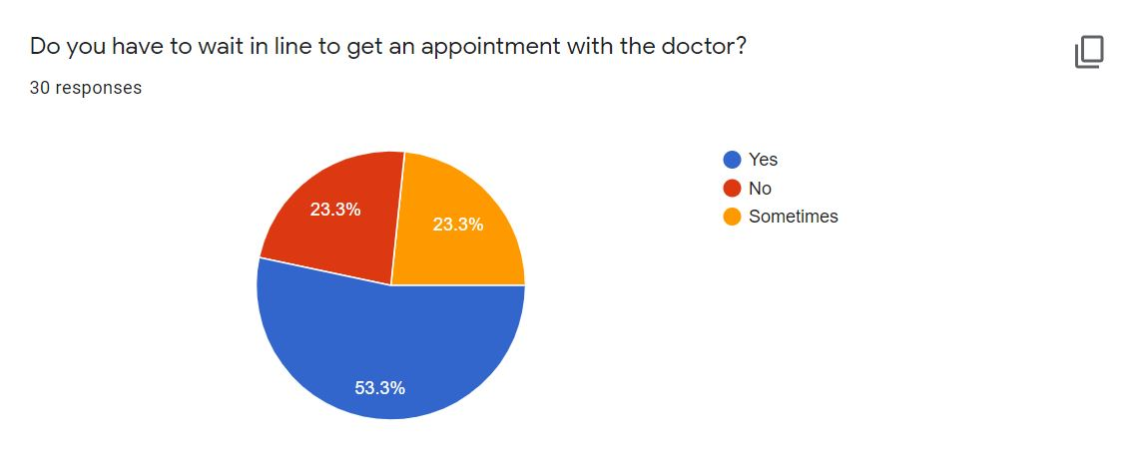

Figure 1: Survey of problem

According to a survey done, it was found that over 50% had to wait in long lines to get an appointment with the doctor whereas around 23% sometimes had to wait in lines.

## 

## 1.3 Project as a Solution

This Dental Appointment System is important for the country as technology grows fast in the world. The goal of developing this project is to provide better solutions to the problems faced by patients. This website will allow customers to schedule an appointment for their dental check-up from home or from the office. In the present situation, there is no such appointment system available in Nepal. Patients find it difficult to book an appointment for their dental check-up. Either they must wait a very long line in crowd or must call some known doctors to schedule an appointment. Patients can also view their reports in their profile, so they will never lose their dental record and it will be much easier to access it in future if the patients face any problems.

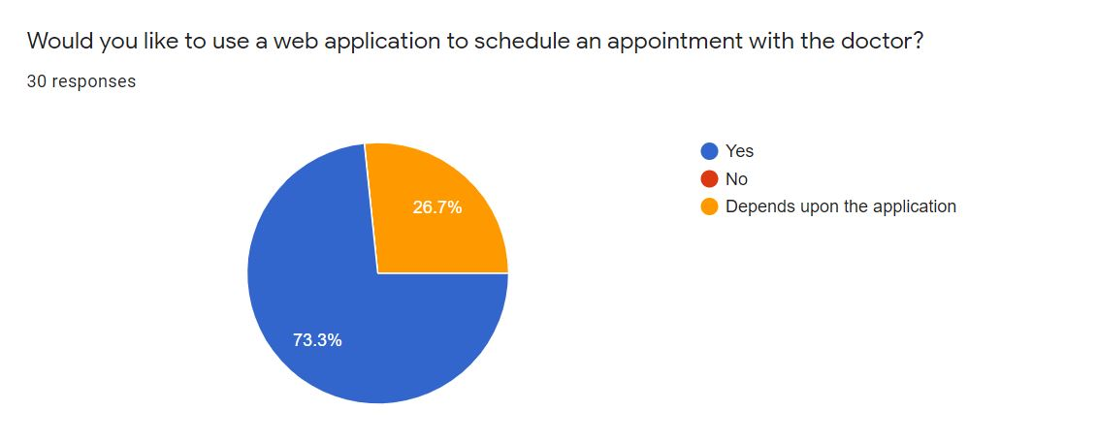

Figure 2: Survey of solution 1

According to the pie chart, it shows that over 70% of them would like to use a web based application to schedule an appointment with the doctor whereas the rest would like to use it depending upon the application.

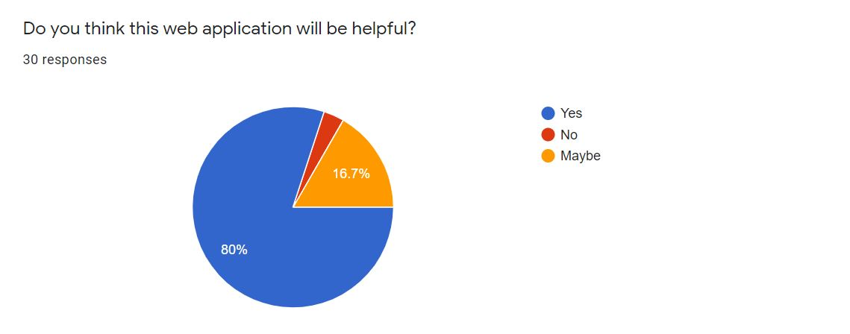

Figure 3: Survey of solution 2

According to the above pie chart of the survey, it was found that 80% of the people thought this web application will be useful whereas 16.7% thought it might be helpful.

At the end of this project, a prototype will be created that will provide a solution to the problem found. This system would be a web-based system where an overall online registration process and appointments will be carried out. Finally, the proposed system would save time for the patients.

## 1.4 Aims and Objectives

The primary aim of this project is to create a user-friendly web application that allows users to schedule a dental check-up appointment and save time rather than going to the clinic and waiting in line.

The following objectives are pursued in order to achieve this aim:

* To learn about the Python and its Django Framework along with it features.
* To use a relational database to comprehend and implement a database management system in the real world.
* To create a web application that allows to people book an appointment for their dental check-up.
* To work on the project using incremental methodology.
* Make the UI as user-friendly and interactive as possible.

## 1.5 Structure of the report

### 1.5.1 Background

* About end user
* Understanding the solution
* Similar Projects
* Comparisons

### 1.5.2 Development

* Considered Methodologies
* Selected Methodolgy
* Phases of methodology
* Survey Results
  + Pre-Survey Results
  + Post-Survey Results
* Requirement Analysis
* Design
* Implementation

### 1.5.3 Testing and Analysis

* Test Plan
  + Unit Testing, Test plan
  + System Testing, Test Plan
* Unit Testing
* System Testing
* Critical Analysis

### 1.5.4 Conclusion

* Legal, Social and Ethical Issues
  + Legal Issues
  + Social Issues
  + Ethical Issues
* Advantages
* Limitations
* Future Work

# 2. Background

## 2.1 About the end users

### 2.1.1 Discussion with client

Phulchowki Dental Care is a dental clinic located at Thaiba, Lalitpur. The founder and Managing Director of the clinic, Dr. Prashamsa Khadka has agreed to be the client for this project as she, including other staff, found this project very useful, feasible and effective.

According to Dr. Prashamsa Khadka, Founder and Managing Director of Phulchowki Dental Care, the following issues were identified during the discussion and meeting:

**Problem:**

According to her, there wasn't any system to book an appointment. People either had to call or wait in line. The lines were very long and sometimes very crowded as well. Especially in time of covid, it was very hard to even maintain social distance which increased the risk of transmission. She also stated that the records were written manually in a paper which made it very hard to access the records. Patients used to lose their reports frequently which made them difficult to have access to their previous history. So she had been looking for such system to implement.

**Solution:**

This system will allow users to book the appointment. Users can view the list of available doctors and select their desired doctors for their desired services. The system allows them to book, cancel and check the booking status. The report can also be uploaded which makes it easier for both patient and doctors.

**Client's Requirements:**

* Users should have their profile.
* Users should be able to book their appointment easily through the system.
* The system should also have features to cancel the appointment as well as check the appointment booking status.
* List of available doctors along with their description.
* Admin should be able to cancel user's appointment if the need arises.
* User should be able to view their report online as well.
* The Admin will manage the doctor's list and well as the user's list.
* The Admin will upload the doctor's approved report to the system for the user's to see.

### 2.1.2 End Users

The end users for the application will be multiple people who wants to book a dental appointment. The targeted users are the general public looking for an easier way to schedule a dental appointment with the doctor.

## 2.2 Understanding the solution

**2.2.1 Overview of the system**

The system is web-based application named "Dental Appointment System" for "Phulchowki Dental Care" clinic located in Thaiba, Lalitpur. The main objective of the application is to provide an online platform for users to book their dental appointment based on their time and convenience. It is a simple application in which user can also view their reports of their appointment visit and select their desired doctors and services.

**2.2.2 Technology**

**Django Python Framework:**

For my project, I have decided to use the Django Python Framework. The reason I chose this framework is because it has better CDN connectivity and content management. It also has a faster processing. Django uses the MTV architecture due to which the transmission over the internet is easier and faster.

**HTML, CSS, JavaScript and Bootstrap**

For the frontend of the web application, I have decided to use HTML, CSS, JavaScript and Bootstrap, which is the framework of CSS.

**SQLite3**

For the database, I have decided to use SQLite to store the database. Django uses SQLite database by default so it is easier to use this database than others which is why I chose this.

**Visual Studio Code IDE:**

The IDEs that I will be using to develop the application is Visual Studio Code. Microsoft's Visual Studio Code (often known as VS Code) is a free open source text editor. Windows, Linux, and macOS are all supported by VS Code. Although the editor is minimal, it contains several strong capabilities that have helped VS Code become one of the most popular development environment tools in recent years.

**Hardware Requirements**

For the project to run, it doesn't need any high-end hardware device. Just a normal working device with a proper internet connection will work fine.

## 2.3 Similar Projects

**2.3.1 Dent-inn**

Dent-inn is a dental clinic located at Durbar-marg of Kathmandu, Nepal. The application is a web based application. In this application, you can fill out an online appointment form. The form requires name, phone, email, date, time, preferred doctor and message. However, you cannot select a particular service from the appointment from itself. There is also a section where you can view the in house doctors. In this application, you do not need register as a user. Anyone can just visit the website and book an appointment. There is no section for uploading report meaning you can only book an appointment for your dental check-up and nothing more.

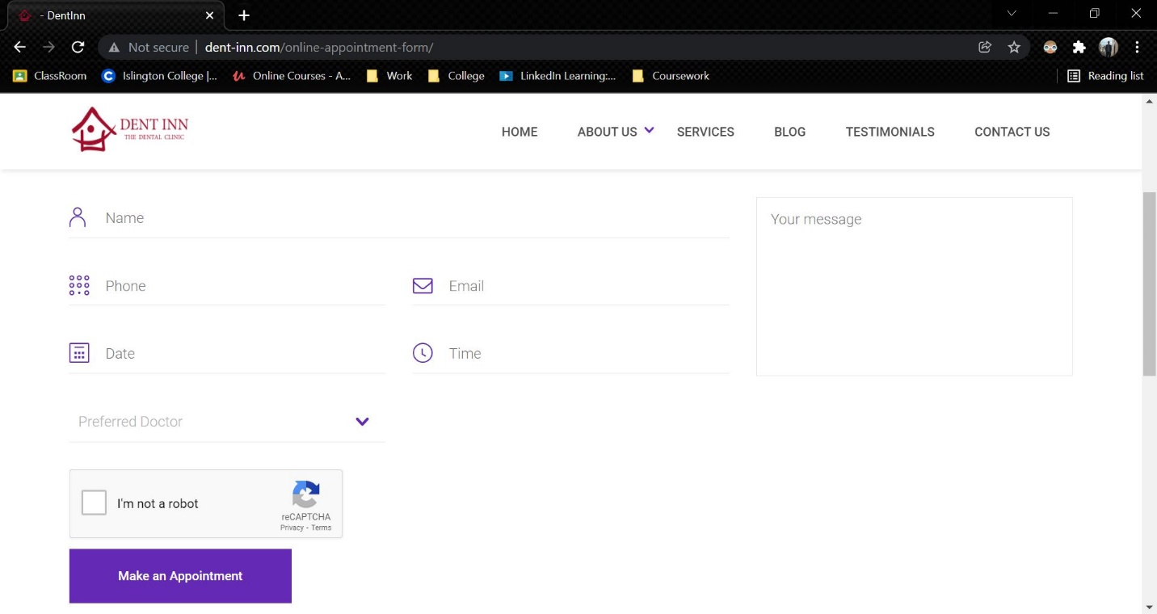

Figure 4: Dent-inn

Link to the website: <http://www.dent-inn.com/>

**2.3.2 DentaLife**

DentaLife is also a dental clinic located at Jamal, Kathmandu. Although the website is similar to Dent-inn, the appointment section of this web is quite different. It used google forms in order to collect the appointment details. This web uses no backend.

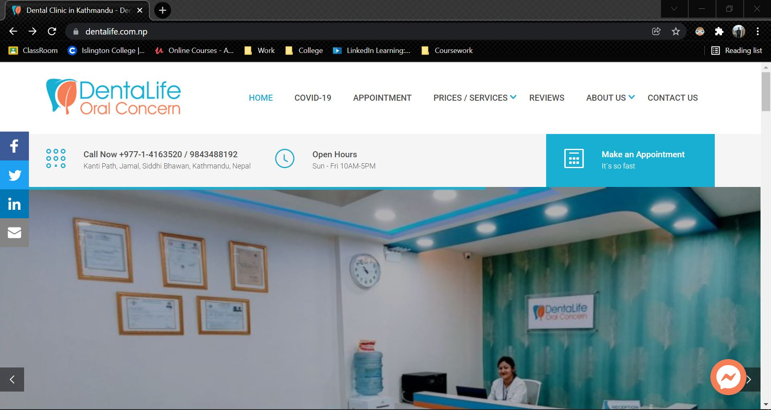

Figure 5: DentaLife

Link to the website: <https://dentalife.com.np/>

**2.3.3 Kumari Dental Care**

Kumari Dental Care is a dental clinic located at Jhamsikhel, Lalitpur. It is also a web based application where any user can book an appointment. In this web application, the first name, last name, email, needs and message. In this clinic, only one doctor is present. There is no login and register feature here as well. There is no report option here as well, meaning user will only use this website once for their appointment.

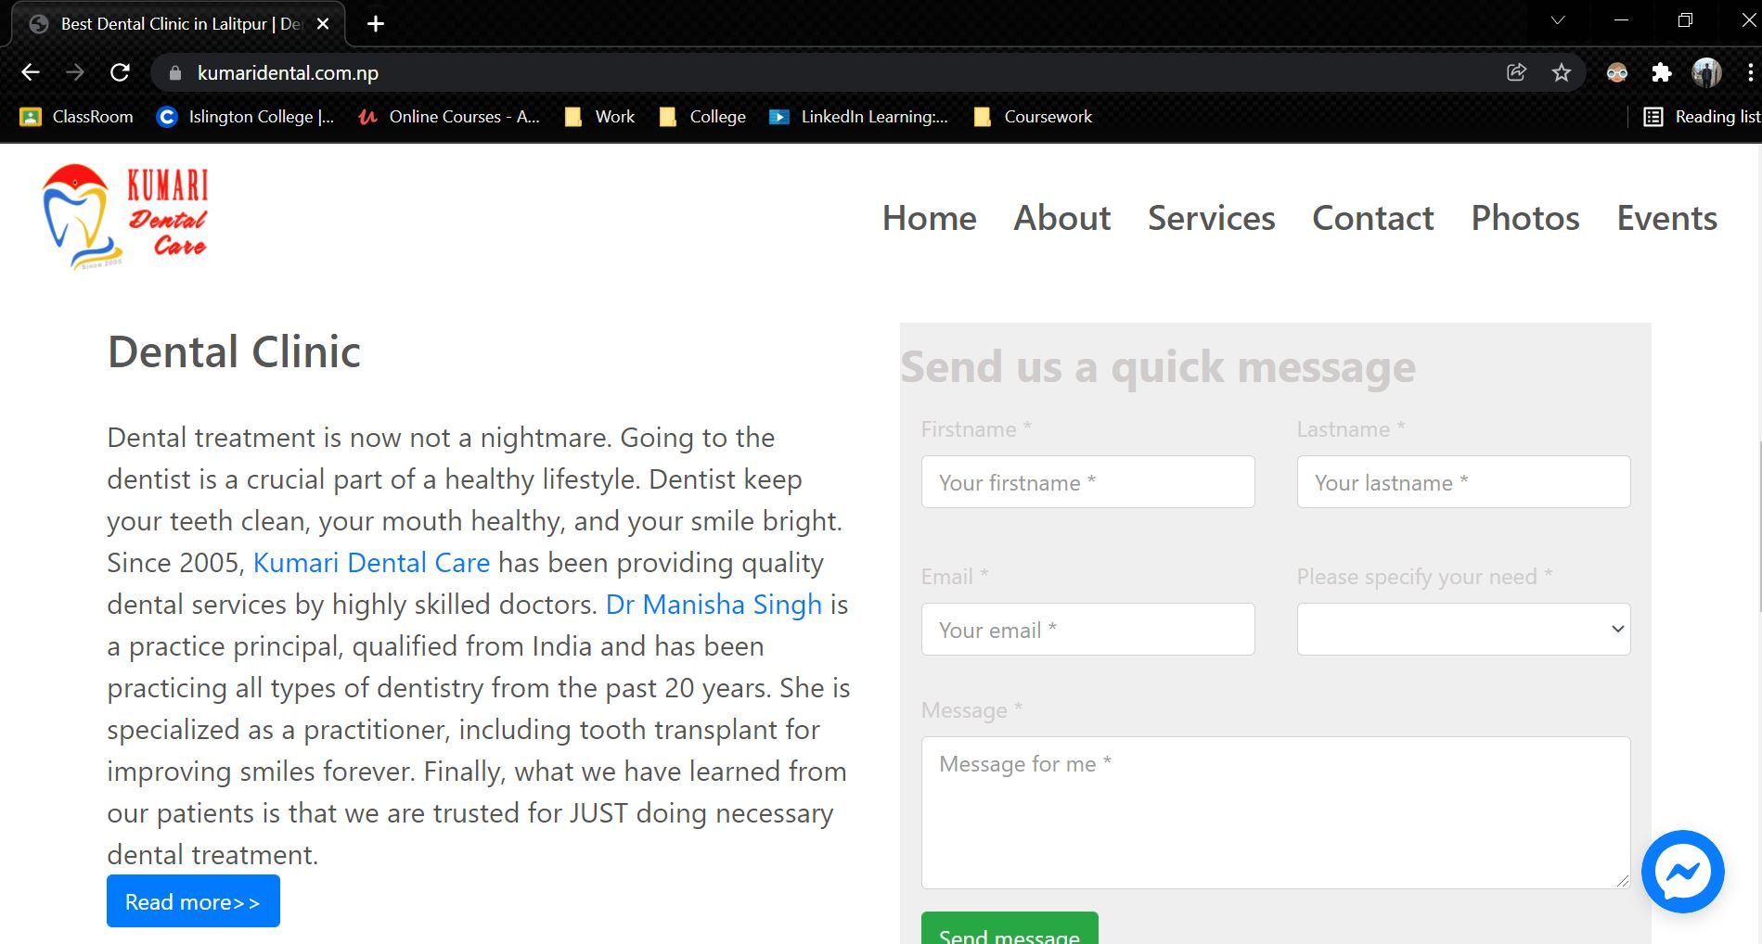

Figure 6: Kumari Dental Care

Link to the website: <https://kumaridental.com.np/index.html>

## 2.4 Comparisons

The table below shows the comparison of different web based applications for the online appointment booking system.

|  |  |  |  |  |  |
| --- | --- | --- | --- | --- | --- |
| S.No | **Features** | Dent-inn | DentaLife | Kumari Dental | My System |
| 1. | Online Appointment Booking Module | ✓ | ✓ | ✓ | ✓ |
| 2. | Doctor Selection | ✓ | ✓ | 🗶 | ✓ |
| 3. | Service Selection | 🗶 | 🗶 | ✓ | ✓ |
| 4. | View Report | 🗶 | 🗶 | 🗶 | ✓ |
| 5. | View Doctors | ✓ | 🗶 | ✓ | ✓ |
| 6. | Login | 🗶 | 🗶 | 🗶 | ✓ |
| 7. | Register | 🗶 | 🗶 | 🗶 | ✓ |
| 8. | Day and Time Selection | ✓ | ✓ | ✓ | ✓ |
| 9. | Extra Note | ✓ | ✓ | ✓ | ✓ |

Table 1: Analysis of Similar Project

# 3. Development

## 3.1 Considered Methodologies

**3.1.1 RUP Methodology**

The Rational Unified Process (RUP) is an approach for developing agile software. The project life cycle is divided into four phases by RUP. All six main development disciplines are practiced at each phase: business modelling, requirements, analysis and design, implementation, testing, and deployment. RUP provides a systematic way to build this type of system, focusing on the production of an executable architecture in the early stages of the project, that is, before committing resources on a large scale. (TestBytes, 2019)

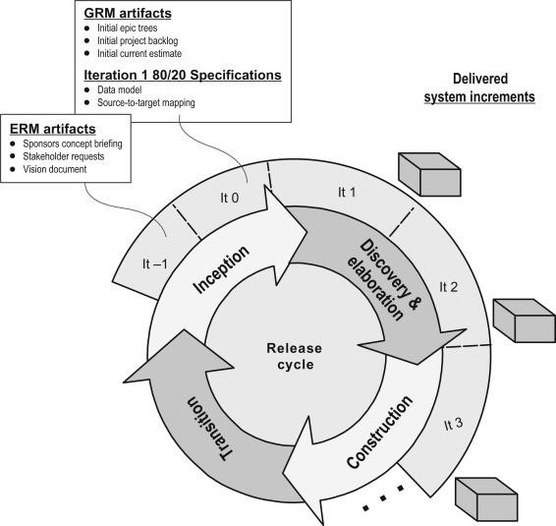

Figure 7: RUP Methodology (TestBytes, 2019)

**3.1.2 Prototype Methodology**

Prototype Model is a software development model in which prototype is built, tested, and reworked until an acceptable prototype is achieved. (Martin, 2021) It also serves as a foundation for the creation of the final system or software. It's best used in situations where the project's requirements aren't fully understood. It is an iterative, trial-and-error process that occurs between the developer and the client.

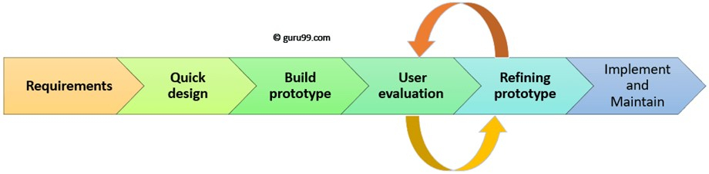

Figure 8: Prototype Methodology (Martin, 2021)

**3.1.3 Incremental Methodology**

In Incremental Methodology, first a simple working system is constructed and supplied to the customer, with only a few basic features. Over many successive iterations successive versions are implemented and delivered to the customer until the desired system is realised. (Mall, 2014) The following diagram shows the incremental development model:

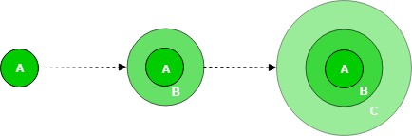

Figure 9: Incremental Methodology (GeeksForGeeks, 2019)

## 3.2 Selected Methodology

**Incremental Methodology**

I chose the Incremental Model methodology for my project. The incremental model is a software development technique in which the model is defined, implemented, and tested one step at a time until the product is complete. It consists of both development and maintenance. When a product meets all of its specifications, it is said to be done. This model combines the elements of the waterfall model with the iterative philosophy of prototyping. (Ghahrai, 2016) I picked this methodology over the iterative model because the iterative model requires us to receive input from the project manager after each feature. Furthermore, the incremental model differs from the iterative model in that the iterative model involves the addition of new features, whereas the incremental model involves the refinement of existing features. This approach is commonly utilized in the development of online applications. Also, I utilized incremental since the requirements and features are extremely clear and can be implemented and delivered in each phase.

The product is broken down into multiple parts, each of which is designed and constructed independently (termed as builds). When all of the components have been completed, they are delivered to the client. This allows for partial product usage while avoiding a lengthy development process. It also necessitates a significant upfront financial investment, with the long wait time eliminated. This model of development also helps ease the traumatic effect of introducing completely new system all at once.

(Ghahrai, 2016)

## 3.3 Phases of Methodology

There are 4 phases involves in the Incremental model and they are enumerated below:

**3.3.1 Requirement Analysis:**

The first stage in the incremental model is to analyse the product's problem situation and identify the specifications. The functional requirements of the system are understood by the requirement analysis team. This procedure is essential for designing apps utilizing the incremental model. All of the system's criteria are obtained during this procedure through study of publications, books, and web sites, as well as surveys and interviews with end users.

The requirements for my system were acquired through a survey and analysed based on how the end user would want to utilize the program and what features they desired.

**3.3.2 Design and Development:**

Following the collection of all specifications, the major functions and features to be employed in the software are determined. Risks are identified during this phase, as are the instruments that will be used. During this phase, wireframes, use case diagrams, collaboration diagrams, sequence diagrams, and class diagrams are also created. The functionality of the system and the development technique have been successfully designed.

After analysing the requirements, the general design of the project began with the creation of the system's wireframes. Following the creation of the wireframe, the class diagram and use cases for the overall system were established. Following the creation of the class diagram, the ERD for the system's database was created, and the system's code/development was initiated.

**3.3.3 Testing:**

After developing the system's functionality, it is tested in this phase to ensure that the developed system is fully functional and error-free. This phase assesses the consistency of all existing functionalities as well as the addition of new features. A variety of testing methods are utilized to test the activity of each task.

Following the end of the system's development, different forms of testing were performed, including unit testing, system testing, Blackbox testing, and Whitebox testing.

**3.3.4 Implementation:**

When the testing phase is finished, the project goes on to the implementation phase. It includes both the final coding developed during the development phase and the testing of the functionality during the testing phase. After this phase is completed, the number of working products is improved and updated all the way to the final system product. This phase reviews and discusses the entire system, as well as the features and modifications that will be required in future iterations.

After testing is completed, the system's final coding is accomplished, and the focus shifts to enhancing the system, fixing errors, and adding new features.

## 3.4 Survey

### 3.4.1 Pre-Survey Results

1. 43.3% of them have their dental check-up in over a year, 26.7% of them in a year, 26.7% in every 6 months and 3.3% in every 3 months.
2. 53.3% have to wait in line to get an appointment, 23.3% sometime have to wait in line and 23.3% of them doesn't have to wait in line.
3. 86.7% have never used an online appointment booking system whereas 13.3% have.
4. 73.3% said they would like to use a web based application to schedule an appointment with the doctor whereas the remaining 26.7% said it would depend on the application.
5. 80% thinks this application will be helpful, 16.7% thinks the application might be helpful whereas 3.3% thought it will not be helpful.
6. 76.7% thinks having an online report will be useful whereas 23.3% thinks it might be useful.

Link to the survey: <https://forms.gle/x1DkhUFqgoDTmZ886>

Click here to see the pre-survey results and responses

### 3.4.2 Post-Survey Results

## 3.5 Requirement Analysis

## 3.6 Design

Below are the Designs like Use Case Diagram, Entity Relation Diagram, Collaboration Diagram, Activity Diagram and Sequence Diagram for all the various functionalities of the project.

**ERD**

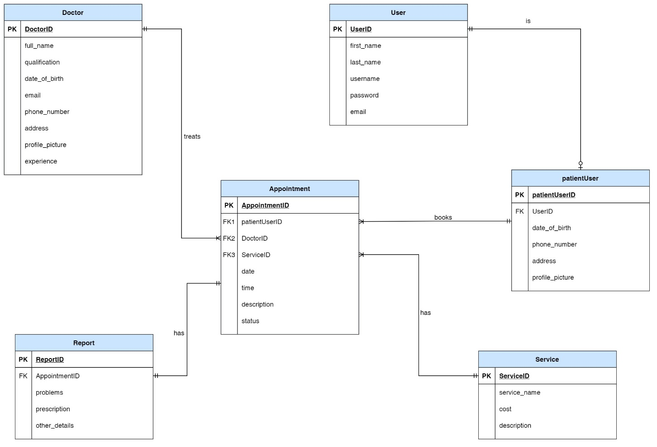

Figure 10: Final ERD:

Here, we can see User is a default database table of Django which has limited fields. So, to extend it, we created a new table called patientUser i.e. all patientUser must be a user but a user can either be a patientUser or an admin. There is Doctor and services table. The appointment table takes patientUser, services and doctor as a foreign key. A doctor treats more than one appointment but an appointment can only belong to one doctor. Similarly, a patientUser can book many appointment but an appointment can only belong to one patientUser. An appointment also has one service but a service can have multiple appointment. The report then takes appointment as a foreign key. A report can belong to only one appointment and an appointment can only have one report.

Details to ERD Creation process

**Overall Use Case Diagram**

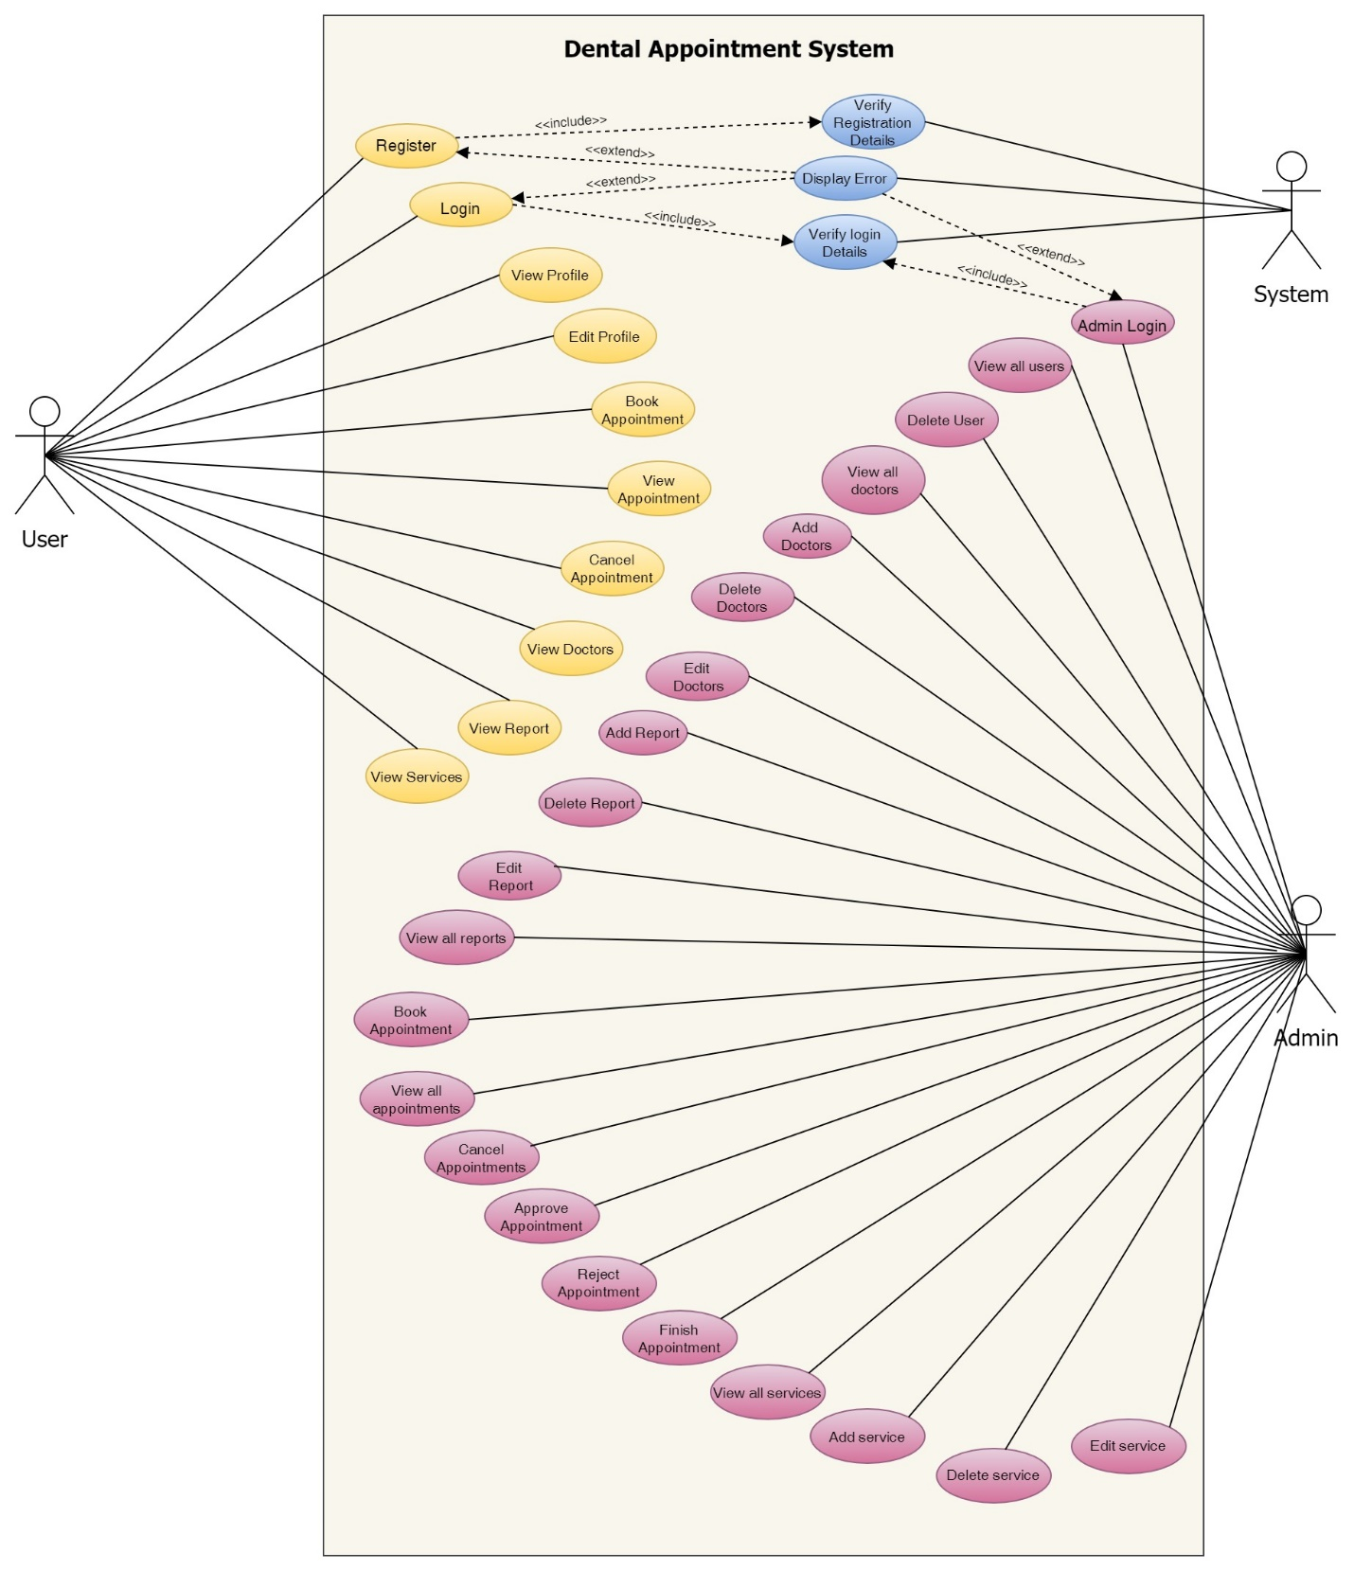

Figure 11: Overall Use Case Diagram

**UML Diagrams**

**User**

1. Register to the system

**High Level Use Case Description**

|  |  |
| --- | --- |
| **Use Case:** | Register |
| **Actor:** | User |
| **Description:** | New users that are not registered in the system register into system. The registration is then verified by the system. |

Table 2: High Level Use Case – User Registration

**Use Case Diagram**

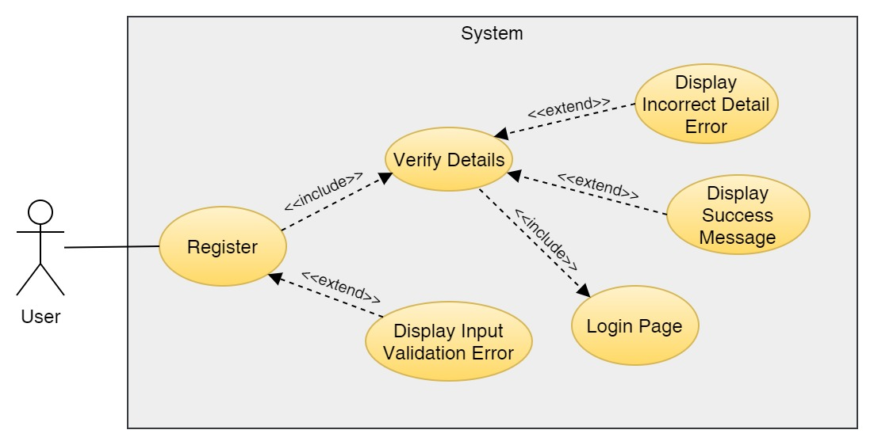

Figure 12: Use Case Diagram – User Registration

**Collaboration Diagram**

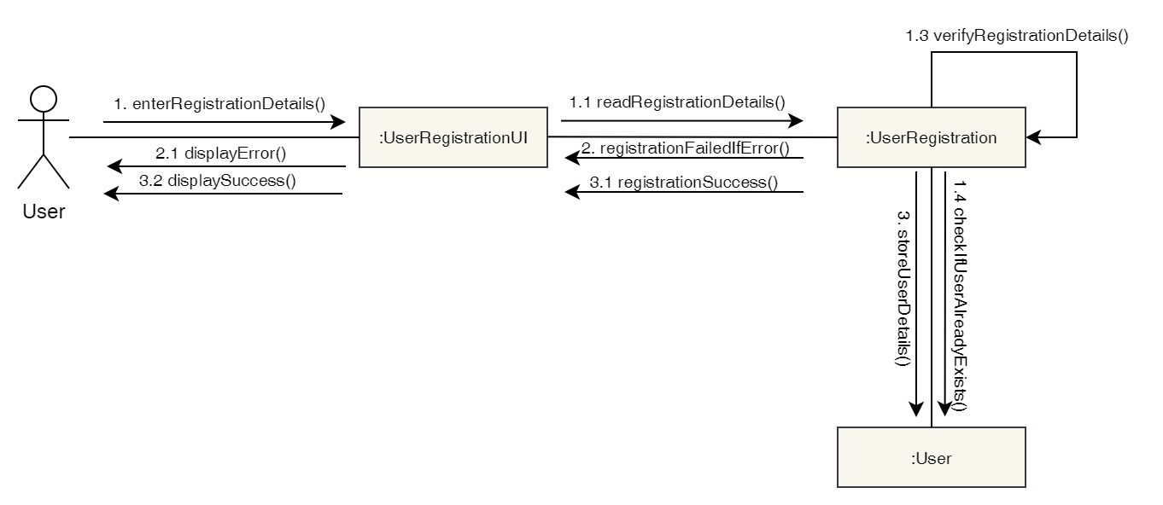

Figure 13: Collaboration Diagram – User Registration

**Activity Diagram**

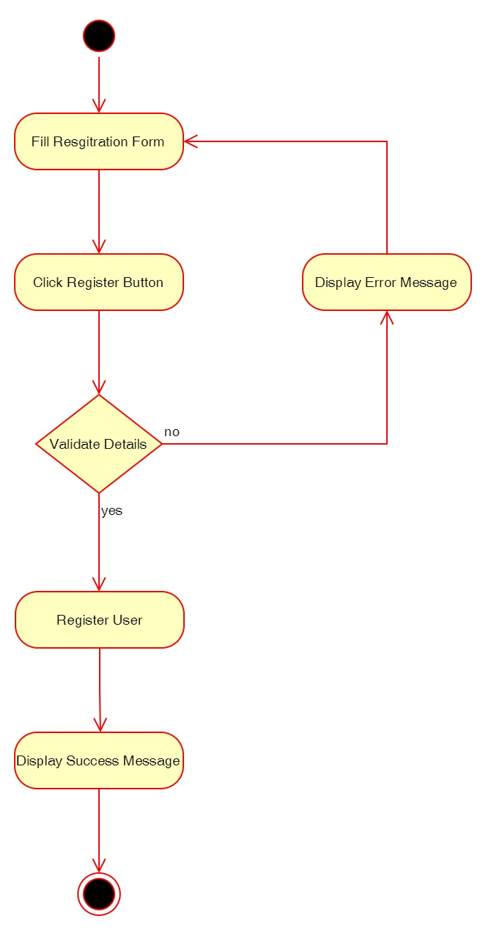

Figure 14: Activity Diagram – User Registration

**Sequence Diagram**

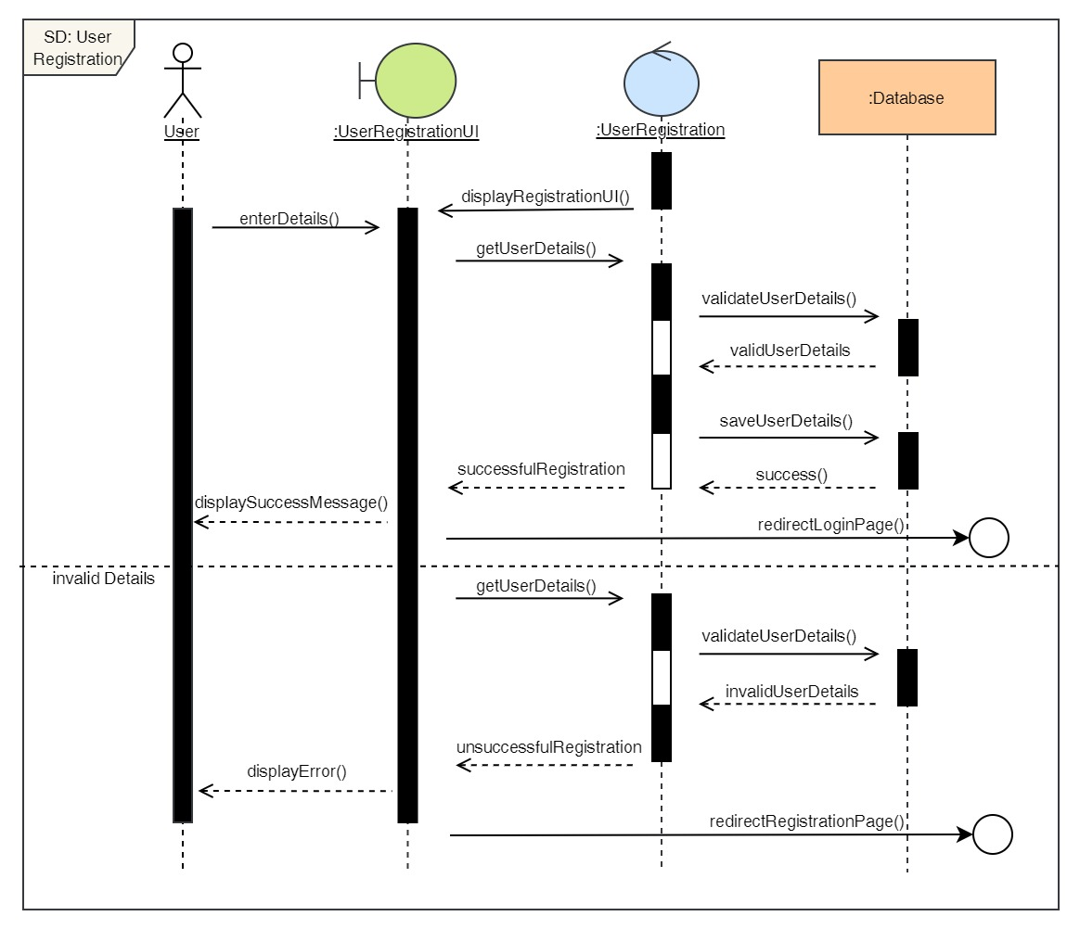

Figure 15: Sequence Diagram – User Registration

2. Login to the system

**High Level Use Case Description**

|  |  |
| --- | --- |
| **Use Case:** | Login |
| **Actor:** | User |
| **Description:** | In order to use the system and use its features, the user must log in to the system. The login details is then verified by the system. |

Table 3: High Level Use Case – User Login

**Use Case Diagram**

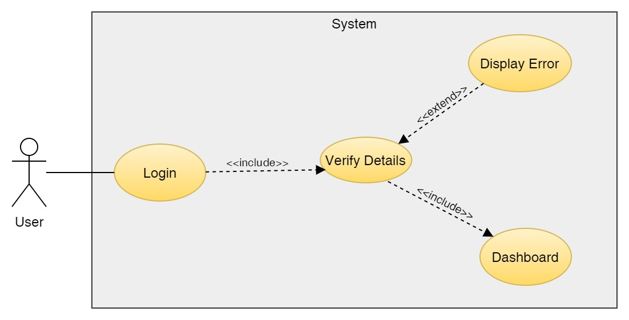

Figure 16: Use Case Diagram – User Login

**Collaboration Diagram**

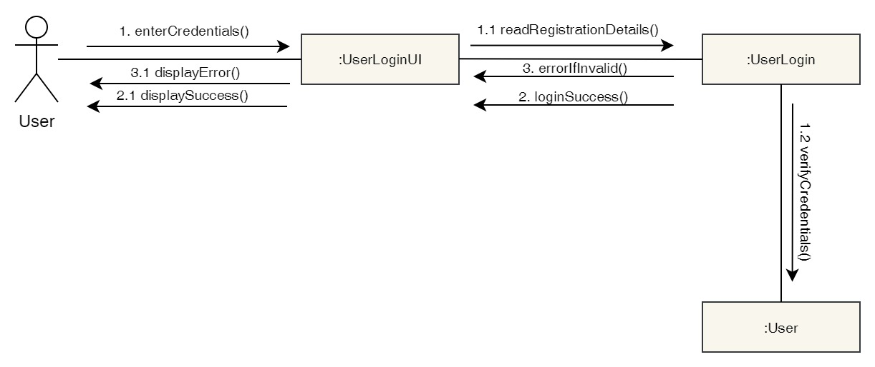

Figure 17: Collaboration Diagram – User Login

**Activity Diagram**

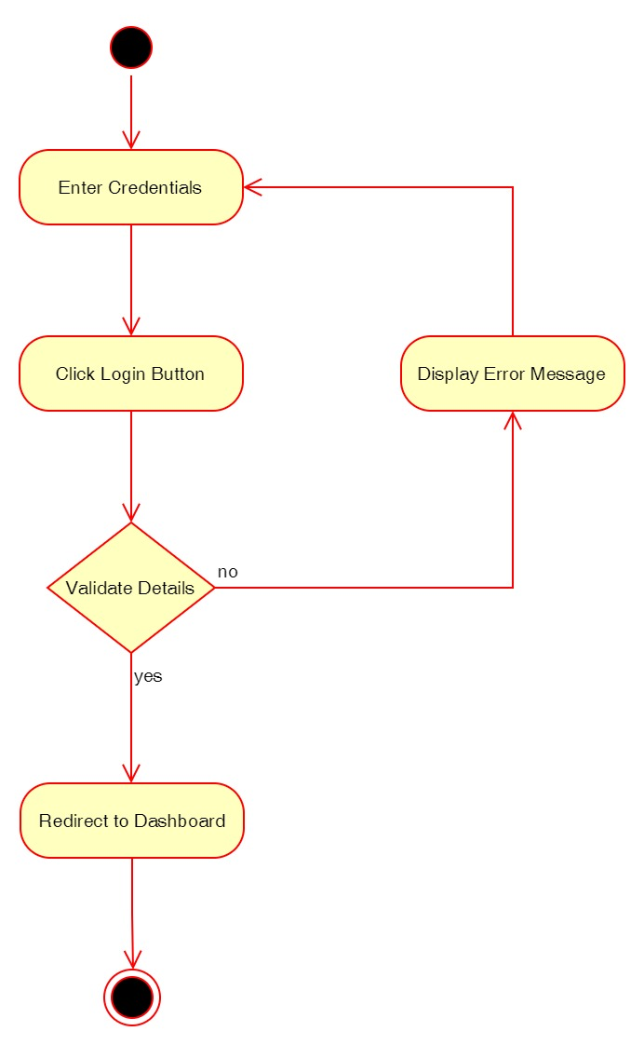

Figure 18: Activity Diagram – User Login

**Sequence Diagram**

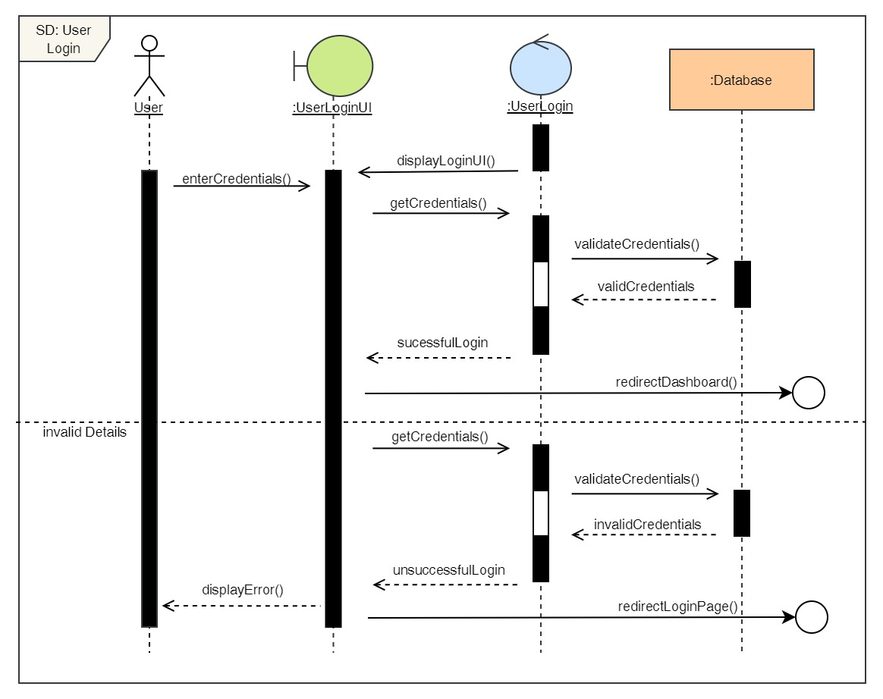

Figure 19: Sequence Diagram – User Login

3. View Profile

**High Level Use Case Description**

|  |  |
| --- | --- |
| **Use Case:** | View Profile |
| **Actor:** | User |
| **Description:** | The user can view their profile where they can see their details which they input. |

Table 4: High Level Use Case – User View Profile

**Use Case Diagram**

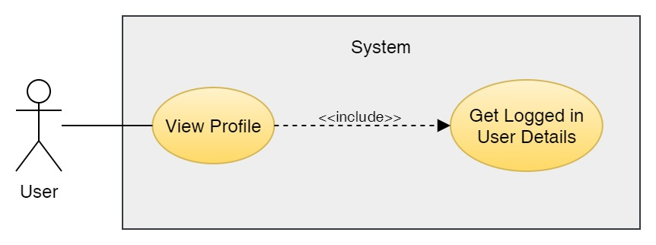

Figure 20: Use Case Diagram – User View Profile

**Collaboration Diagram**

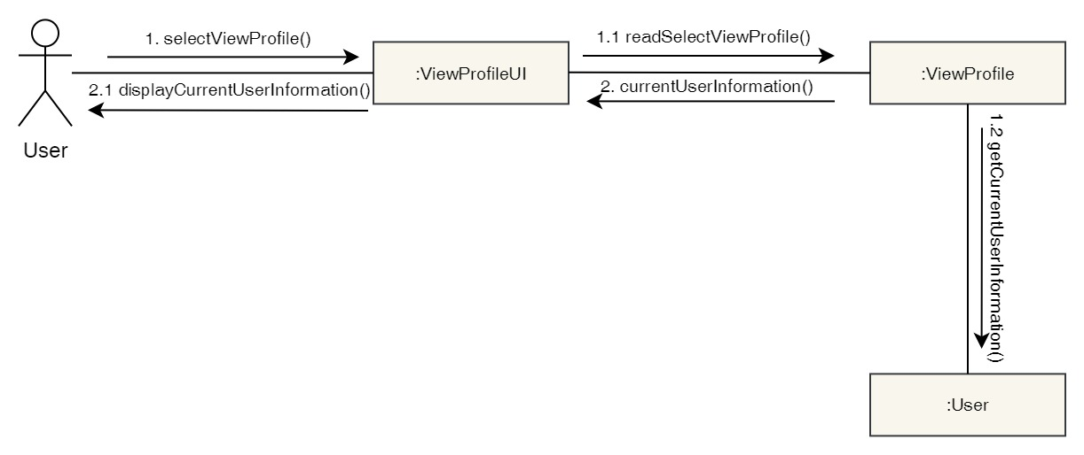

Figure 21: Collaboration Diagram – User View Profile

**Activity Diagram**

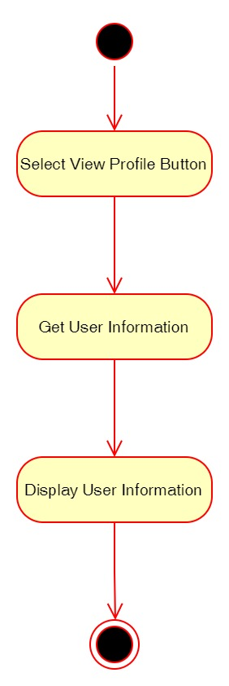

Figure 22: Activity Diagram – User View Profile

**Sequence Diagram**

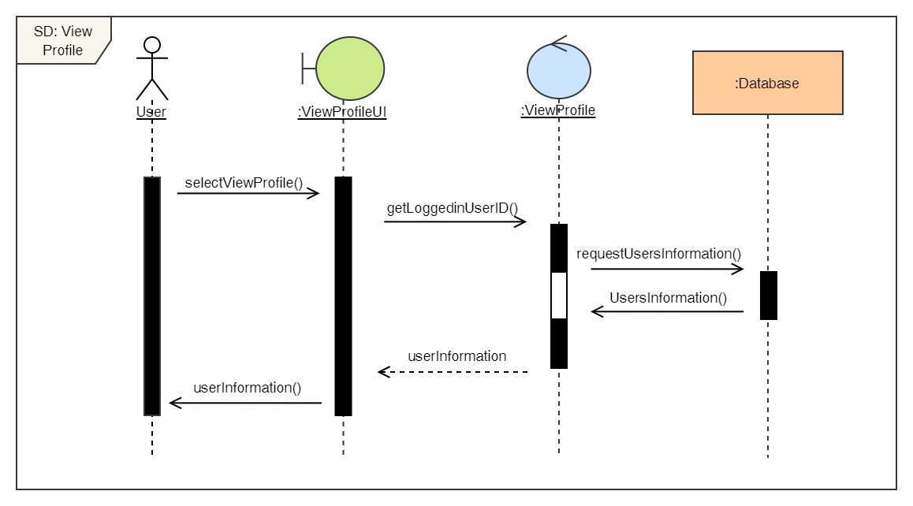

Figure 23: Sequence Diagram – User View Profile

4. Edit Profile

**High Level Use Case Description**

|  |  |
| --- | --- |
| **Use Case:** | Edit Profile |
| **Actor:** | User |
| **Description:** | The user can update their profile details if they have changed anything from what they previously entered. |

Table 5: High Level Use Case – User Edit Profile

**Use Case Diagram**

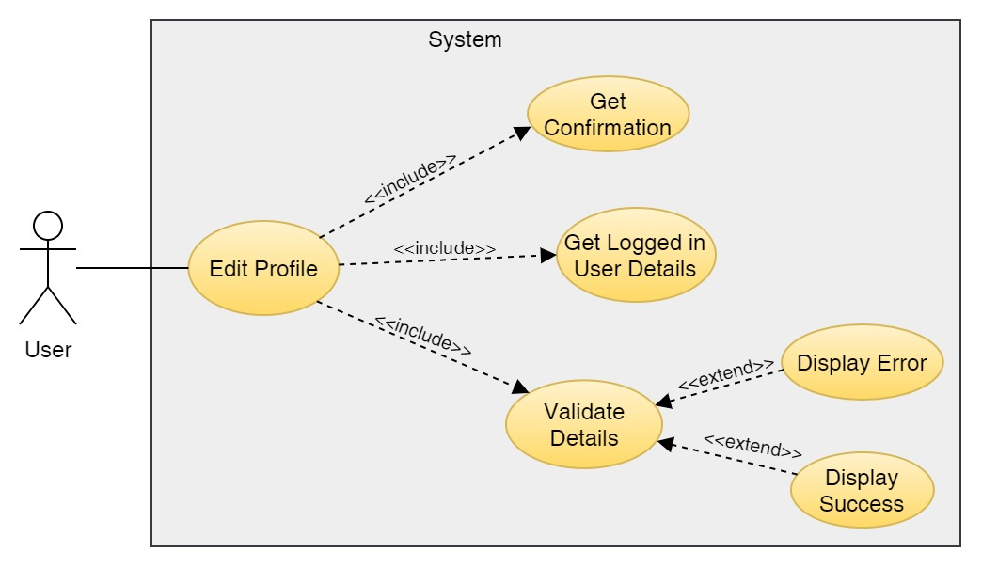

Figure 24: Use Case Diagram – User Edit Profile

**Collaboration Diagram**

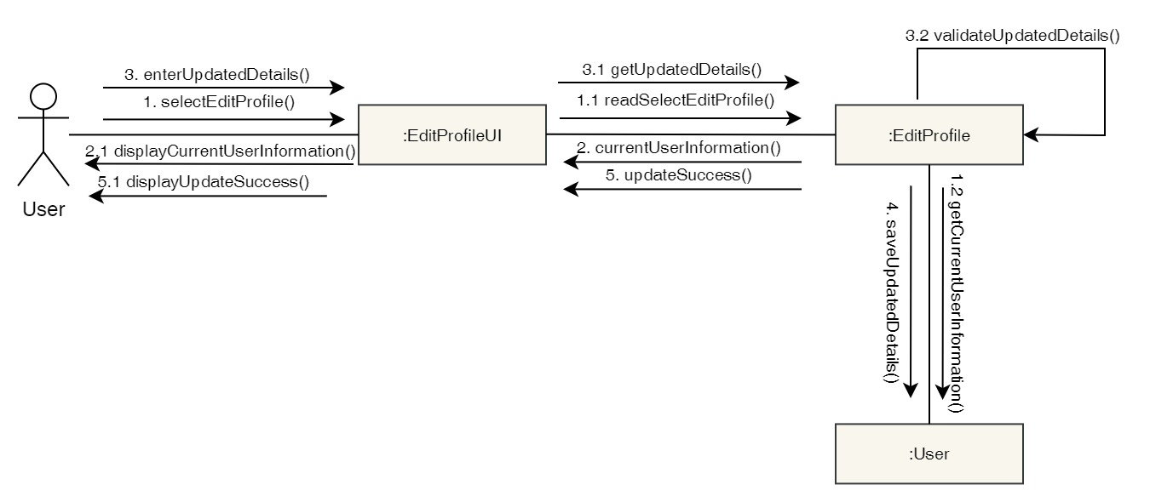

Figure 25: Collaboration Diagram – User Edit Profile

**Activity Diagram**

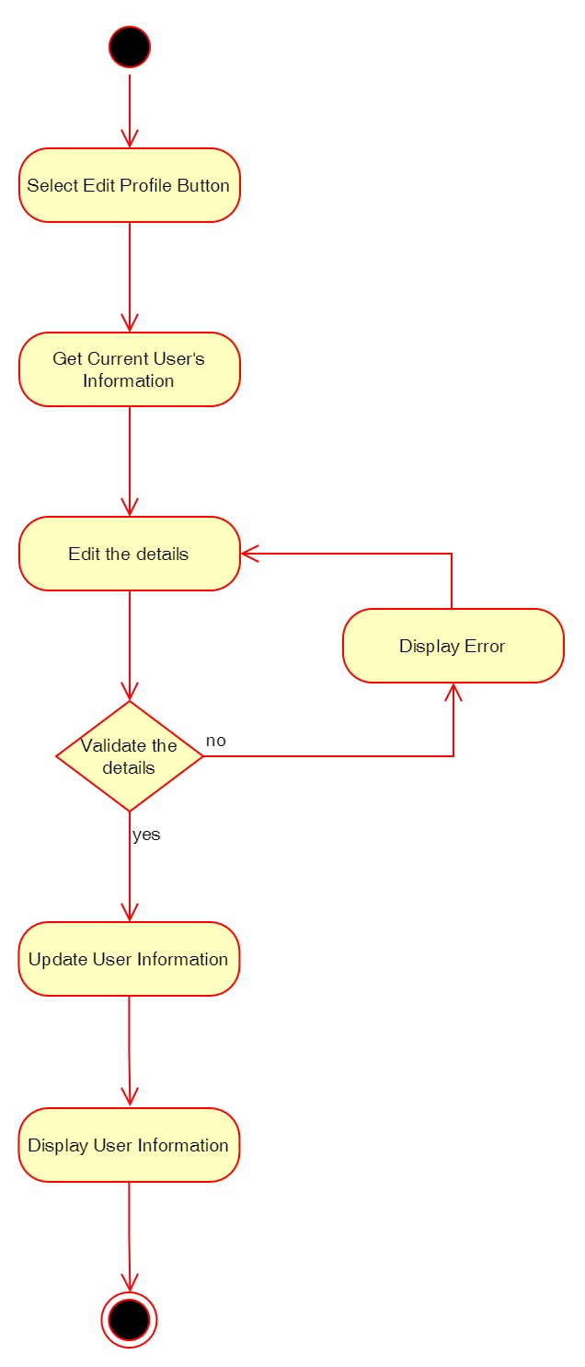

Figure 26: Activity Diagram – User Edit Profile

**Sequence Diagram**

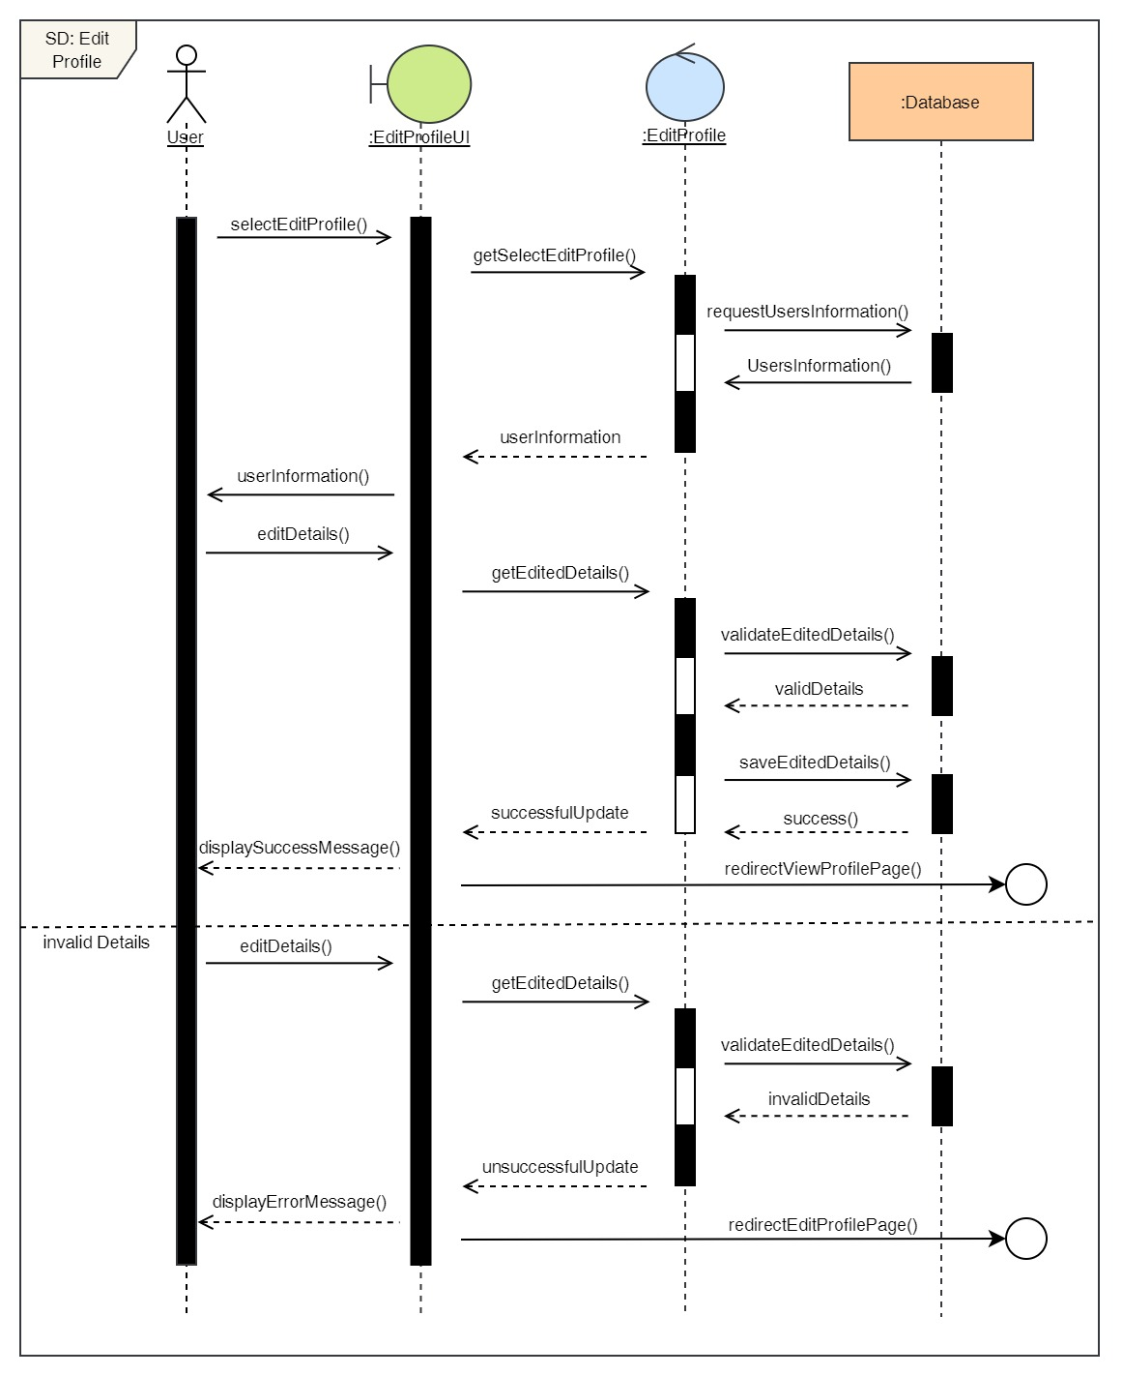

Figure 27: Sequence Diagram – User Edit Profile

5. Book a Dental Appointment

**High Level Use Case Description**

|  |  |
| --- | --- |
| **Use Case:** | Book Appointment |
| **Actor:** | User |
| **Description:** | User can book appointment for any dental services by selecting the desired date, time, doctor and service. |

Table 6: High Level Use Case – User Book Appointment

**Use Case Diagram**

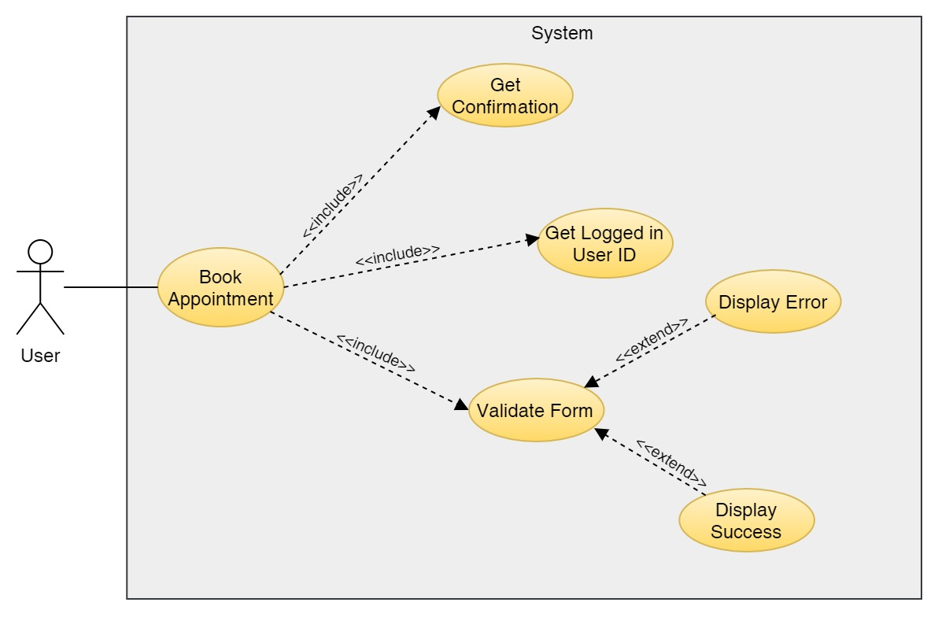

Figure 28: Use Case Diagram – User Book Appointment

**Collaboration Diagram**

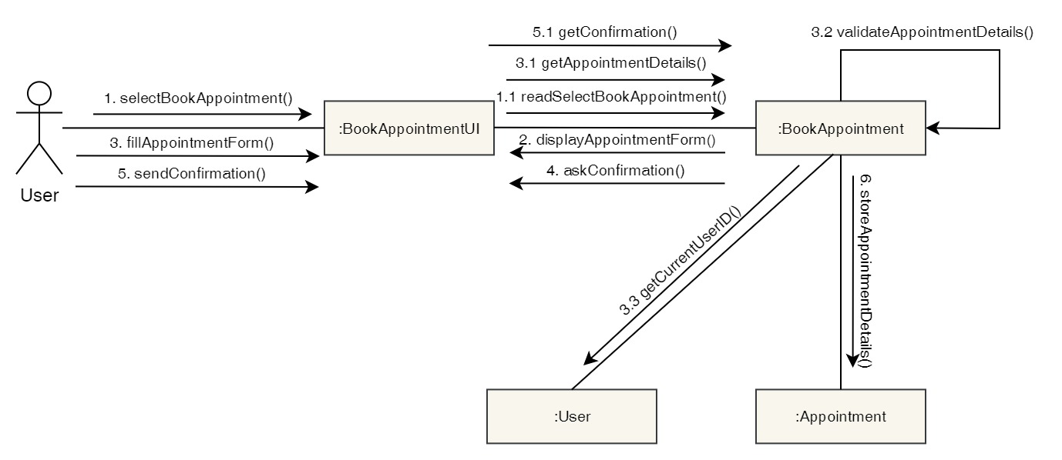

Figure 29: Collaboration Diagram – User Book Appointment

**Activity Diagram**

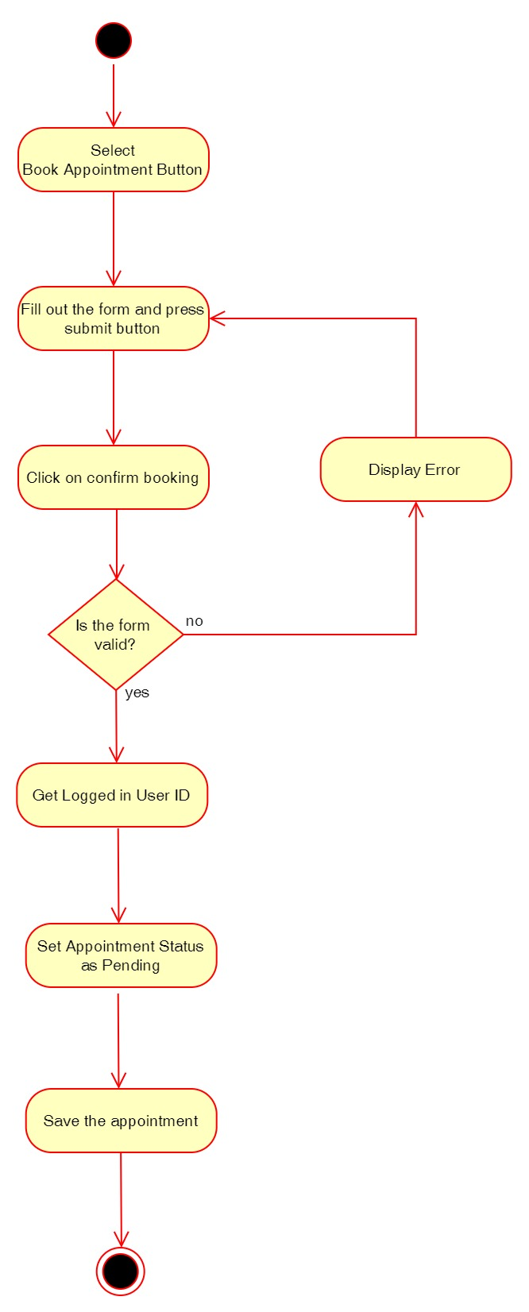

Figure 30: Activity Diagram – User Book Appointment

**Sequence Diagram**

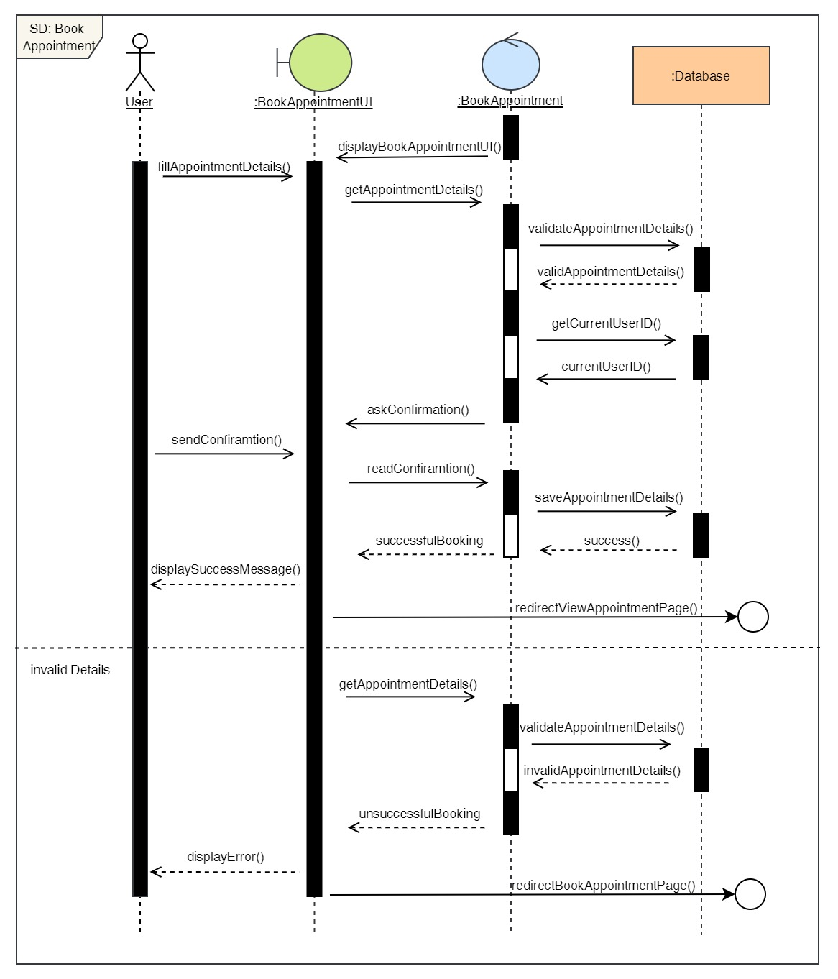

Figure 31: Sequence Diagram – User Book Appointment

6. View Appointment

**High Level Use Case Description**

|  |  |
| --- | --- |
| **Use Case:** | View Appointment |
| **Actor:** | User |
| **Description:** | Users can view their current appointments as well as their appointments history. |

Table 7: High Level Use Case – User View Appointment

**Use Case Diagram**

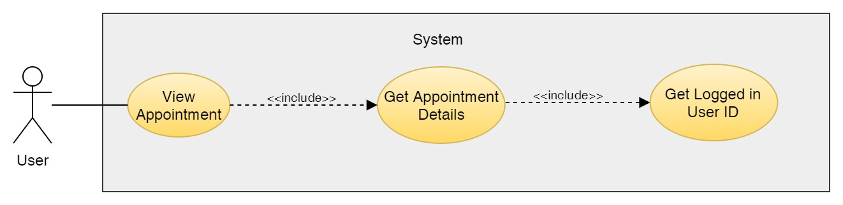

Figure 32: Use Case Diagram – User View Appointment

**Collaboration Diagram**

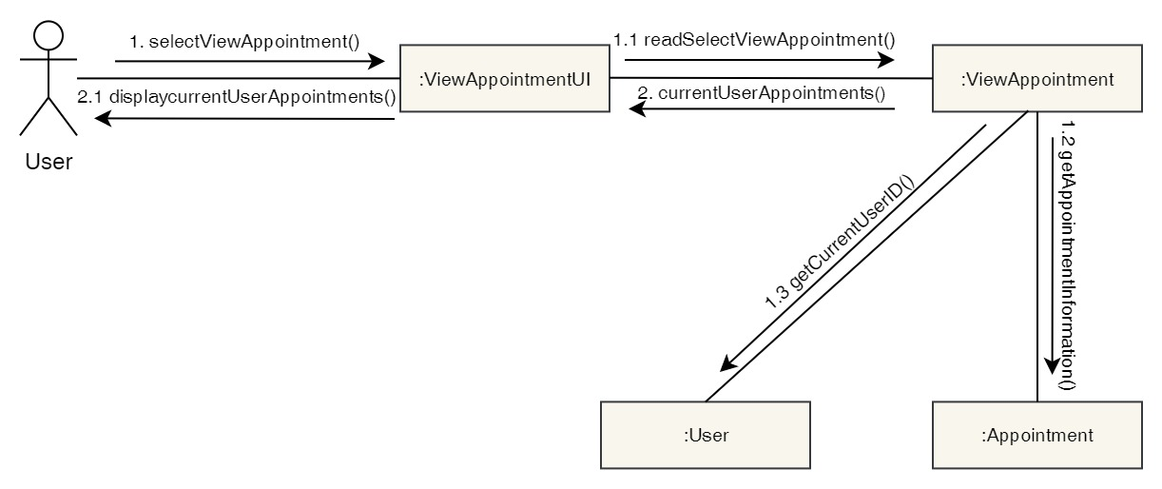

Figure 33: Collaboration Diagram – User View Appointment

**Activity Diagram**

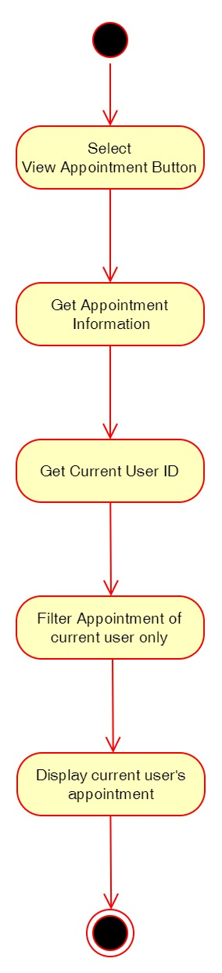

Figure 34: Activity Diagram – User View Appointment

**Sequence Diagram**

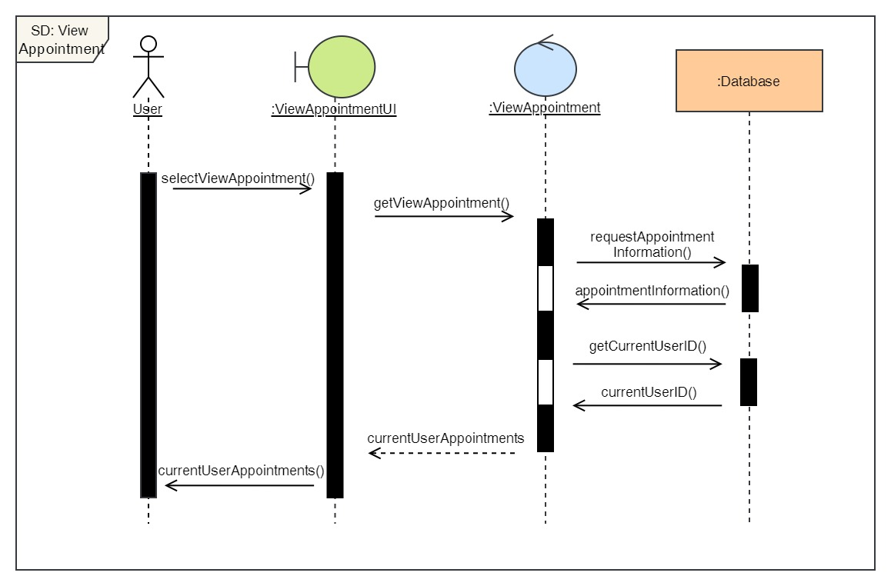

Figure 35: Sequence Diagram – User View Appointment

7. Cancel Appointment

**High Level Use Case Description**

|  |  |
| --- | --- |
| **Use Case:** | Cancel Appointment |
| **Actor:** | User |
| **Description:** | The user can cancel their pending appointment or the appointment that has been confirmed. |

Table 8: High Level Use Case – User Cancel Appointment

**Use Case Diagram**

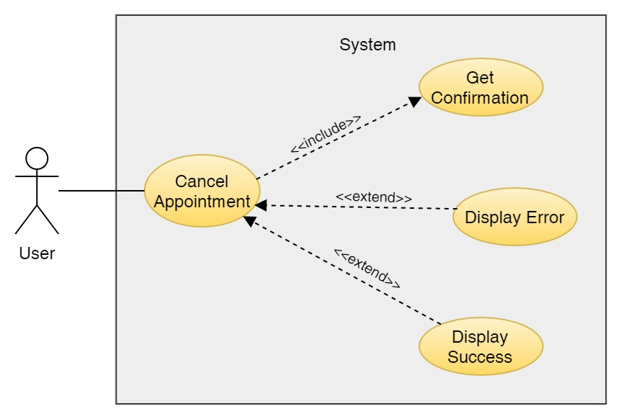

Figure 36: Use Case Diagram – User Cancel Appointment

**Collaboration Diagram**

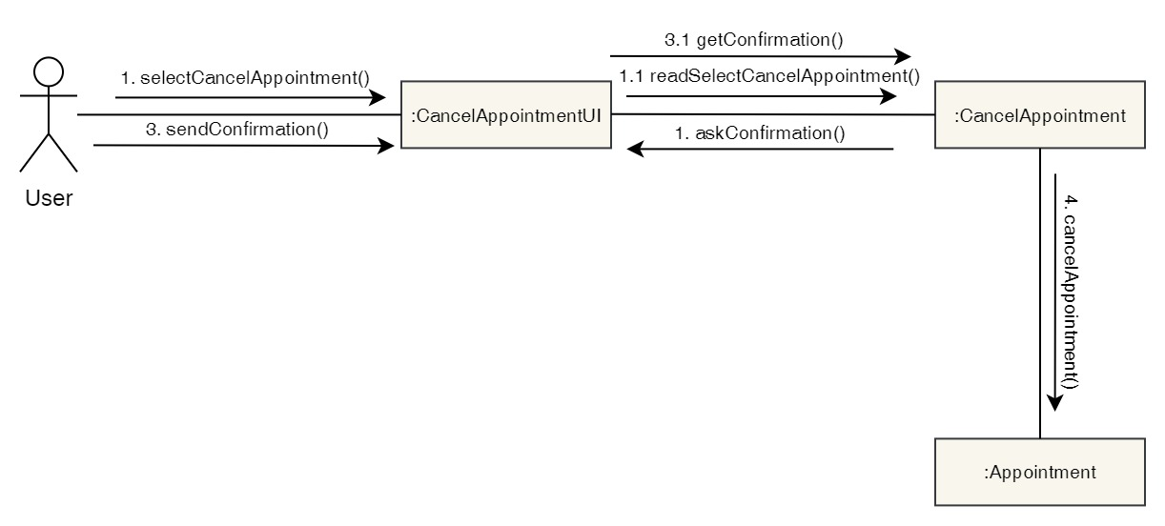

Figure 37: Collaboration Diagram – User Cancel Appointment

**Activity Diagram**

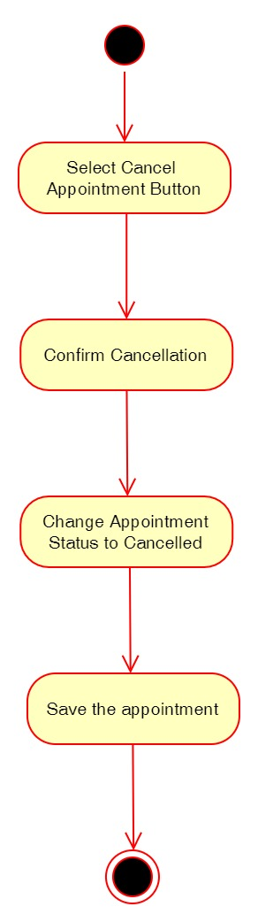

Figure 38: Activity Diagram – User Cancel Appointment

**Sequence Diagram**

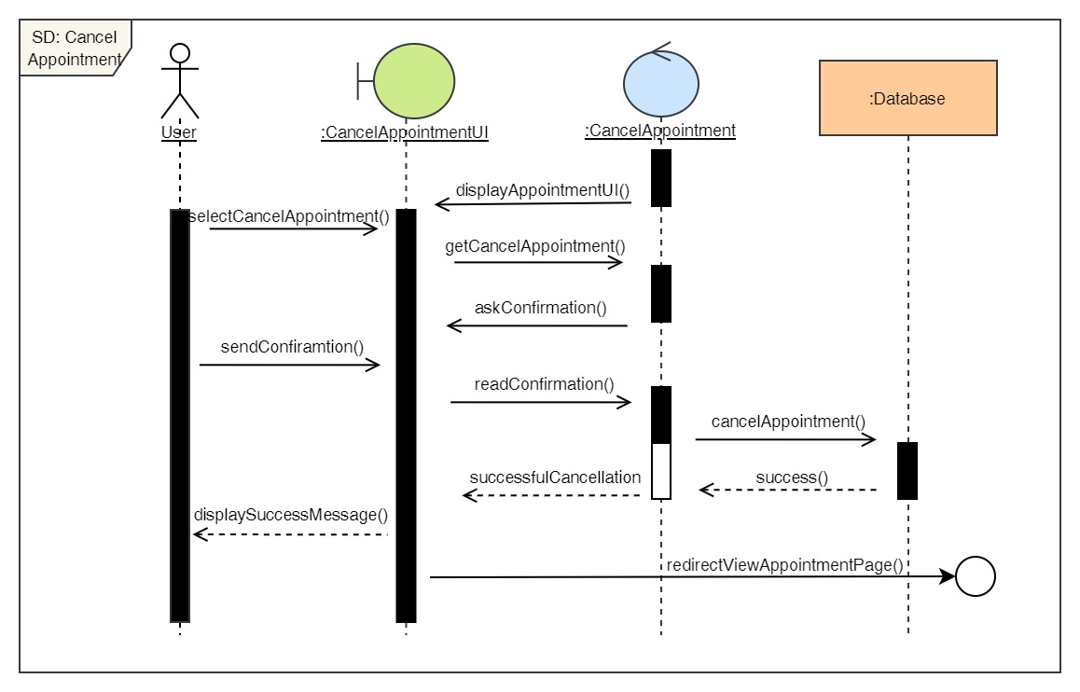

Figure 39: Sequence Diagram – User Cancel Appointment

8. View available doctors

**High Level Use Case Description**

|  |  |
| --- | --- |
| **Use Case:** | View Doctors |
| **Actor:** | User |
| **Description:** | Users can view doctors that are available at the clinic and read their description and see their qualification as well. |

Table 9: High Level Use Case – User View Doctors

**Use Case Diagram**

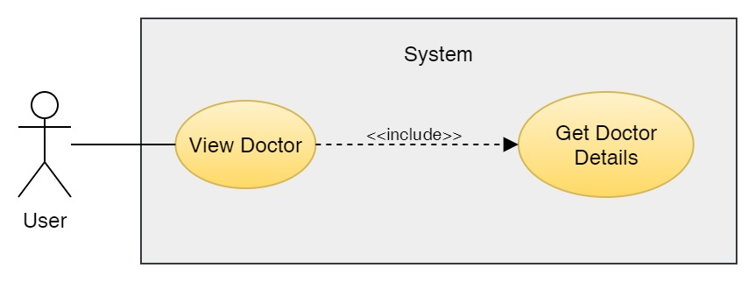

Figure 40: Use Case Diagram – User View Doctor

**Collaboration Diagram**

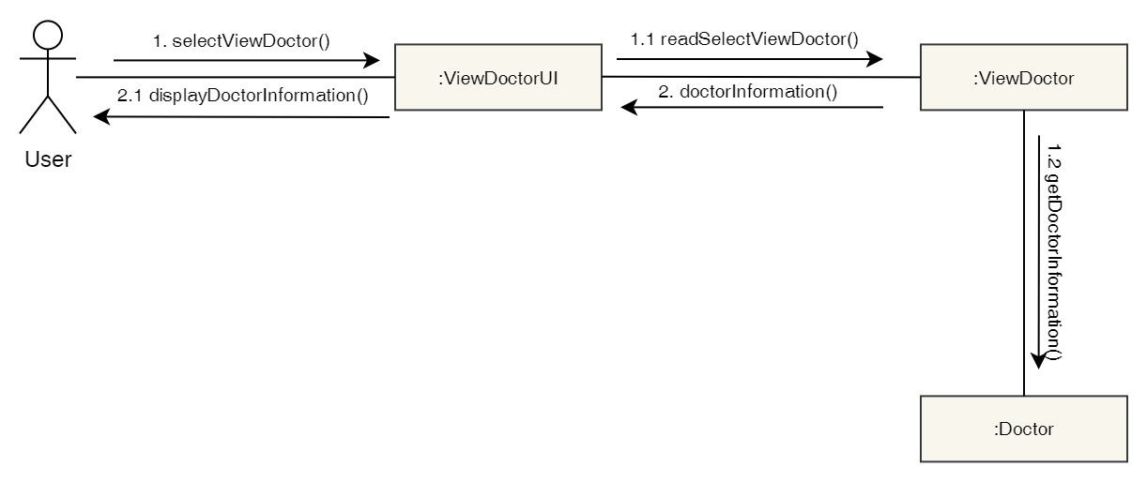

Figure 41: Collaboration Diagram – User View Doctor

**Activity Diagram**

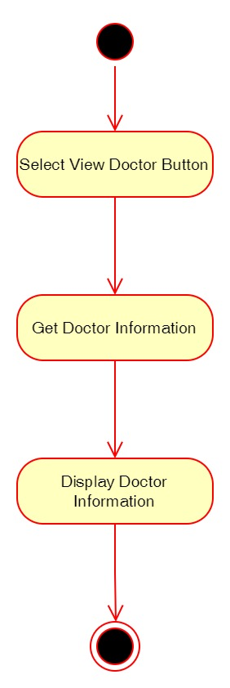

Figure 42: Activity Diagram – User View Doctor

**Sequence Diagram**

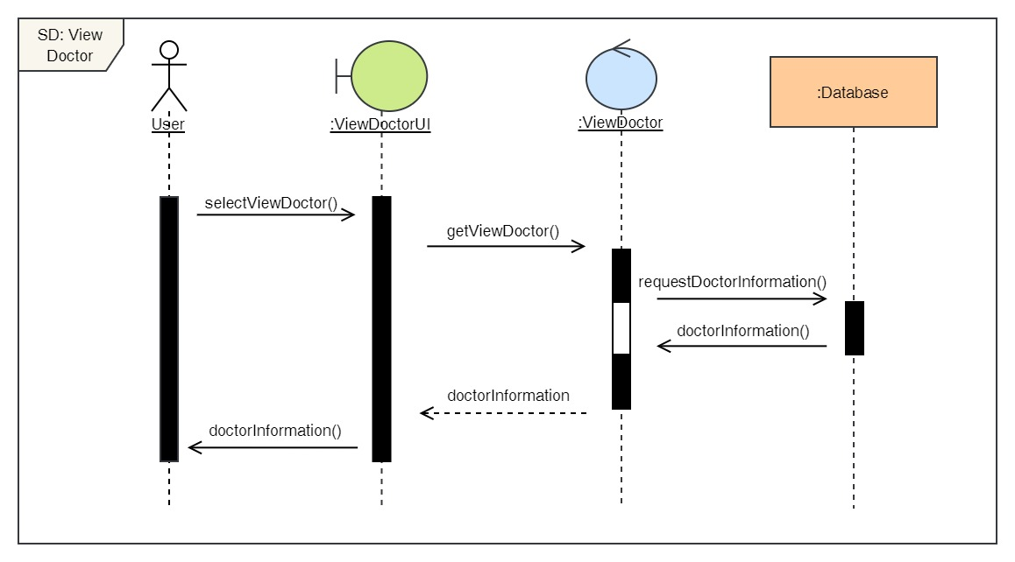

Figure 43: Sequence Diagram – User View Doctor

9. View report

**High Level Use Case Description**

|  |  |
| --- | --- |
| **Use Case:** | View Report |
| **Actor:** | User |
| **Description:** | Users can view report about their visit to the clinic. They can download it as well. |

Table 10: High Level Use Case – User View Report

**Use Case Diagram**

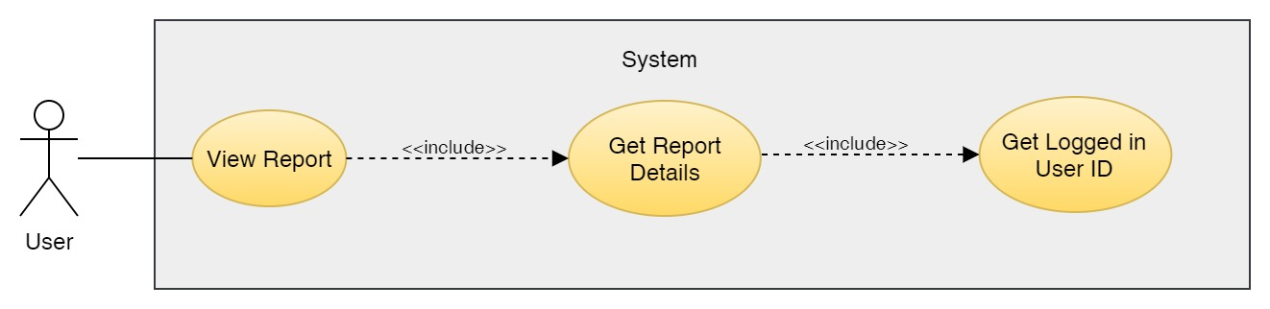

Figure 44: Use Case Diagram – User View Report

**Collaboration Diagram**

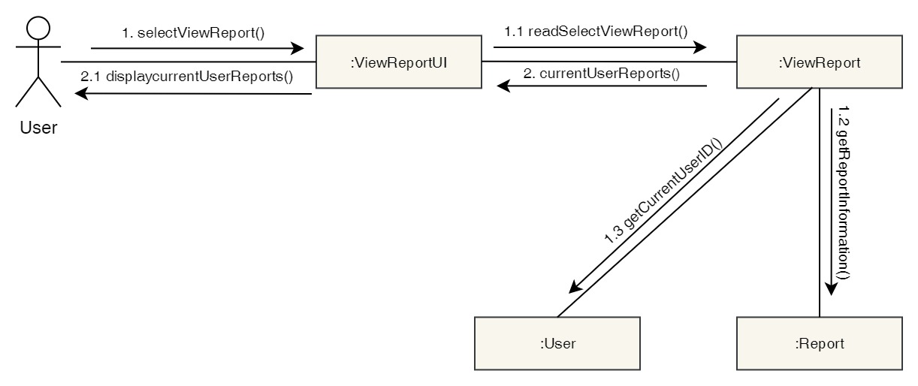

Figure 45: Collaboration Diagram – User View Report

**Activity Diagram**

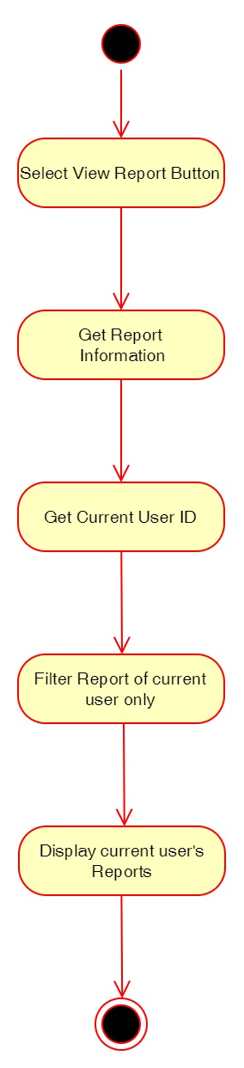

Figure 46: Activity Diagram – User View Report

**Sequence Diagram**

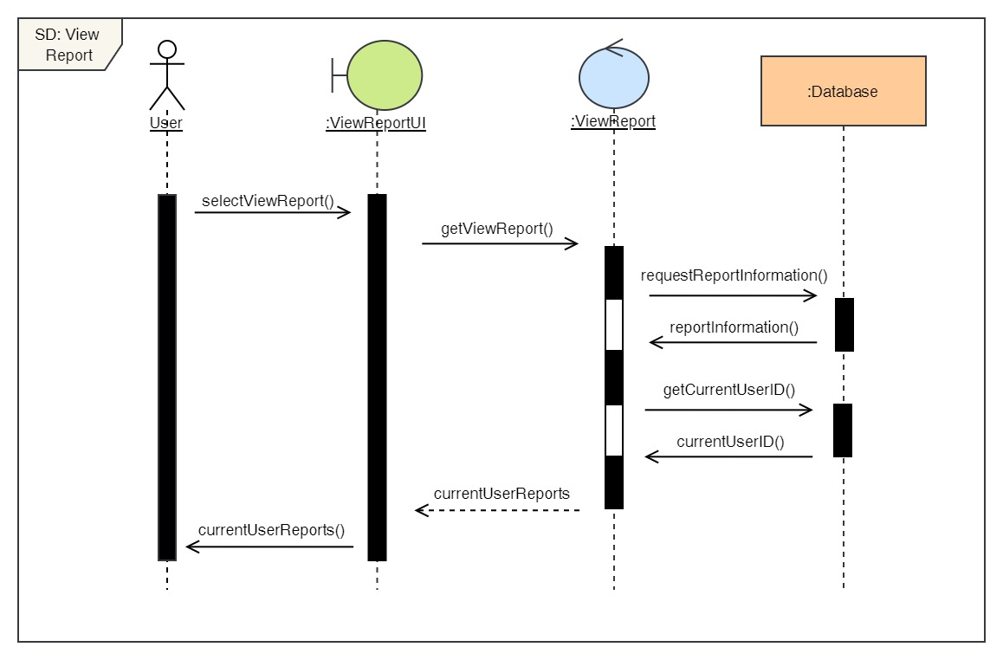

Figure 47: Sequence Diagram – User View Report

10. View services

**High Level Use Case Description**

|  |  |
| --- | --- |
| **Use Case:** | View Services |
| **Actor:** | User |
| **Description:** | Users can view the list of services available along with the cost of it and description. |

Table 11: High Level Use Case – User View Services

**Use Case Diagram**

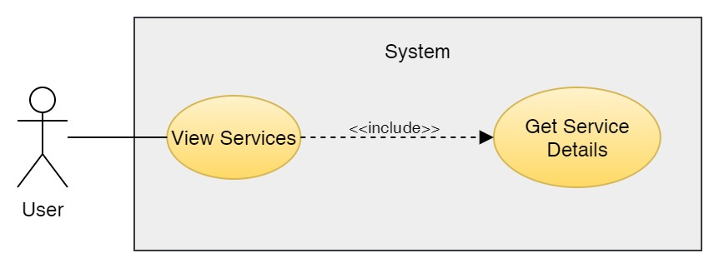

Figure 48: Use Case Diagram – User View Services

**Collaboration Diagram**

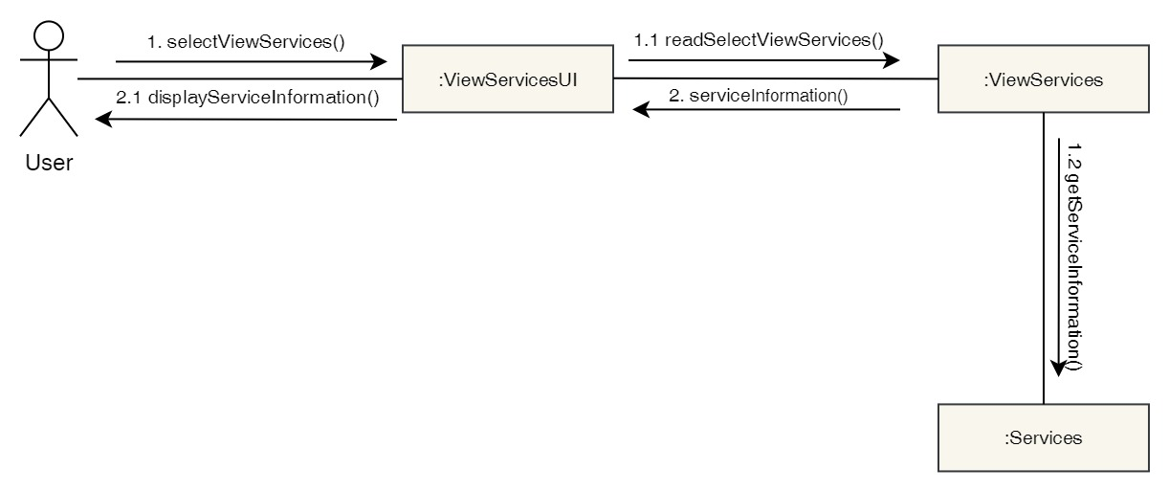

Figure 49: Collaboration Diagram – User View Services

**Activity Diagram**

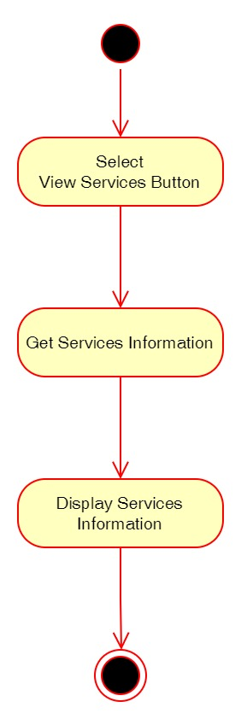

Figure 50: Activity Diagram – User View Services

**Sequence Diagram**

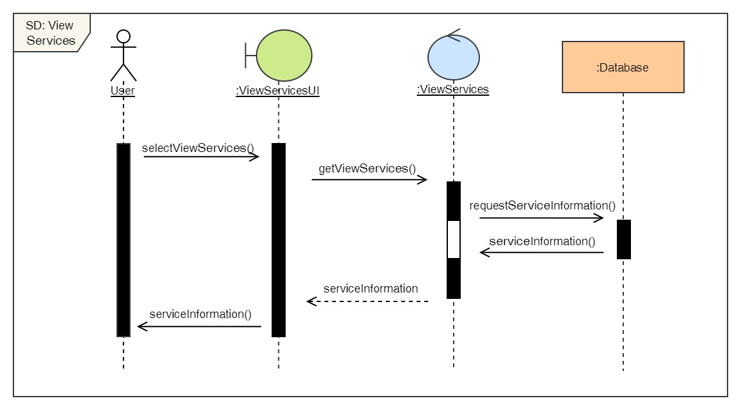

Figure 51: Sequence Diagram – User View Services

**Admin**

11. Login to the system

**High Level Use Case Description**

|  |  |
| --- | --- |
| **Use Case:** | Admin Login |
| **Actor:** | Admin |
| **Description:** | In order to use the admin side system and its features, the admin must log in to the system. The login details is then verified by the system. |

Table 12: High Level Use Case – Admin Login

**Use Case Diagram**

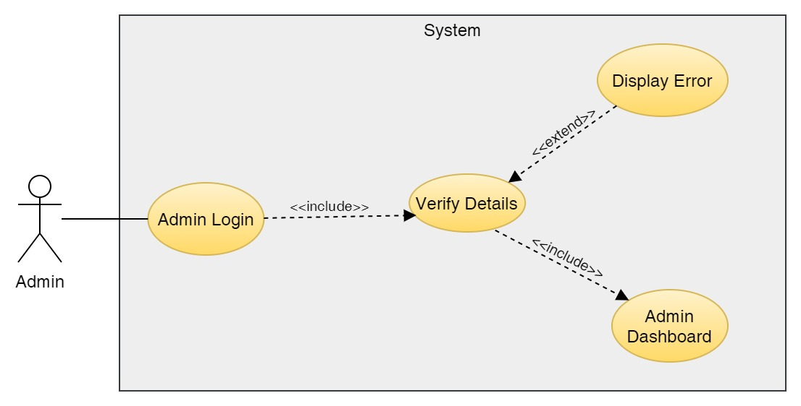

Figure 52: Use Case Diagram – Admin Login

**Collaboration Diagram**

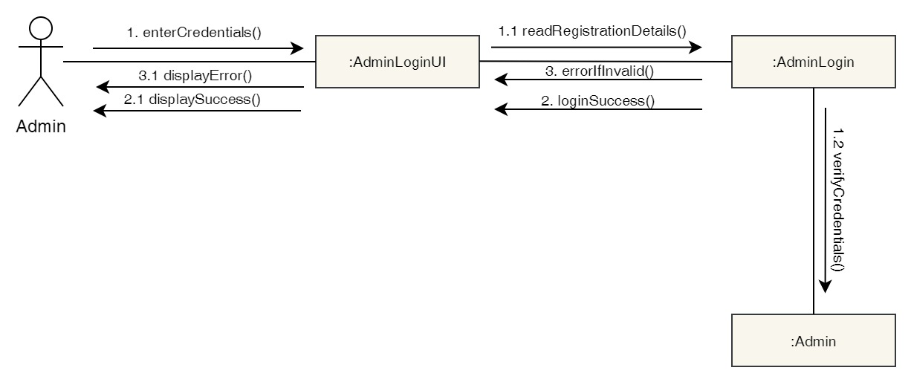

Figure 53: Collaboration Diagram – Admin Login

**Activity Diagram**

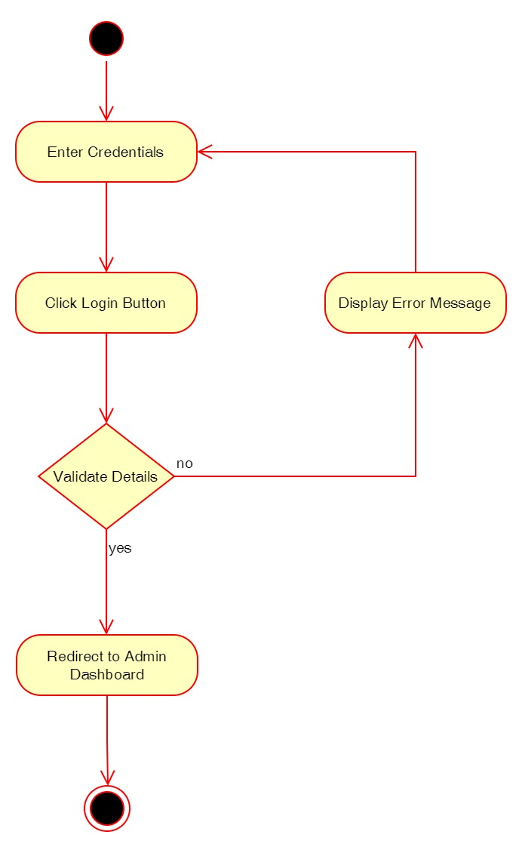

Figure 54: Activity Diagram – Admin Login

**Sequence Diagram**

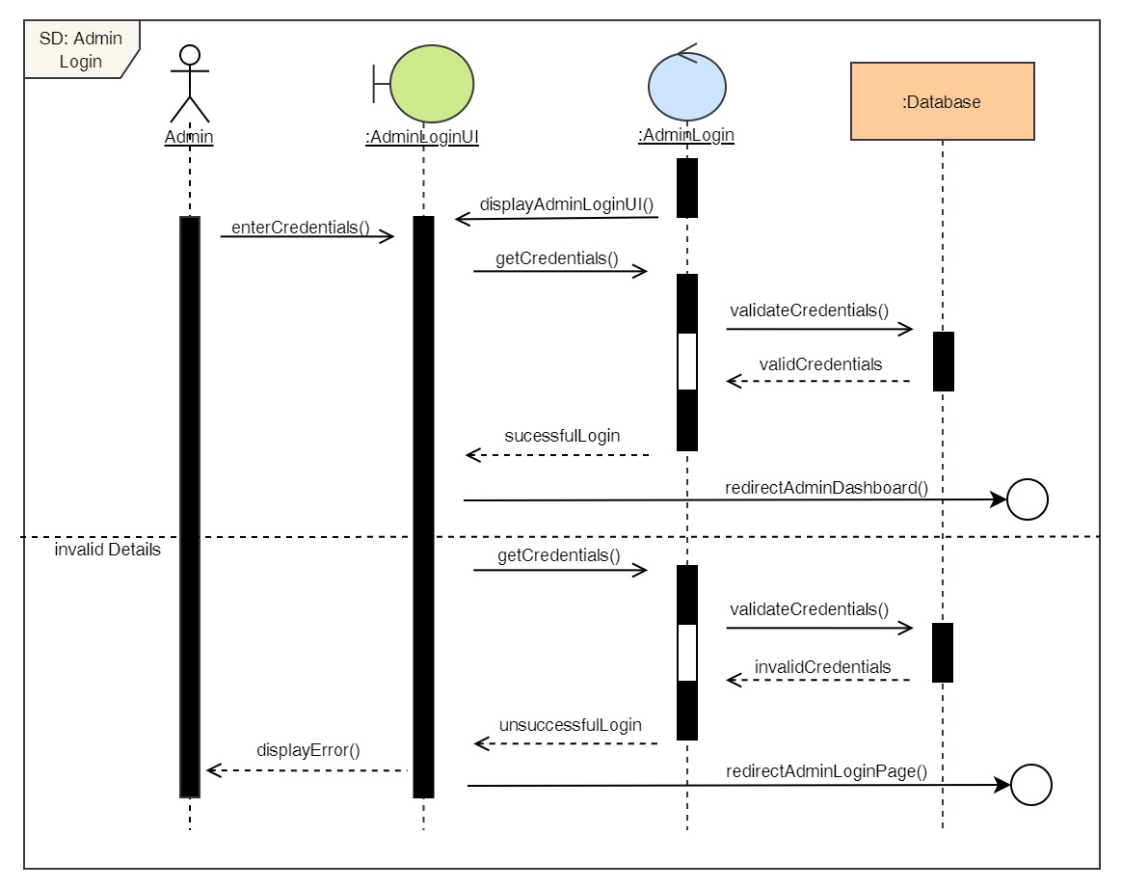

Figure 55: Sequence Diagram – Admin Login

12. View all users

**High Level Use Case Description**

|  |  |
| --- | --- |
| **Use Case:** | View all users |
| **Actor:** | Admin |
| **Description:** | Admin can view all the user that are registered to the system. |

Table 13: High Level Use Case – Admin View Users

**Use Case Diagram**

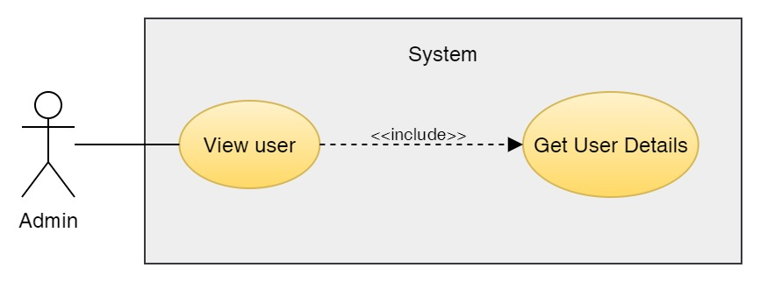

Figure 56: Use Case Diagram – Admin View Users

**Collaboration Diagram**

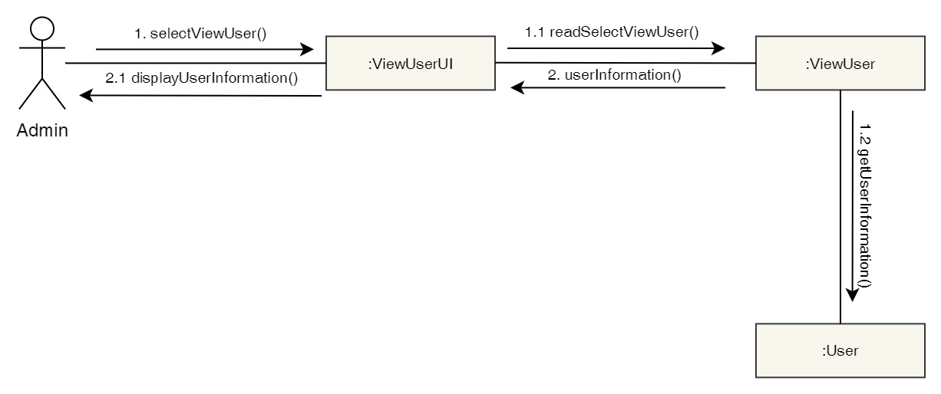

Figure 57: Collaboration Diagram – Admin View Users

**Activity Diagram**

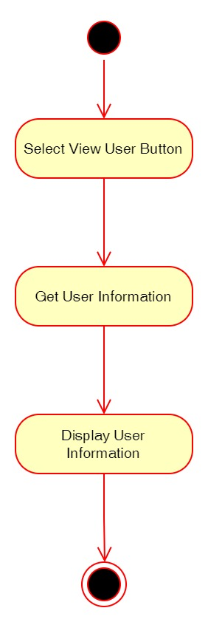

Figure 58: Activity Diagram – Admin View Users

**Sequence Diagram**

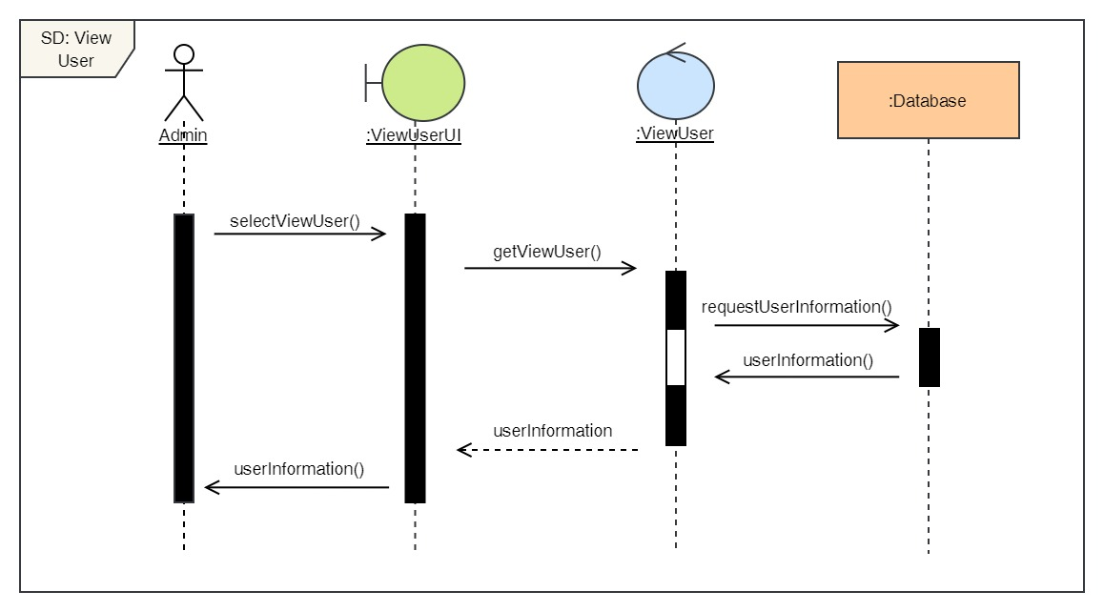

Figure 59: Sequence Diagram – Admin View Users

13. Delete users

**High Level Use Case Description**

|  |  |
| --- | --- |
| **Use Case:** | De-Register User |
| **Actor:** | Admin |
| **Description:** | Admin can delete existing users from the system. |

Table 14: High Level Use Case – Admin Delete Users

**Use Case Diagram**

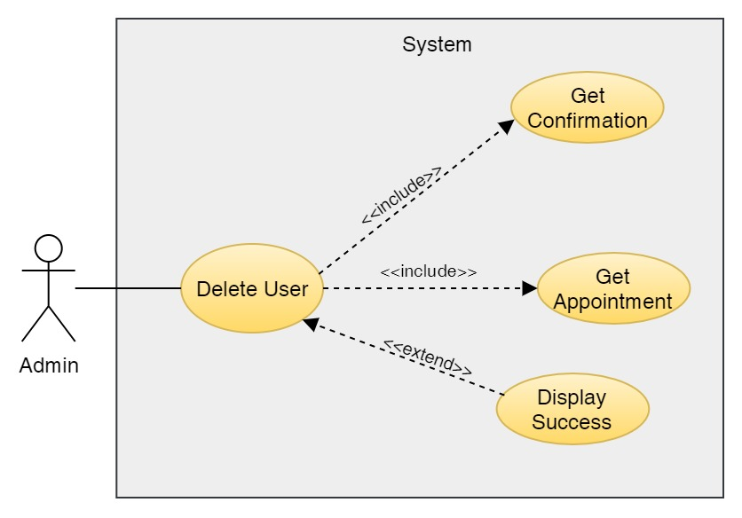

Figure 60: Use Case Diagram – Admin Delete Users

**Collaboration Diagram**

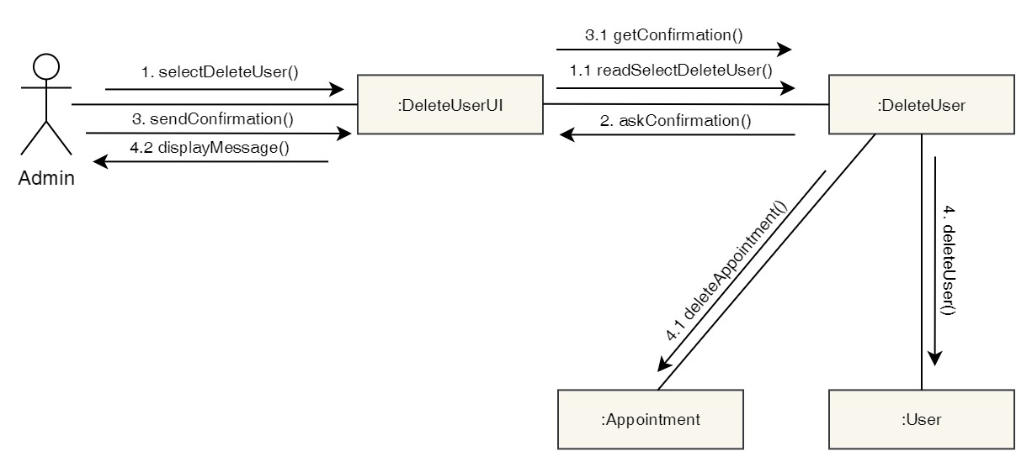

Figure 61: Collaboration Diagram – Admin Delete Users

**Activity Diagram**

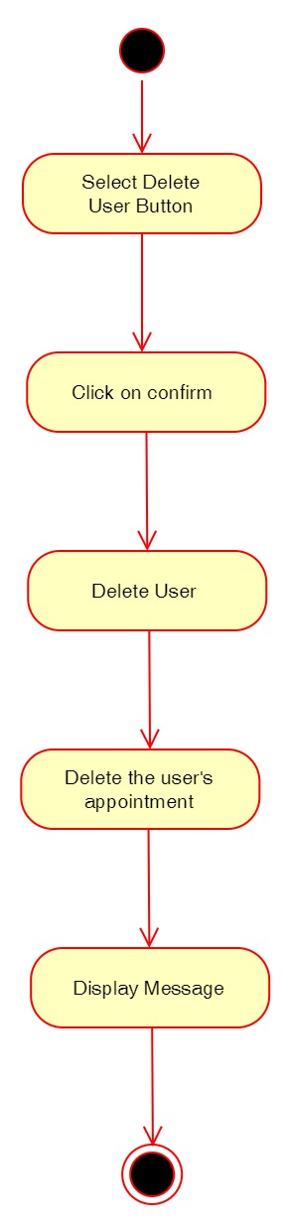

Figure 62: Activity Diagram – Admin Delete Users

**Sequence Diagram**

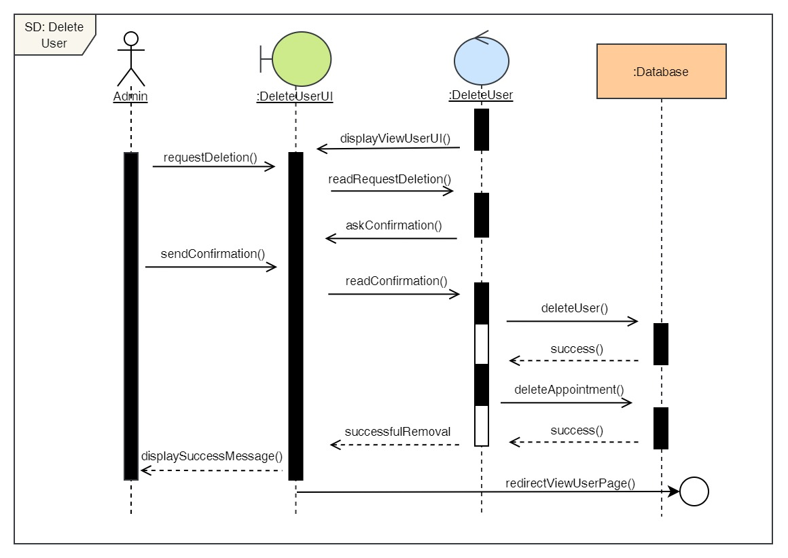

Figure 63: Sequence Diagram – Admin Delete Users

14. View all doctors

**High Level Use Case Description**

|  |  |
| --- | --- |
| **Use Case:** | View doctors |
| **Actor:** | Admin |
| **Description:** | Admin can view all the existing doctors in the system. |

Table 15: High Level Use Case – Admin View Doctors

**Use Case Diagram**

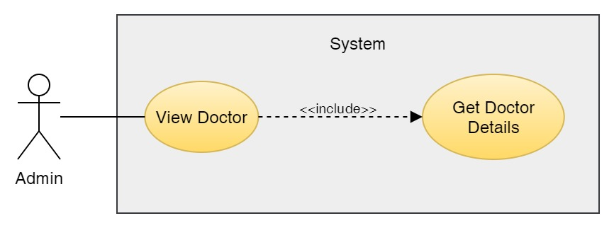

Figure 64: Use Case Diagram – Admin View Doctors

**Collaboration Diagram**

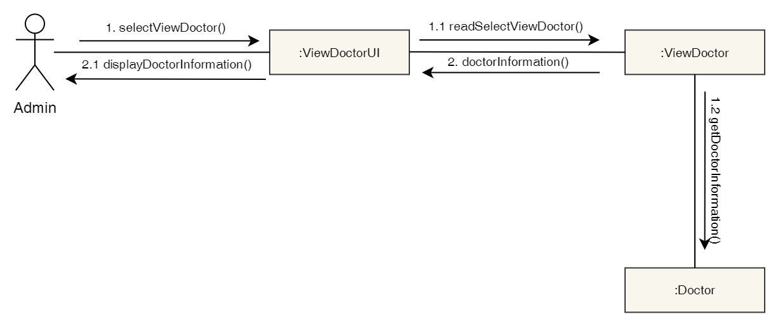

Figure 65: Collaboration Diagram – Admin View Doctors

**Activity Diagram**



Figure 66: Activity Diagram – Admin View Doctors

**Sequence Diagram**

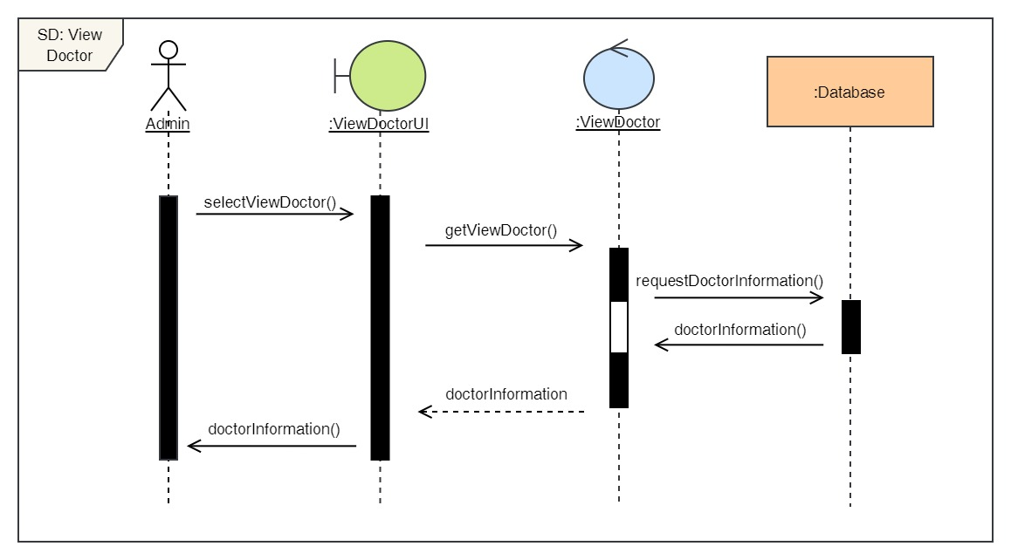

Figure 67: Sequence Diagram – Admin View Doctors

15. Add new doctors

**High Level Use Case Description**

|  |  |
| --- | --- |
| **Use Case:** | Add Doctors |
| **Actor:** | Admin |
| **Description:** | Admin can add new doctors to the system along with their description. |

Table 16: High Level Use Case – Admin Add Doctors

**Use Case Diagram**

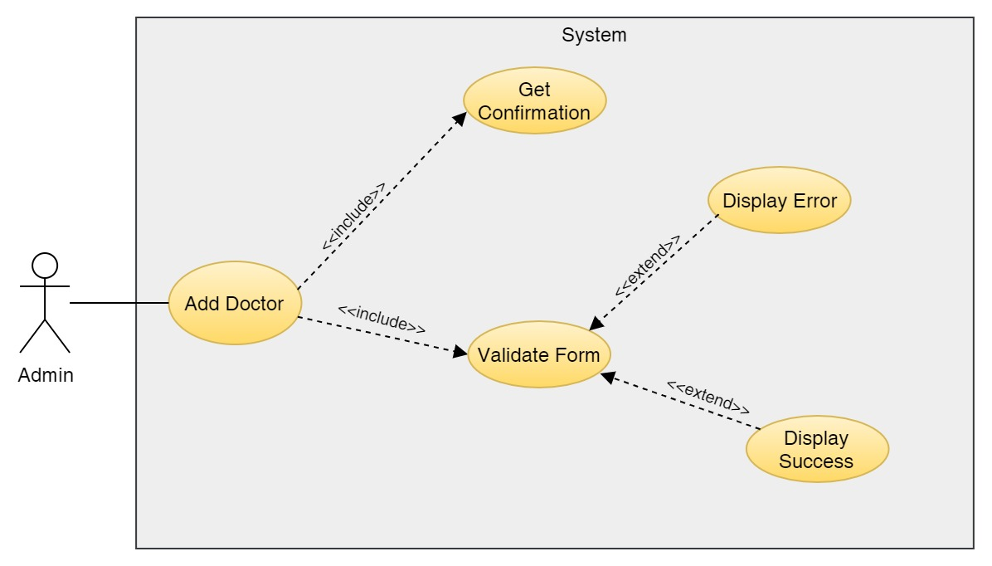

Figure 68: Use Case Diagram – Admin Add Doctors

**Collaboration Diagram**

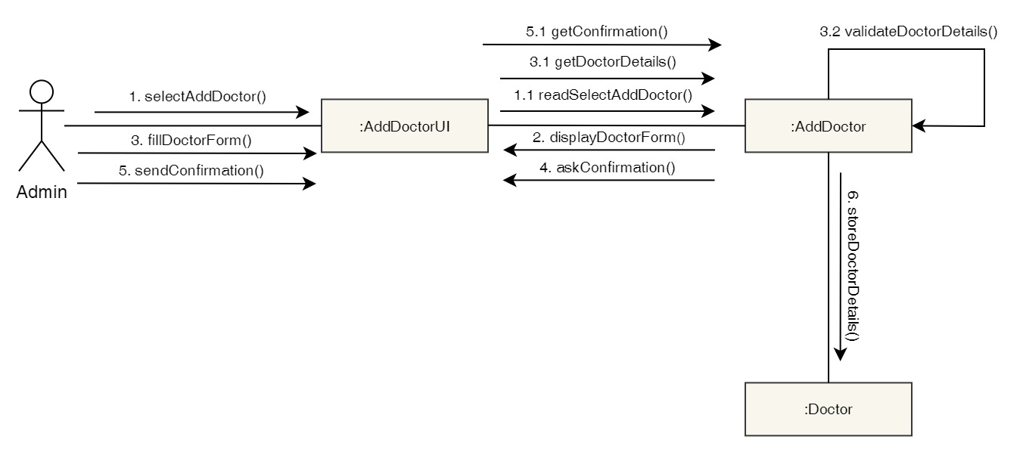

Figure 69: Collaboration Diagram – Admin Add Doctors

**Activity Diagram**

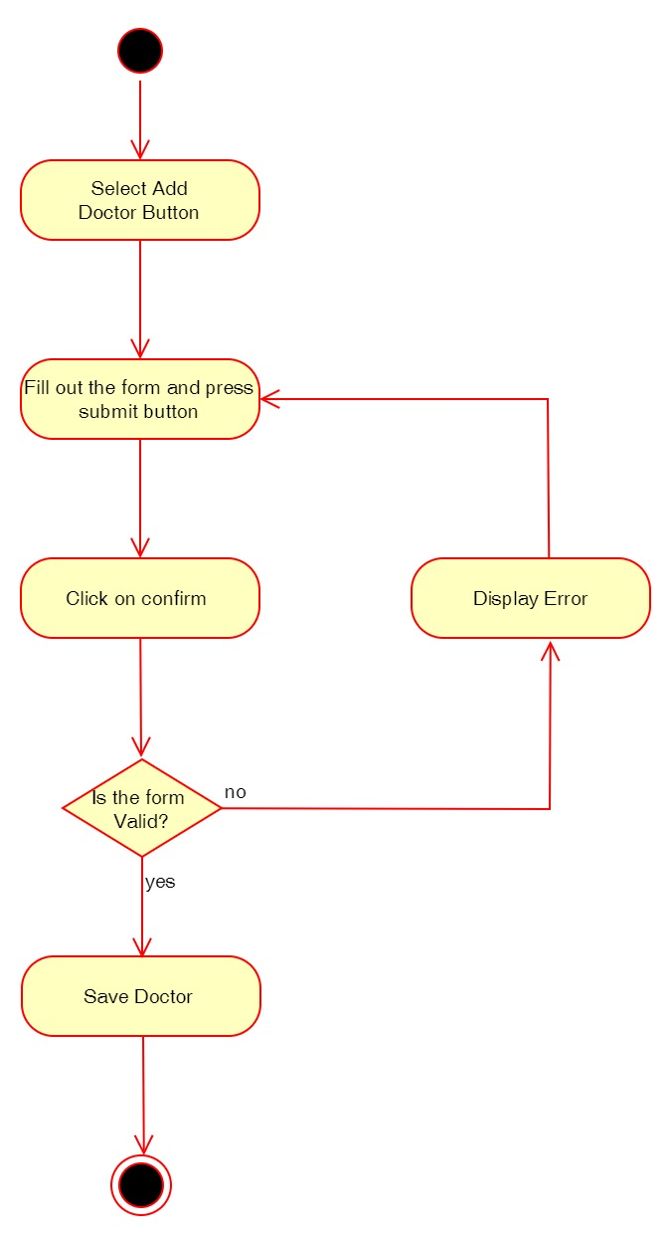

Figure 70: Activity Diagram – Admin Add Doctors

**Sequence Diagram**

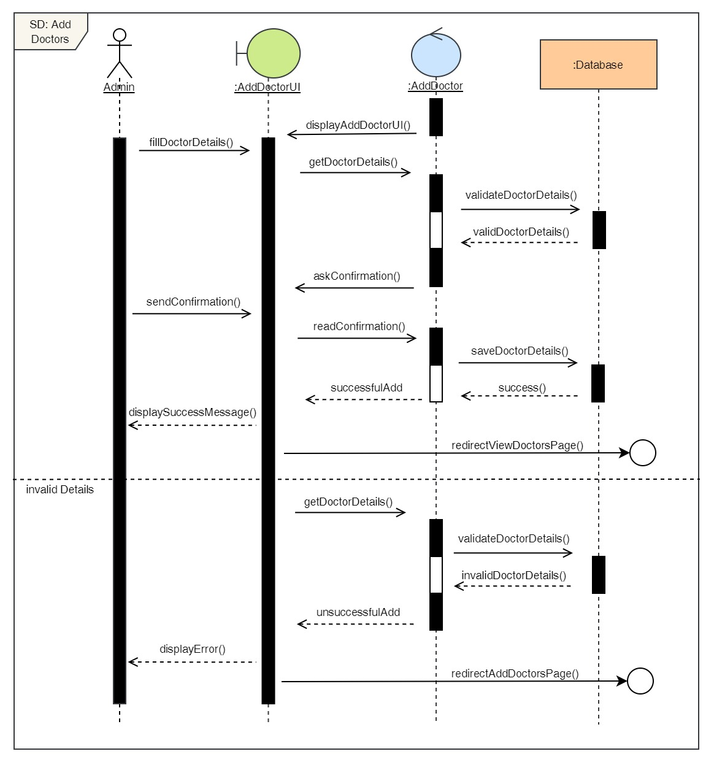

Figure 71: Sequence Diagram – Admin Add Doctors

16. Delete doctors

**High Level Use Case Description**

|  |  |
| --- | --- |
| **Use Case:** | Delete Doctors |
| **Actor:** | Admin |
| **Description:** | Admin can remove existing doctors from the system if the doctor is no longer working in the clinic. |

Table 17: High Level Use Case – Admin Delete Doctors

**Use Case Diagram**

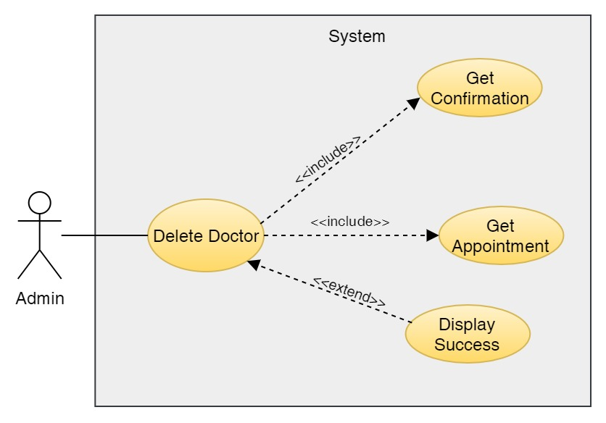

Figure 72: Use Case Diagram – Admin Delete Doctors

**Collaboration Diagram**

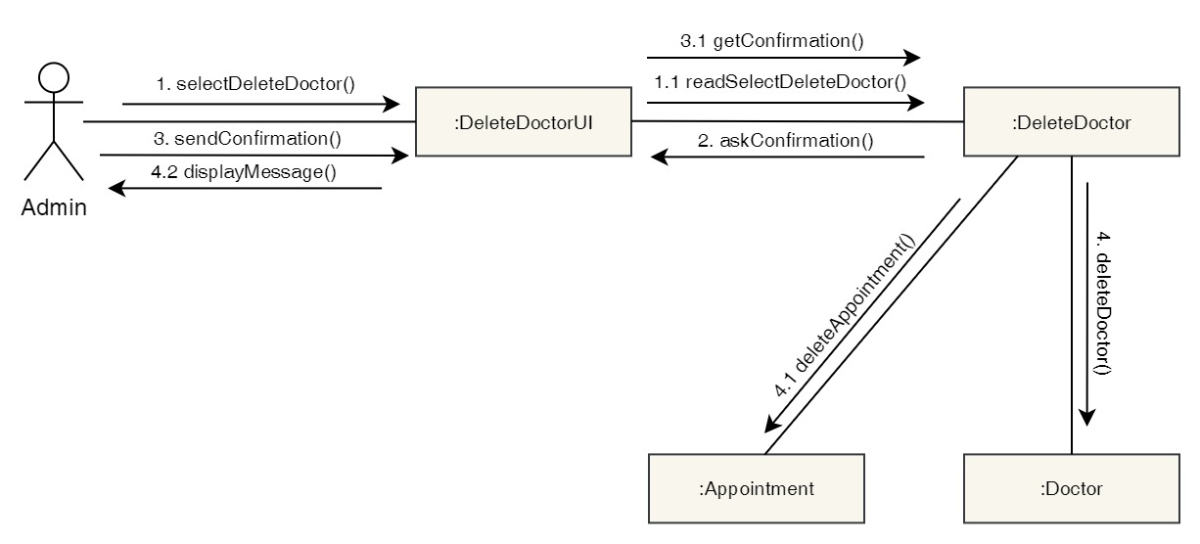

Figure 73: Collaboration Diagram – Admin Delete Doctors

**Activity Diagram**

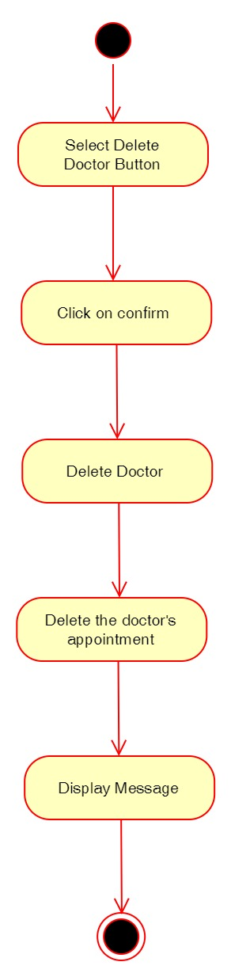

Figure 74: Activity Diagram – Admin Delete Doctors

**Sequence Diagram**

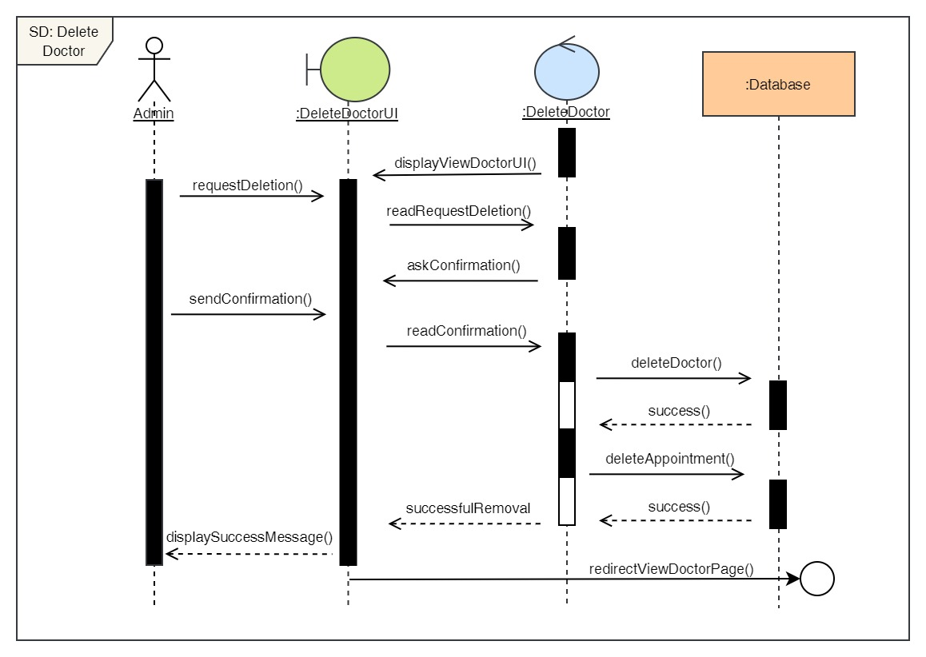

Figure 75: Sequence Diagram – Admin Delete Doctors

17. Edit doctors

**High Level Use Case Description**

|  |  |
| --- | --- |
| **Use Case:** | Edit Doctors |
| **Actor:** | Admin |
| **Description:** | Admin can update the details of the existing doctors in the system. |

Table 18: High Level Use Case – Admin Edit Doctors

**Use Case Diagram**

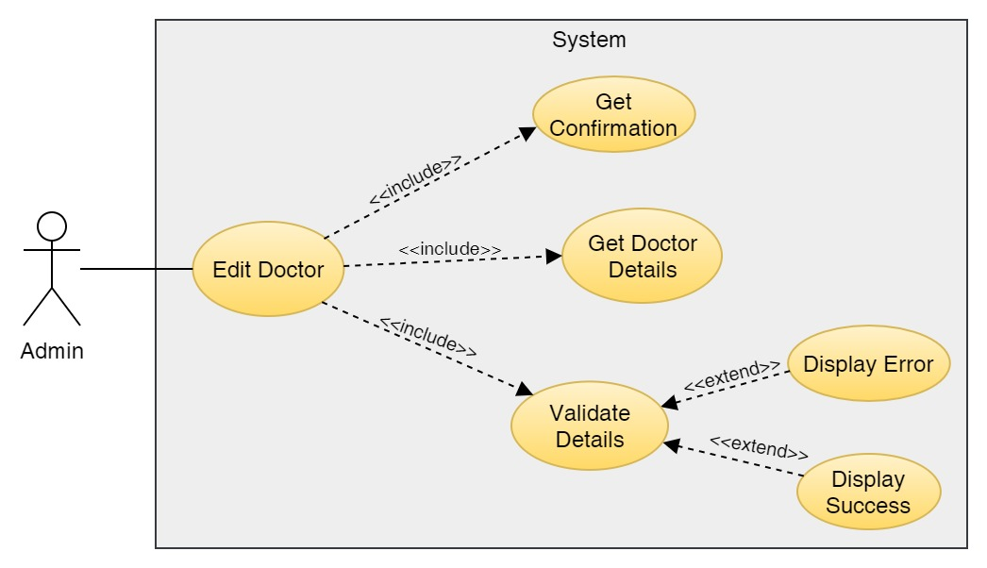

Figure 76: Use Case Diagram – Admin Edit Doctors

**Collaboration Diagram**

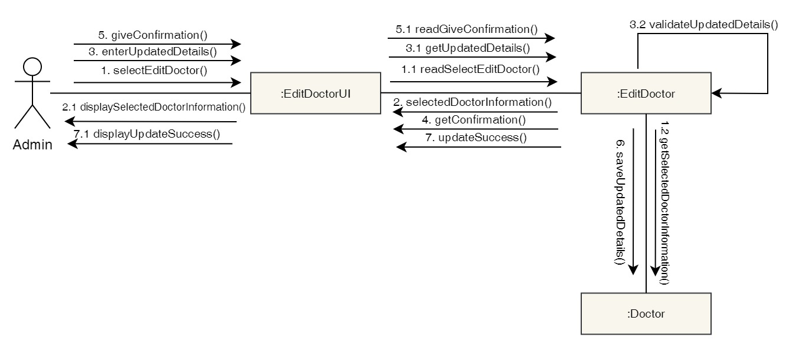

Figure 77: Collaboration Diagram – Admin Edit Doctors

**Activity Diagram**

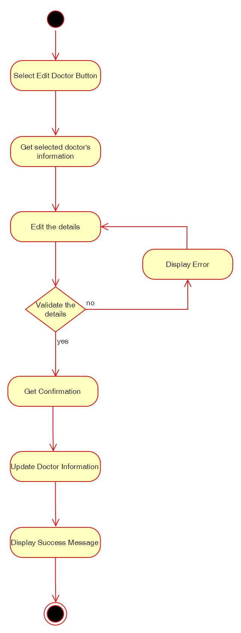

Figure 78: Activity Diagram – Admin Edit Doctors

**Sequence Diagram**

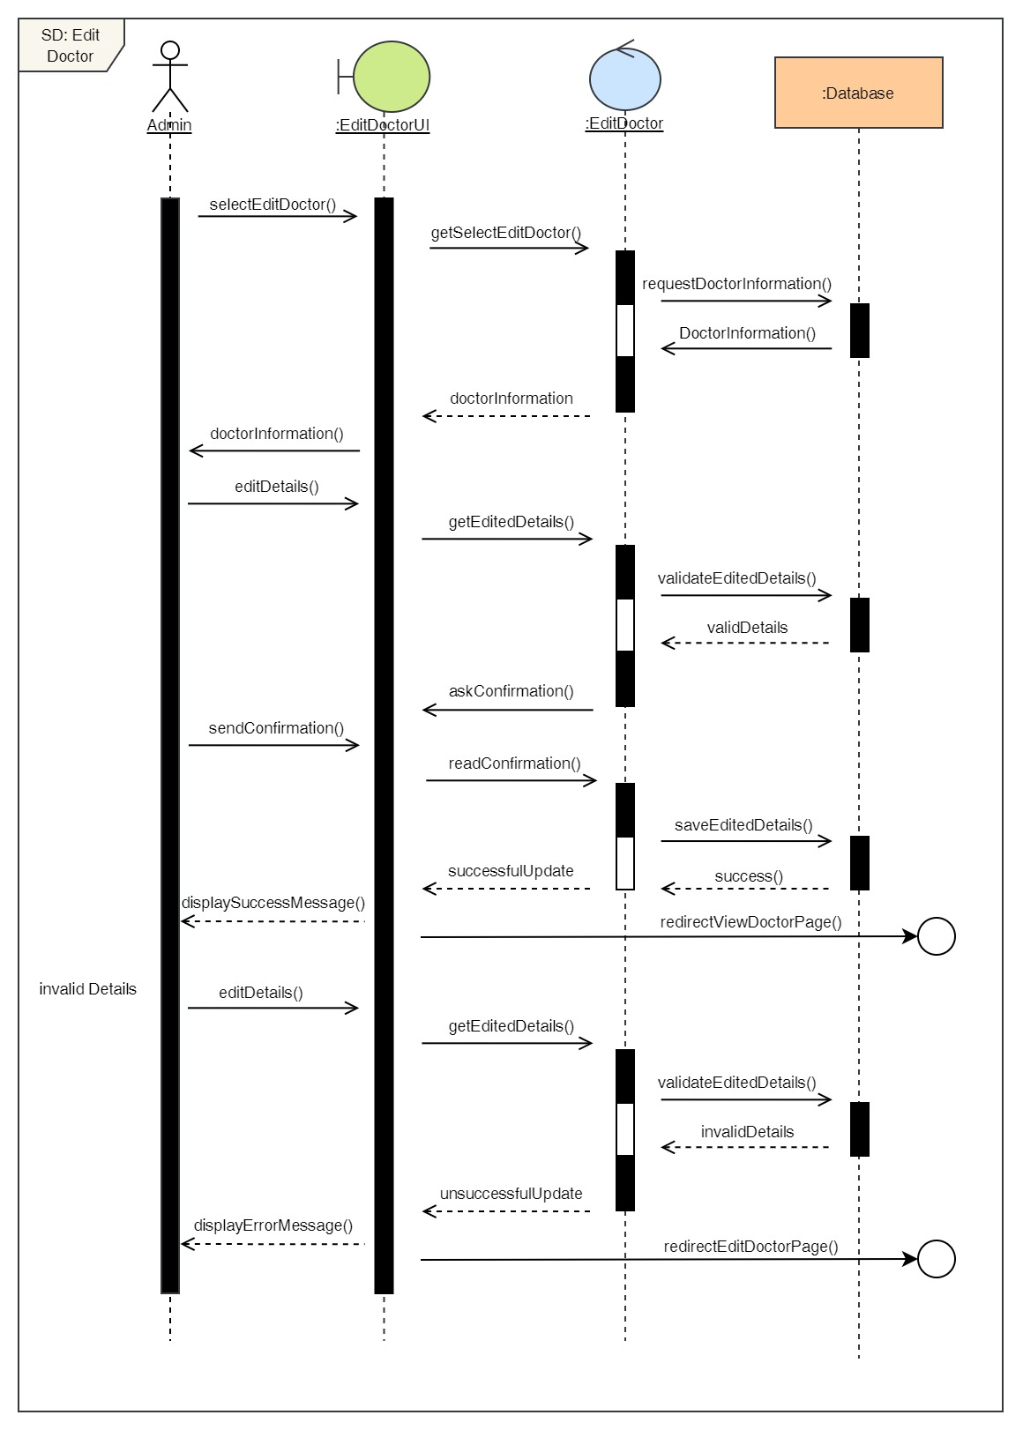

Figure 79: Sequence Diagram – Admin Edit Doctors

18. Add Report

**High Level Use Case Description**

|  |  |
| --- | --- |
| **Use Case:** | Add Report |
| **Actor:** | Admin |
| **Description:** | Admin can add reports of the appointments that has been completed. |

Table 19: High Level Use Case – Admin Add Report

**Use Case Diagram**

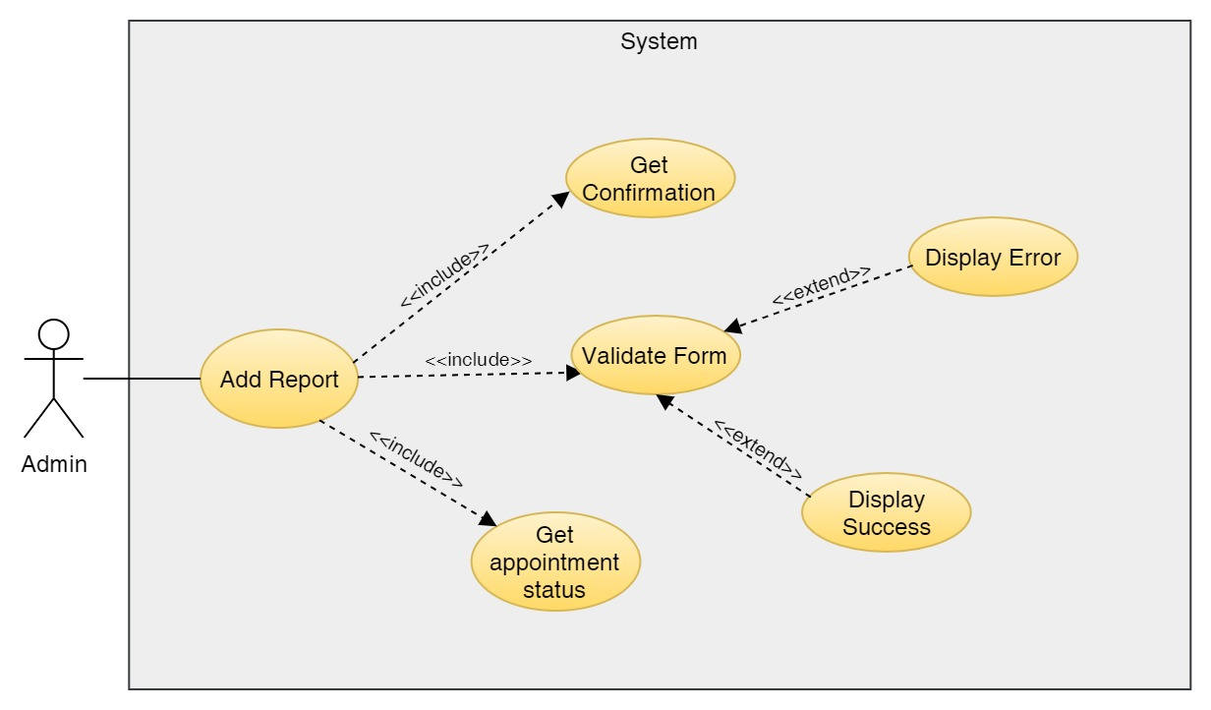

Figure 80: Use Case Diagram – Admin Add Report

**Collaboration Diagram**

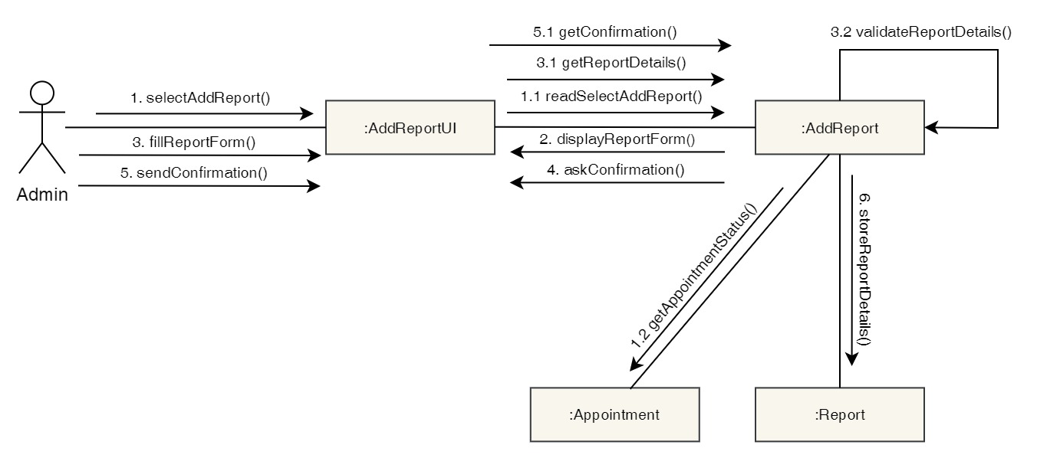

Figure 81: Collaboration Diagram – Admin Add Report

**Activity Diagram**

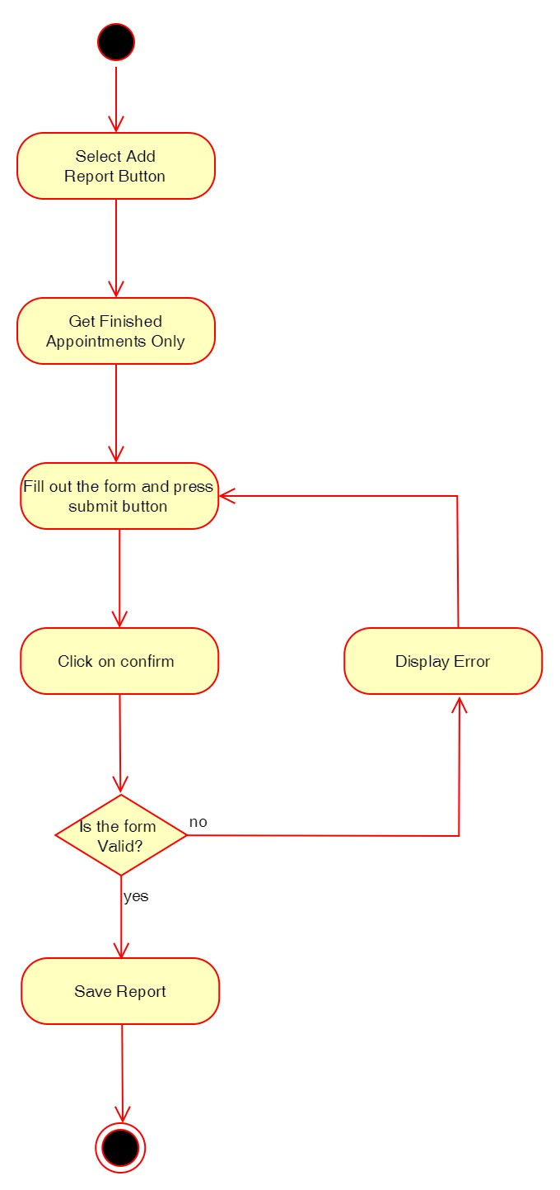

Figure 82: Activity Diagram – Admin Add Report

**Sequence Diagram**

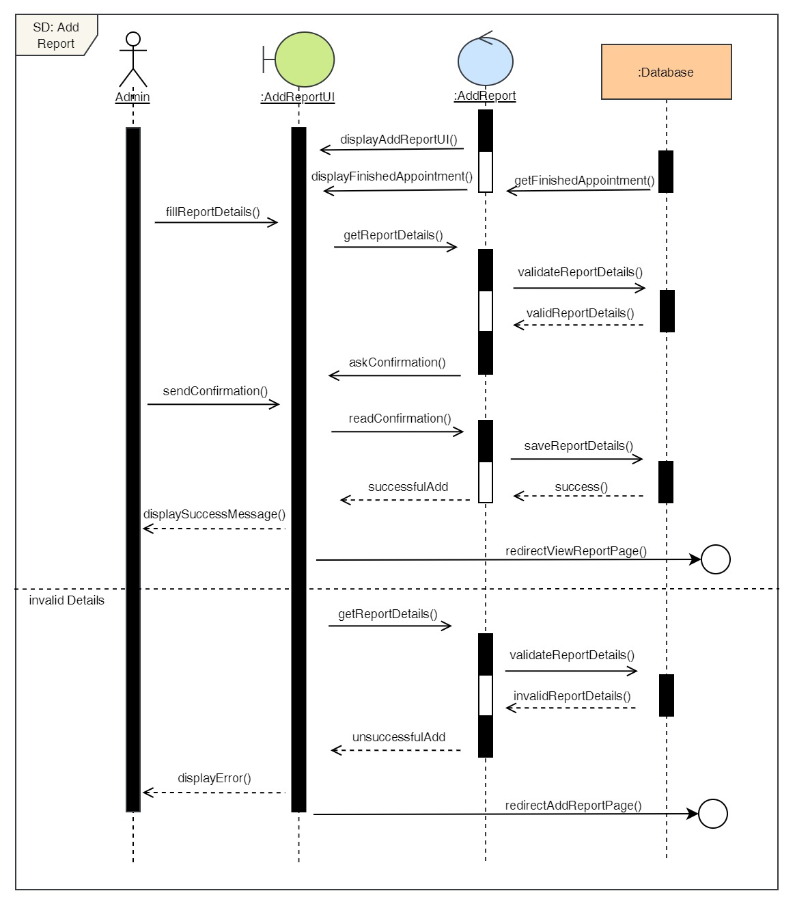

Figure 83: Sequence Diagram – Admin Add Report

19. Delete Report

**High Level Use Case Description**

|  |  |
| --- | --- |
| **Use Case:** | Delete Report |
| **Actor:** | Admin |
| **Description:** | Admin can add remove existing reports from the system. |

Table 20: High Level Use Case – Admin Delete Report

**Use Case Diagram**

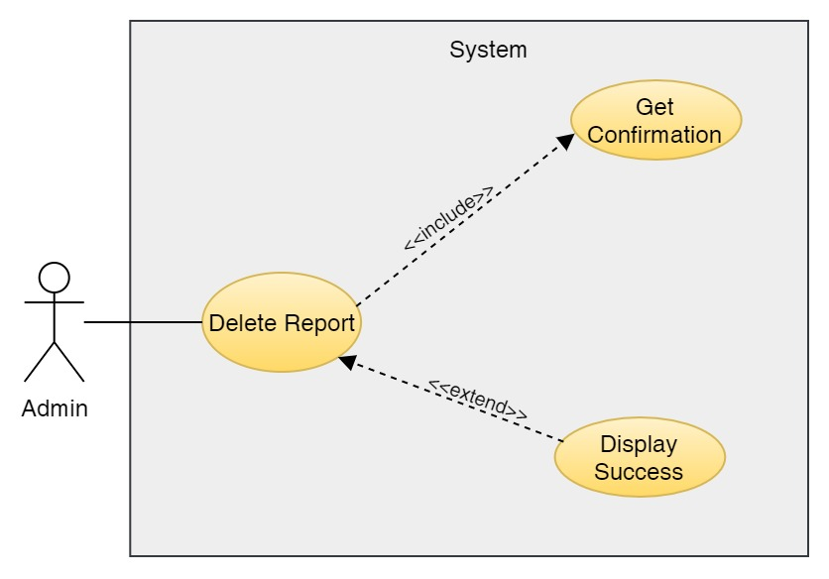

Figure 84: Use Case Diagram – Admin Delete Report

**Collaboration Diagram**

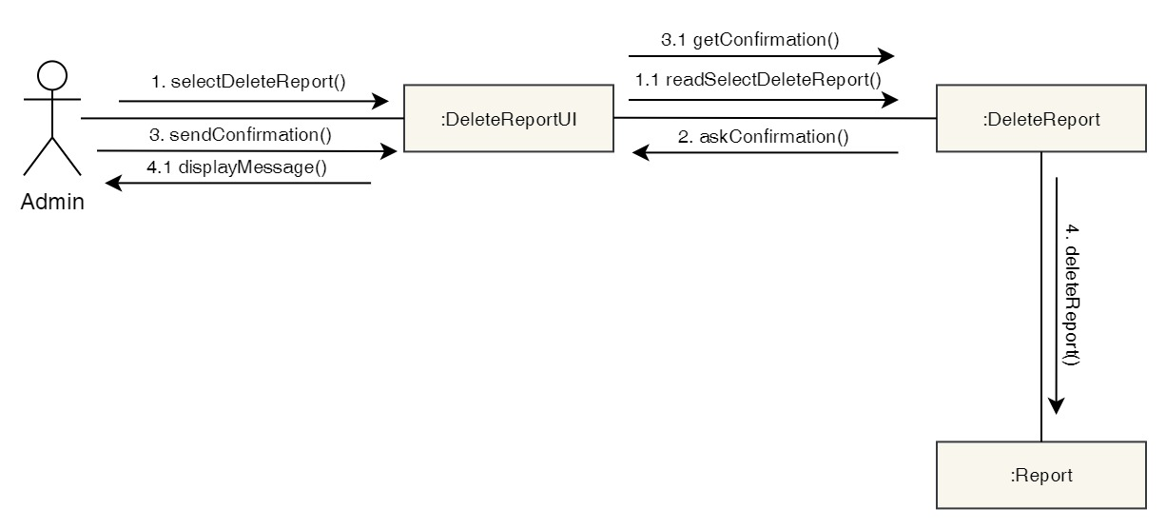

Figure 85: Collaboration Diagram – Admin Delete Report

**Activity Diagram**

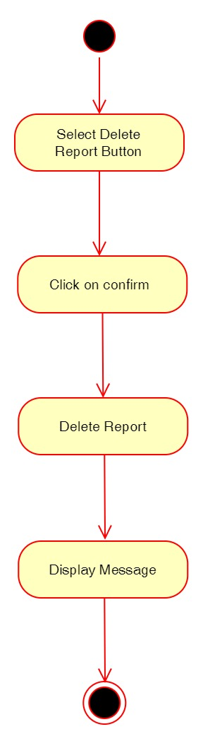

Figure 86: Activity Diagram – Admin Delete Report

**Sequence Diagram**

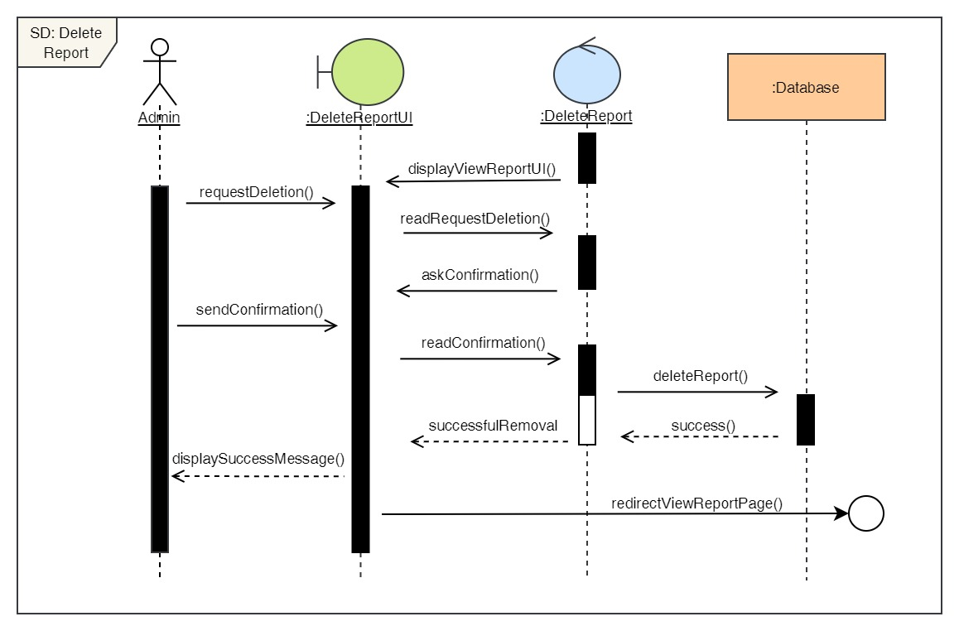

Figure 87: Sequence Diagram – Admin Delete Report

20. Edit reports

**High Level Use Case Description**

|  |  |
| --- | --- |
| **Use Case:** | Edit Reports |
| **Actor:** | Admin |
| **Description:** | Admin can update the details of the existing reports in the system. |

Table 21: High Level Use Case – Admin Edit Report

**Use Case Diagram**

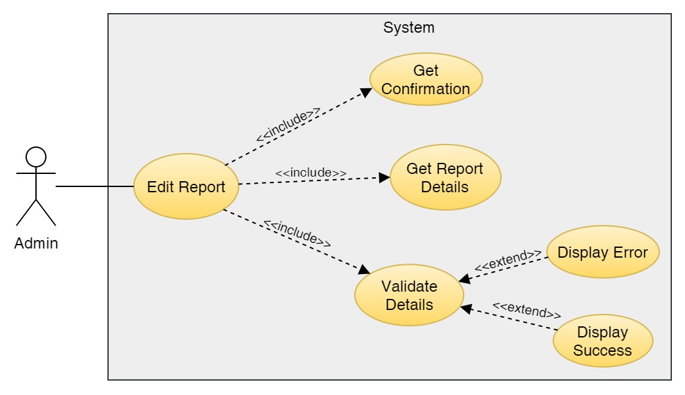

Figure 88: Use Case Diagram – Admin Edit Report

**Collaboration Diagram**

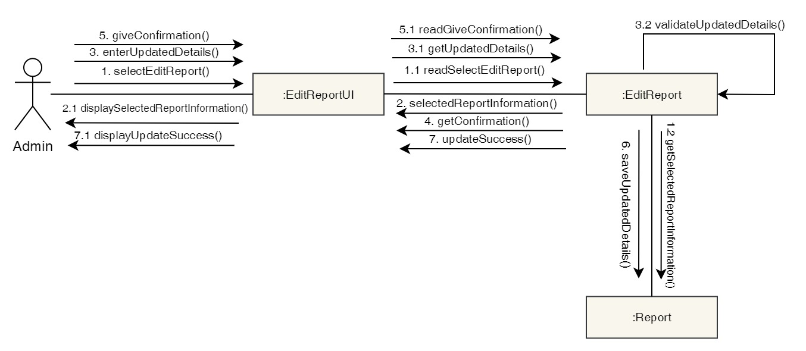

Figure 89: Collaboration Diagram – Admin Edit Report

**Activity Diagram**

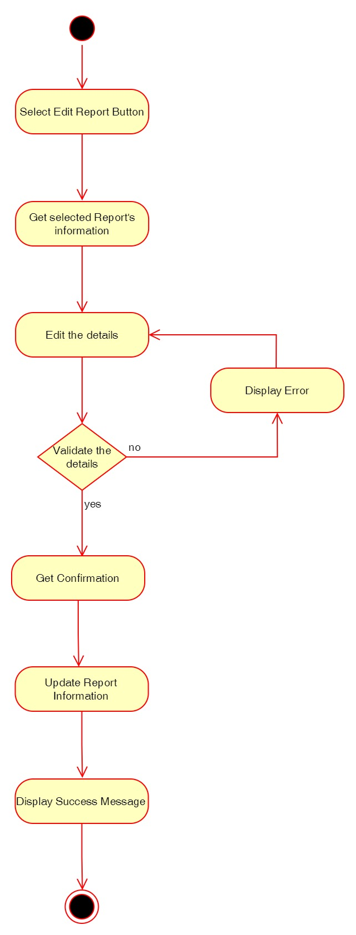

Figure 90: Activity Diagram – Admin Edit Report

**Sequence Diagram**

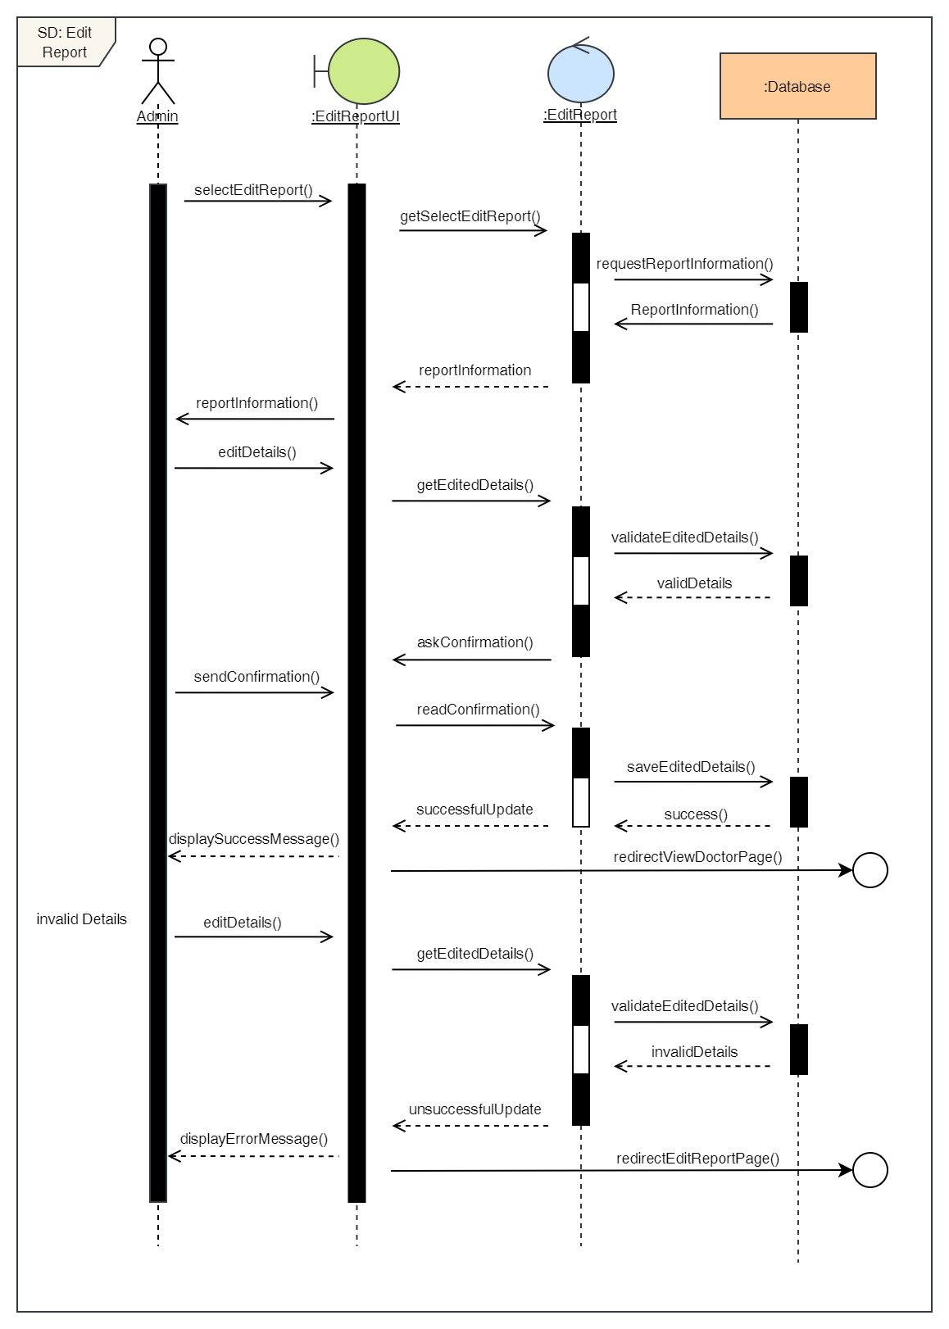

Figure 91: Sequence Diagram – Admin Edit Report

21. View all reports

**High Level Use Case Description**

|  |  |
| --- | --- |
| **Use Case:** | View Reports |
| **Actor:** | Admin |
| **Description:** | Admin can view all the reports of all the users stored in the system. |

Table 22: High Level Use Case – Admin View Reports

**Use Case Diagram**

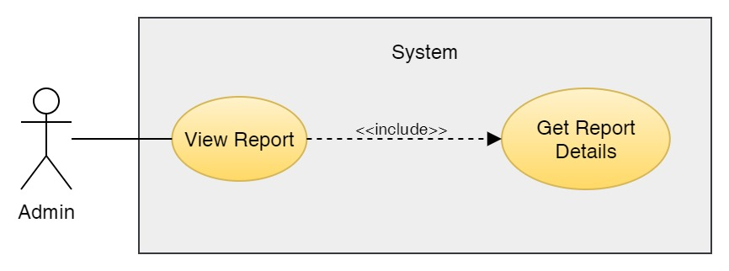

Figure 92: Use Case Diagram – Admin View Reports

**Collaboration Diagram**

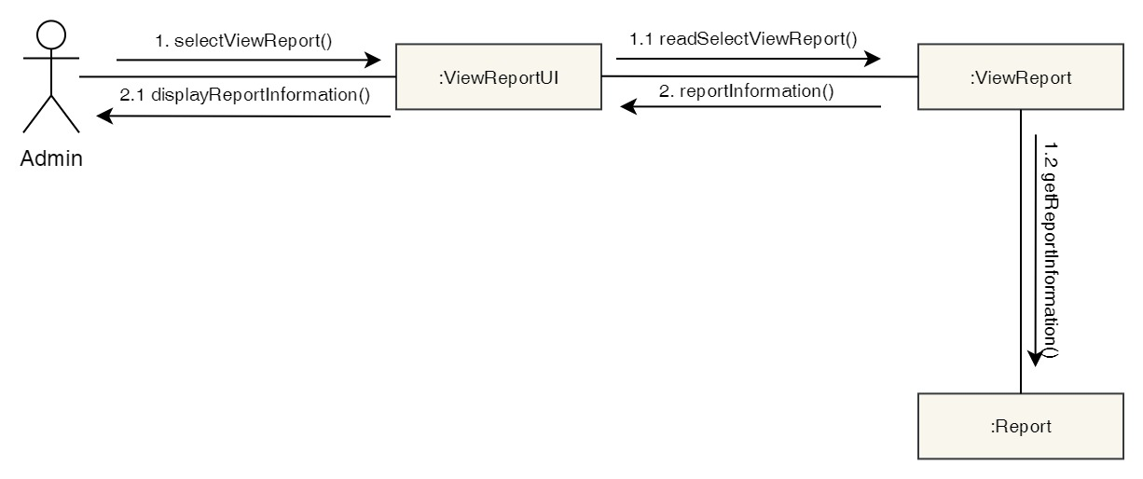

Figure 93: Collaboration Diagram – Admin View Reports

**Activity Diagram**

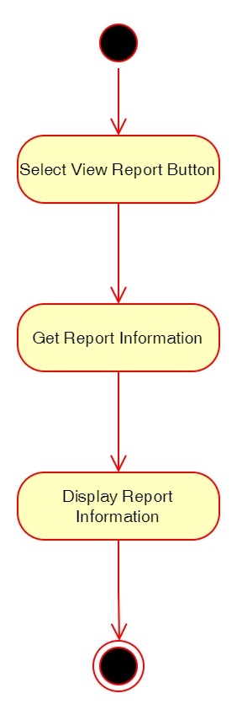

Figure 94: Activity Diagram – Admin View Reports

**Sequence Diagram**

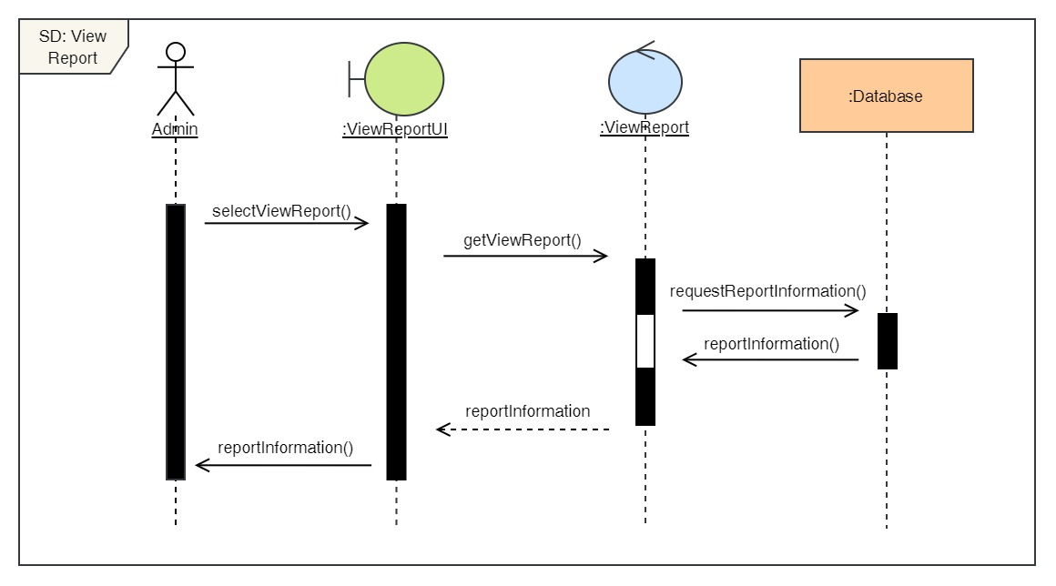

Figure 95: Sequence Diagram – Admin View Reports

22. Book a Dental Appointment

**High Level Use Case Description**

|  |  |
| --- | --- |
| **Use Case:** | Book Appointment |
| **Actor:** | Admin |
| **Description:** | Admin can book appointment for any user and any dental services by selecting the desired date, time, doctor and service. |

Table 23: High Level Use Case – Admin Book Appointment

**Use Case Diagram**

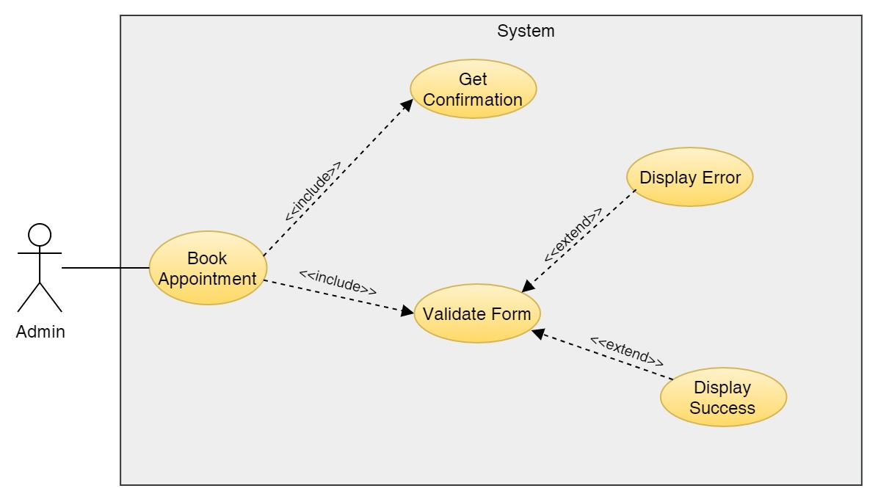

Figure 96: Use Case Diagram – Admin Book Appointment

**Collaboration Diagram**

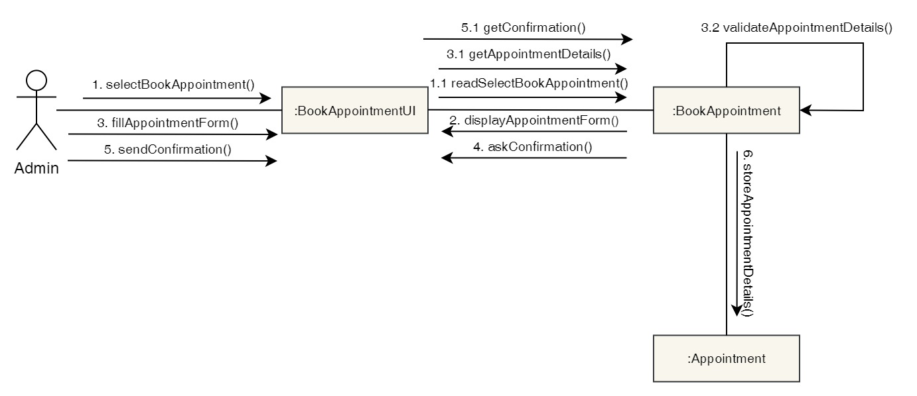

Figure 97: Collaboration Diagram – Admin Book Appointment

**Activity Diagram**

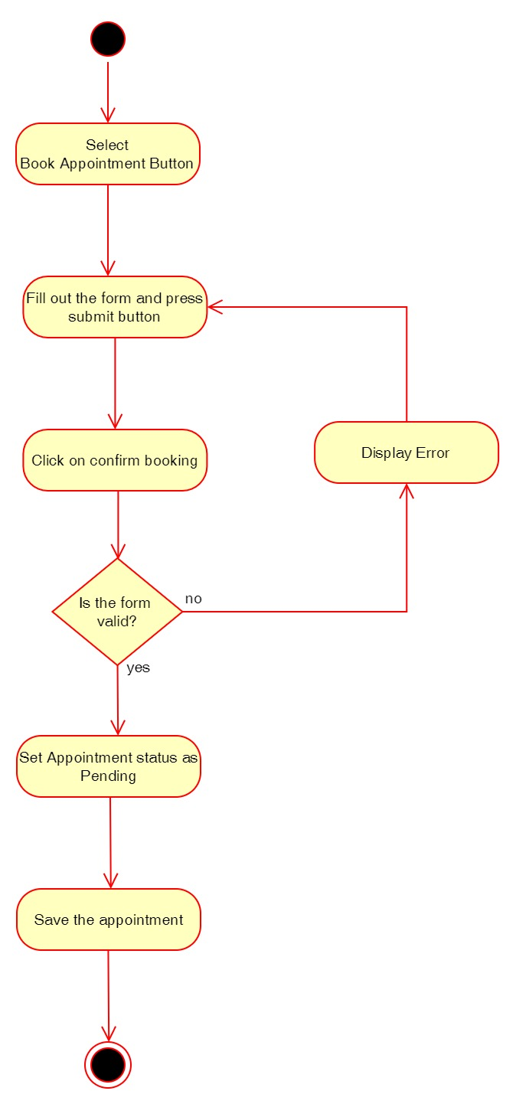

Figure 98: Activity Diagram – Admin Book Appointment

**Sequence Diagram**

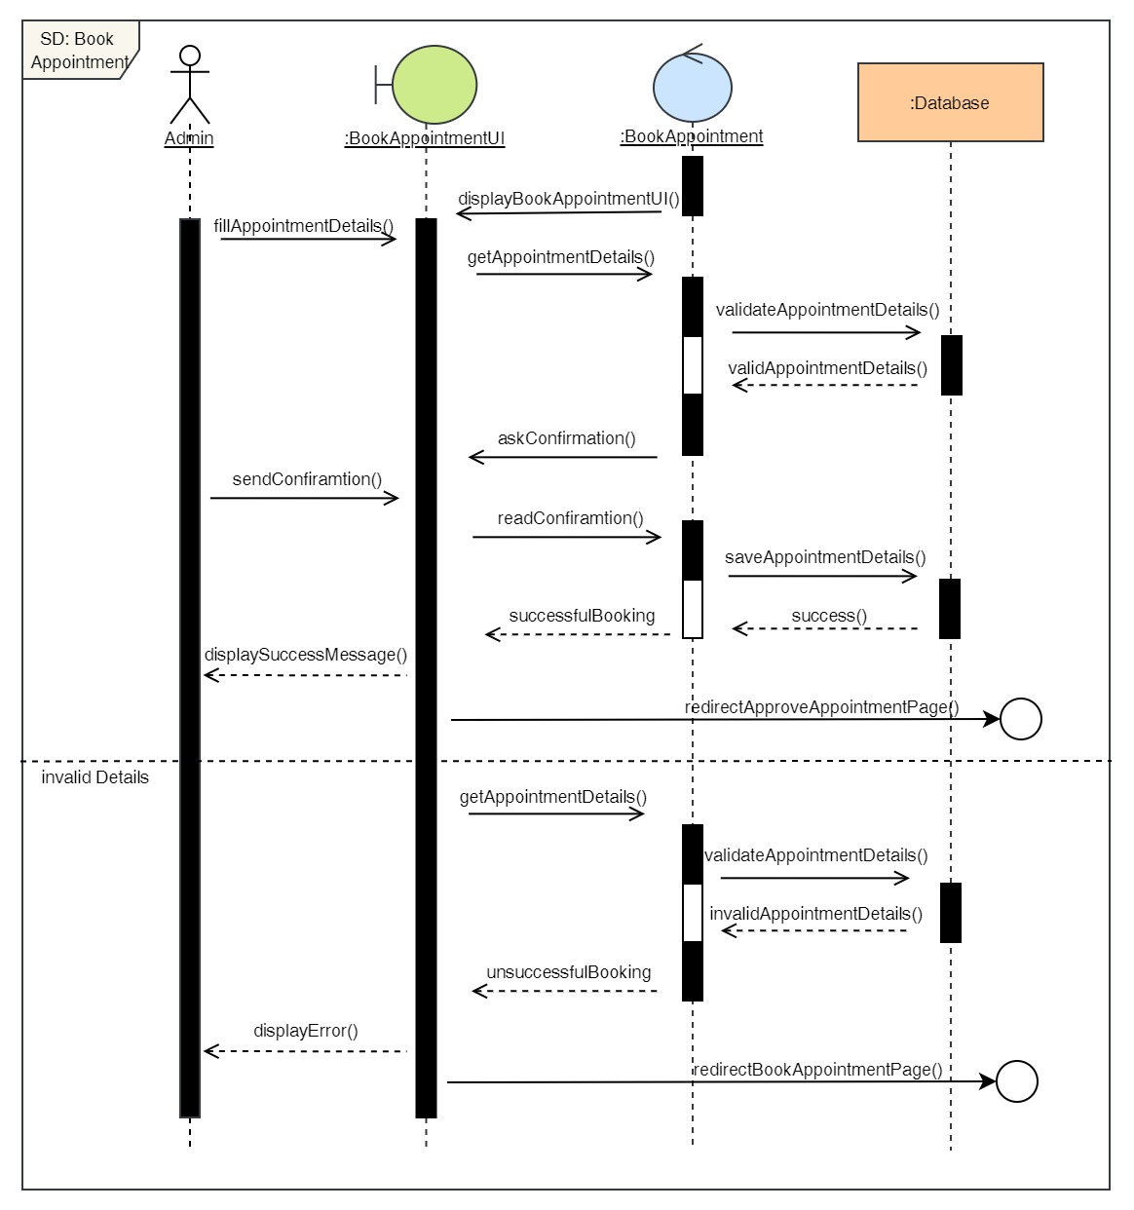

Figure 99: Sequence Diagram – Admin Book Appointment

23. View all appointments

**High Level Use Case Description**

|  |  |
| --- | --- |
| **Use Case:** | View all appointments |
| **Actor:** | Admin |
| **Description:** | Admin can view all the appointments the users have made from the system that is not pending. |

Table 24: High Level Use Case – Admin View Appointments

**Use Case Diagram**

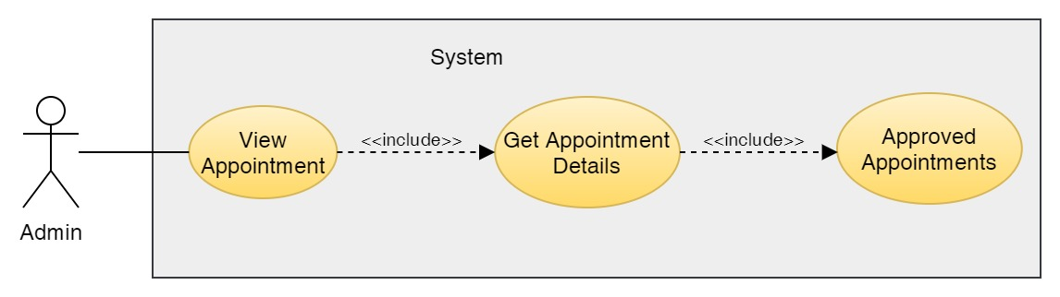

Figure 100: Use Case Diagram – Admin View Appointments

**Collaboration Diagram**

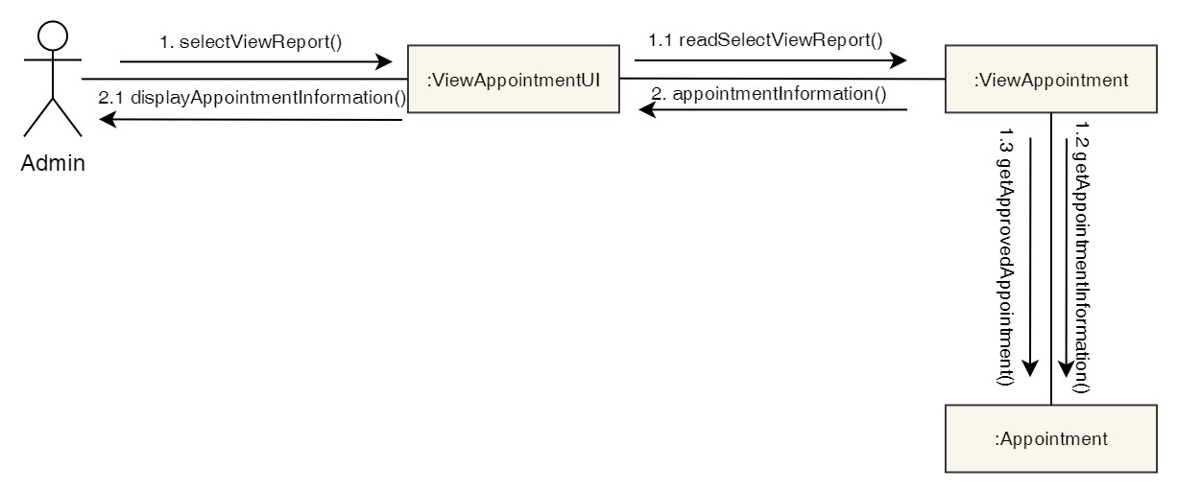

Figure 101: Collaboration Diagram – Admin View Appointments

**Activity Diagram**

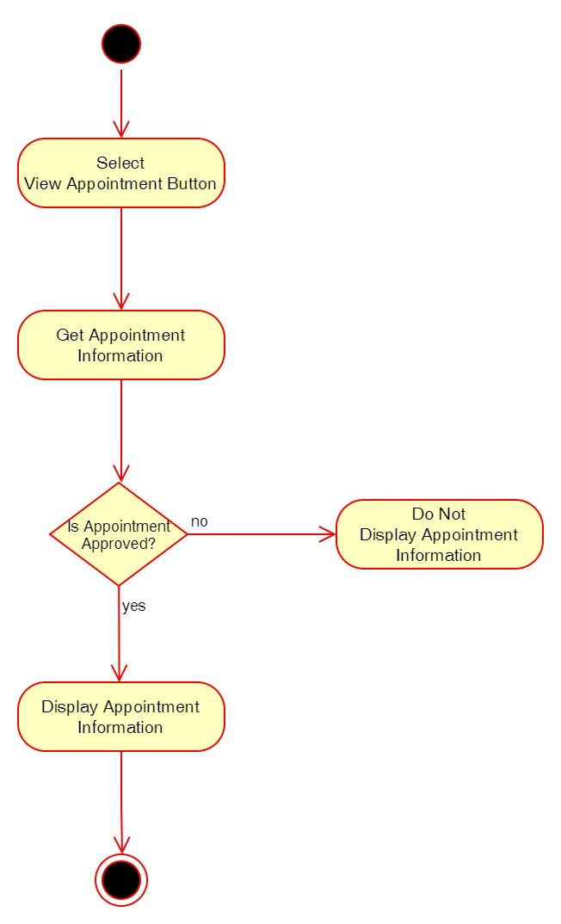

Figure 102: Activity Diagram – Admin View Appointments

**Sequence Diagram**

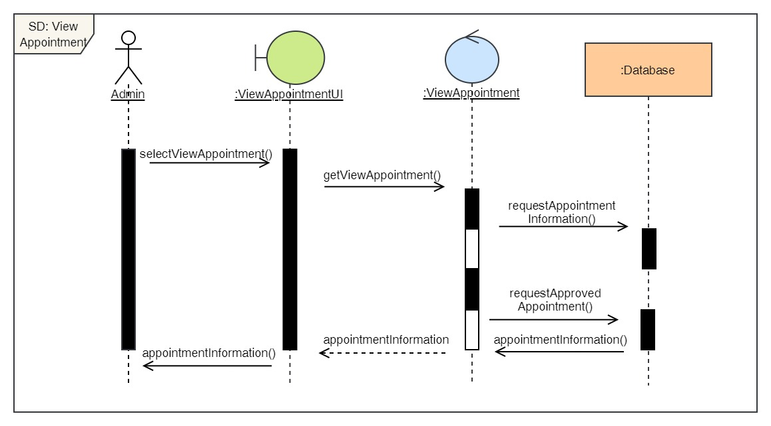

Figure 103: Sequence Diagram – Admin View Appointments

24. Cancel Appointment

**High Level Use Case Description**

|  |  |
| --- | --- |
| **Use Case:** | Cancel Appointment |
| **Actor:** | Admin |
| **Description:** | The admin can cancel appointment of the user's that has already been confirmed. |

Table 25: High Level Use Case – Admin Cancel Appointment

**Use Case Diagram**

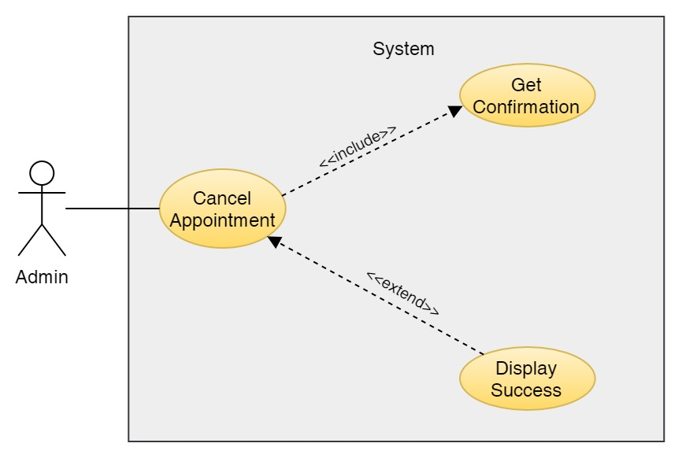

Figure 104: Use Case Diagram – Admin Cancel Appointment

**Collaboration Diagram**

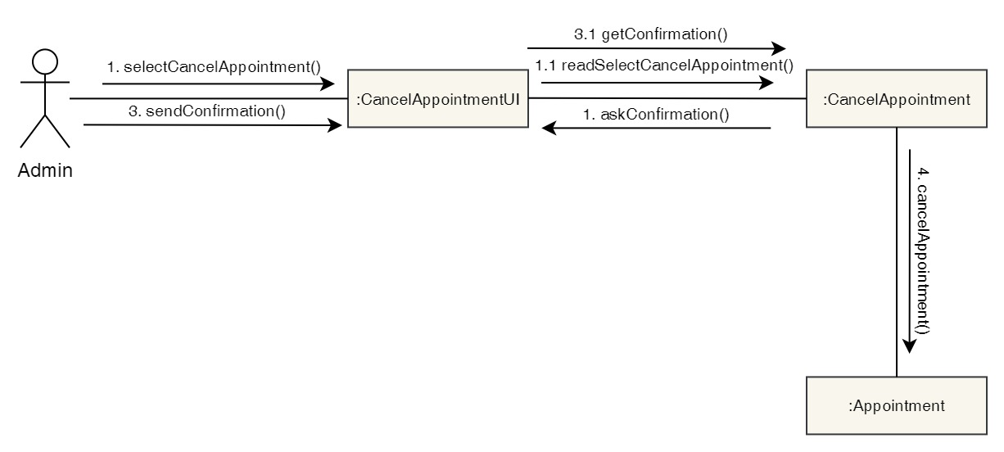

Figure 105: Collaboration Diagram – Admin Cancel Appointment

**Activity Diagram**



Figure 106: Activity Diagram – Admin Cancel Appointment

**Sequence Diagram**

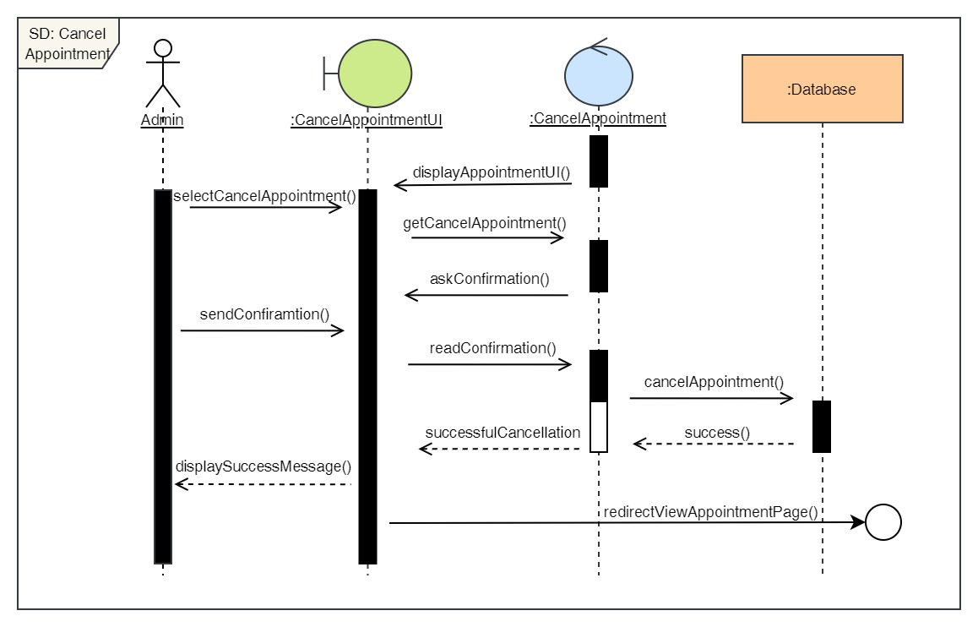

Figure 107: Sequence Diagram – Admin Cancel Appointment

25. Approve Appointment

**High Level Use Case Description**

|  |  |
| --- | --- |
| **Use Case:** | Approve Appointment |
| **Actor:** | Admin |
| **Description:** | When a user books an appointment, it gets in pending stage. The admin then approves the pending appointment and changes the status of the appointment from pending to confirmed. |

Table 26: High Level Use Case – Admin Approve Appointment

**Use Case Diagram**

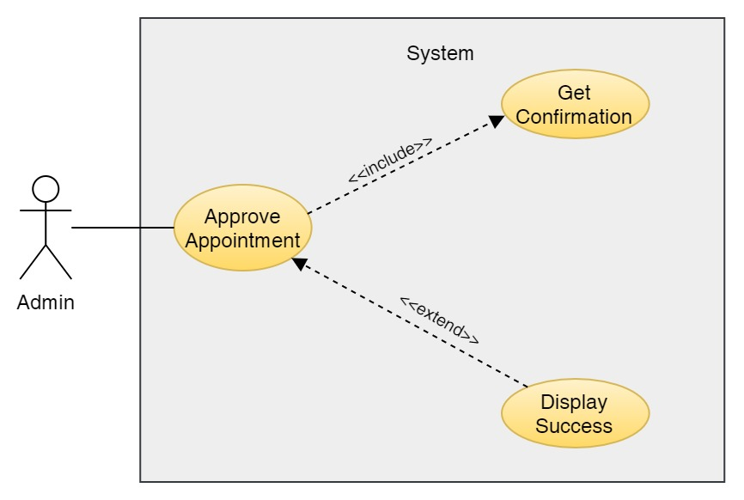

Figure 108: Use Case Diagram – Admin Approve Appointment

**Collaboration Diagram**

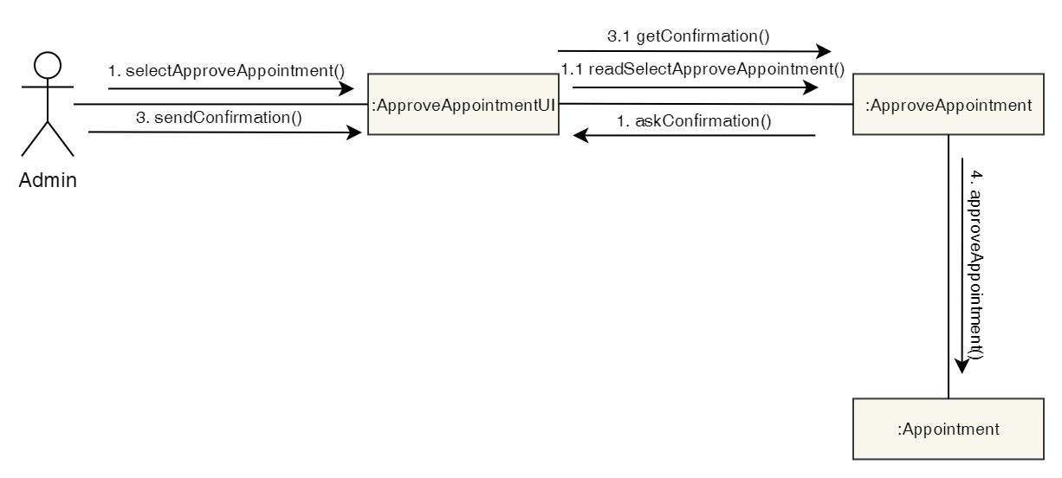

Figure 109: Collaboration Diagram – Admin Approve Appointment

**Activity Diagram**

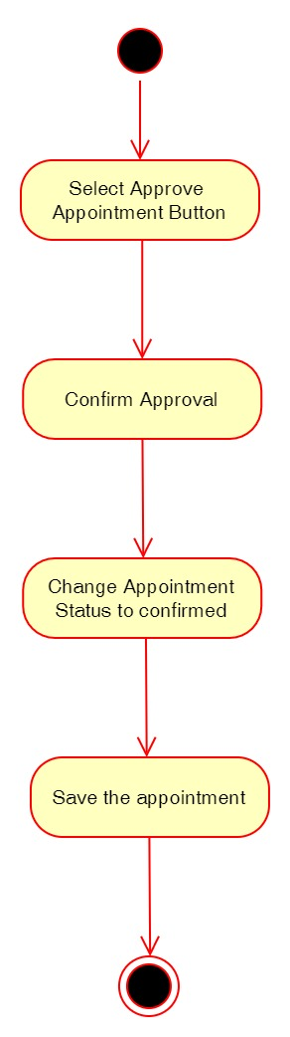

Figure 110: Activity Diagram – Admin Approve Appointment

**Sequence Diagram**

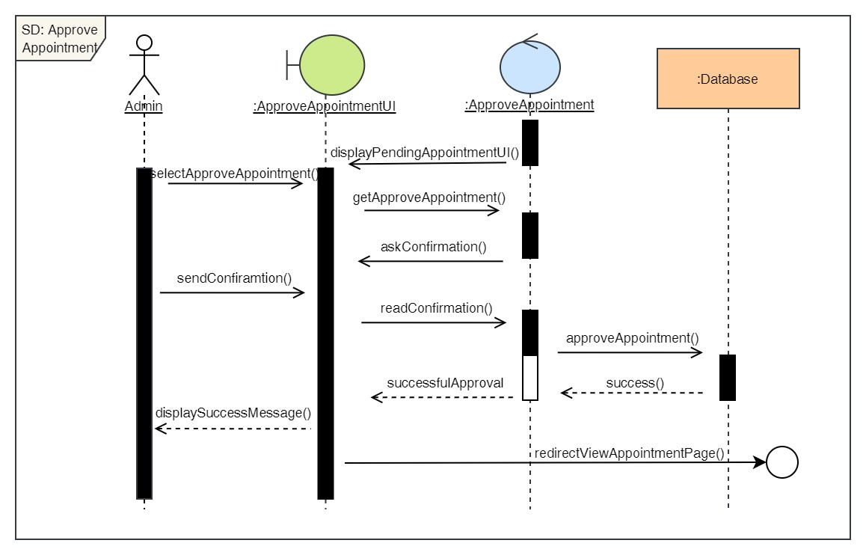

Figure 111: Sequence Diagram – Admin Approve Appointment

26. Reject Appointment

**High Level Use Case Description**

|  |  |
| --- | --- |
| **Use Case:** | Reject Appointment |
| **Actor:** | Admin |
| **Description:** | When a user books an appointment, it gets in pending stage. The admin then rejects the pending appointment if the appointment does not have enough information and changes the status of the appointment from pending to rejected. |

Table 27: High Level Use Case – Admin Reject Appointment

**Use Case Diagram**

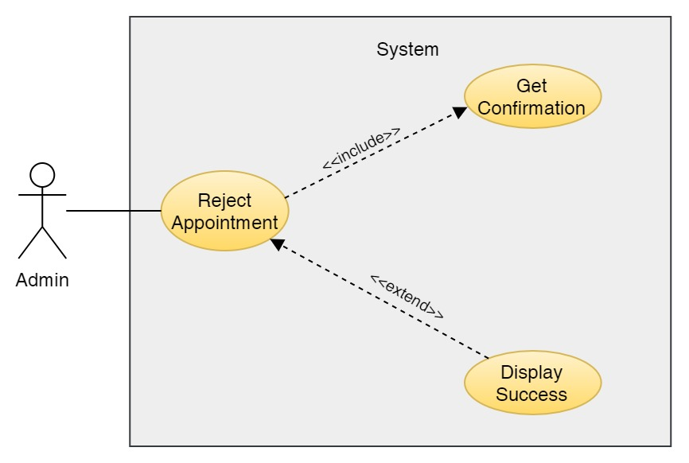

Figure 112: Use Case Diagram – Admin Reject Appointment

**Collaboration Diagram**

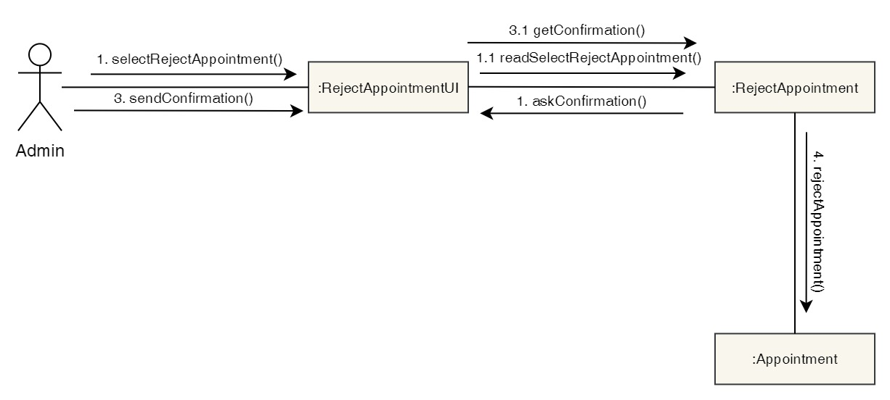

Figure 113: Collaboration Diagram – Admin Reject Appointment

**Activity Diagram**

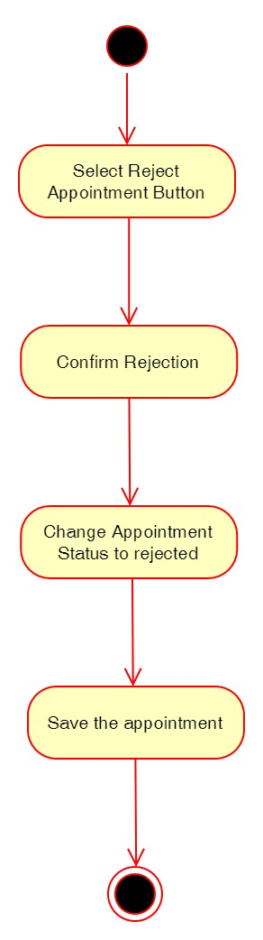

Figure 114: Activity Diagram – Admin Reject Appointment

**Sequence Diagram**

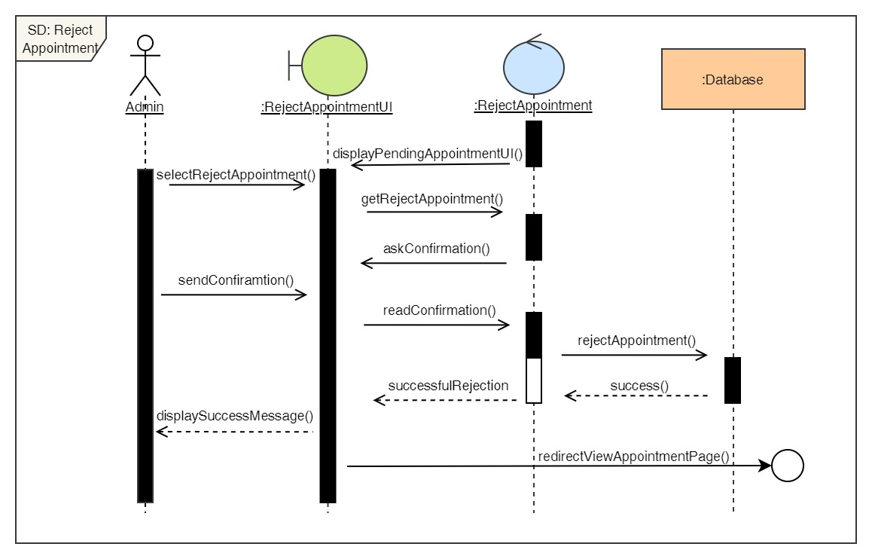

Figure 115: Sequence Diagram – Admin Reject Appointment

27. Finish Appointment

**High Level Use Case Description**

|  |  |
| --- | --- |
| **Use Case:** | Finish Appointment |
| **Actor:** | Admin |
| **Description:** | After the appointment is confirmed, it is in confirmed stage. After the user visits the clinic for their appointment and the appointment is completed, the admin changes the appointment status from confirmed to finished. |

Table 28: High Level Use Case – Admin Finish Appointment

**Use Case Diagram**

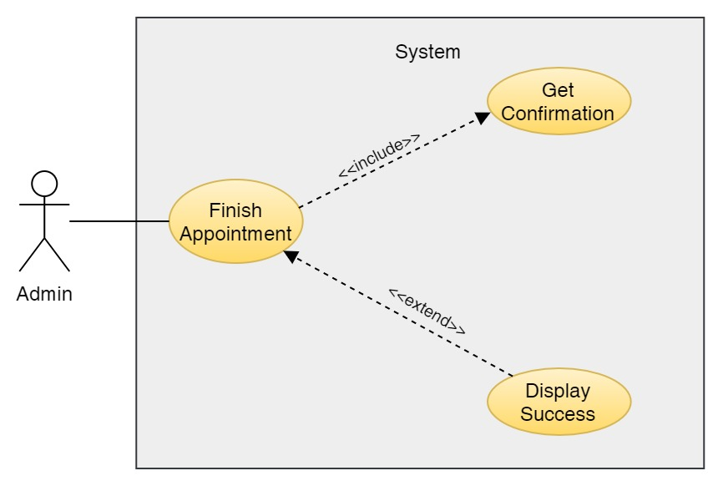

Figure 116: Use Case Diagram – Admin Finish Appointment

**Collaboration Diagram**

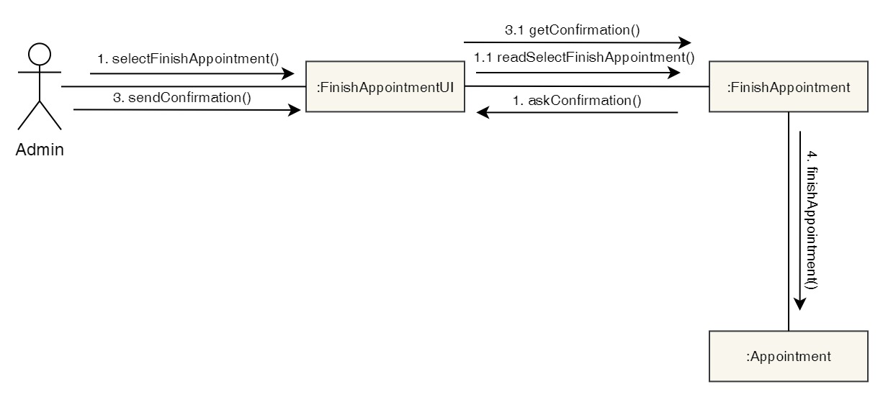

Figure 117: Collaboration Diagram – Admin Finish Appointment

**Activity Diagram**

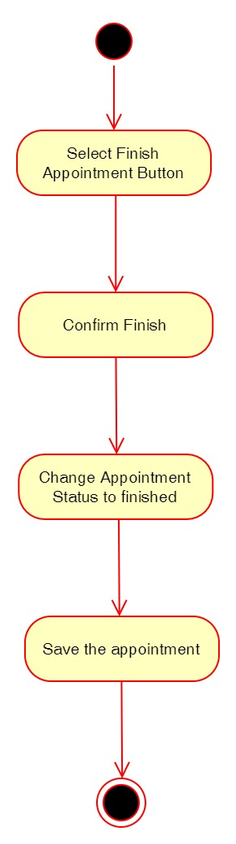

Figure 118: Activity Diagram – Admin Finish Appointment

**Sequence Diagram**

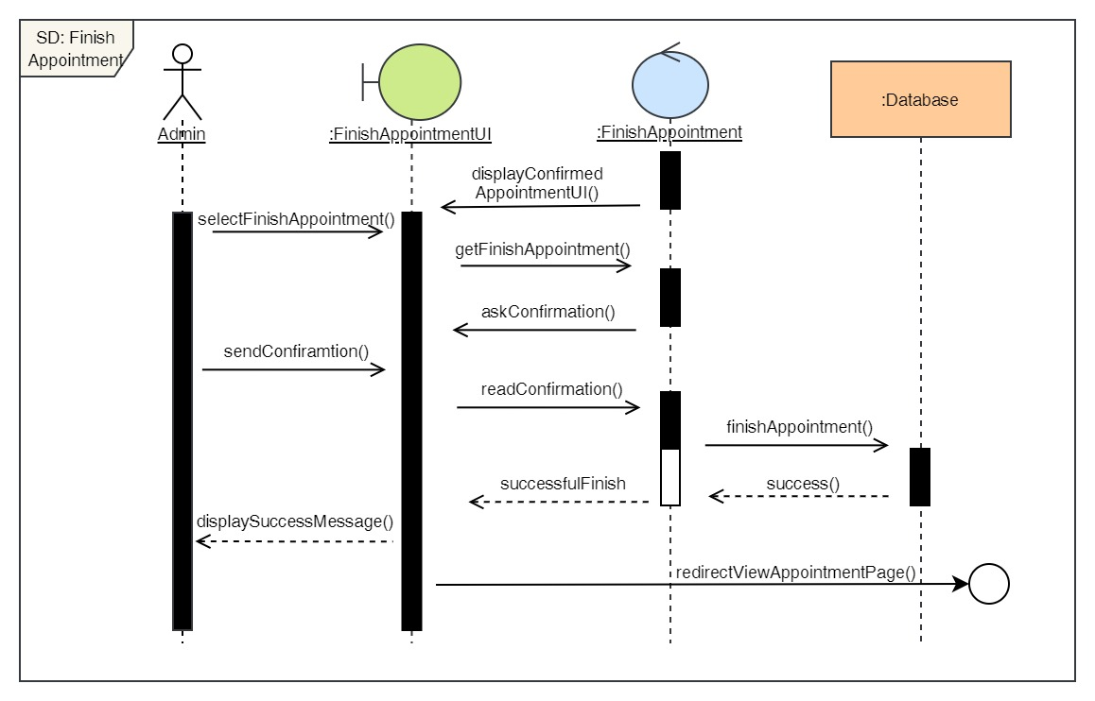

Figure 119: Sequence Diagram – Admin Finish Appointment

28. View all services

**High Level Use Case Description**

|  |  |
| --- | --- |
| **Use Case:** | View Services |
| **Actor:** | Admin |
| **Description:** | Admin can view the list of all the services available along with the cost of it and description. |

Table 29: High Level Use Case – Admin View Services

**Use Case Diagram**

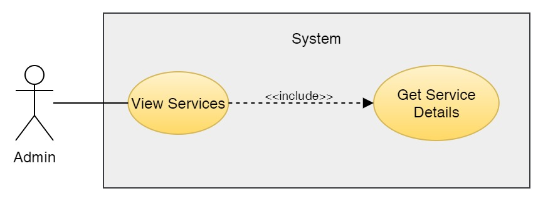

Figure 120: Use Case Diagram – Admin View Services

**Collaboration Diagram**

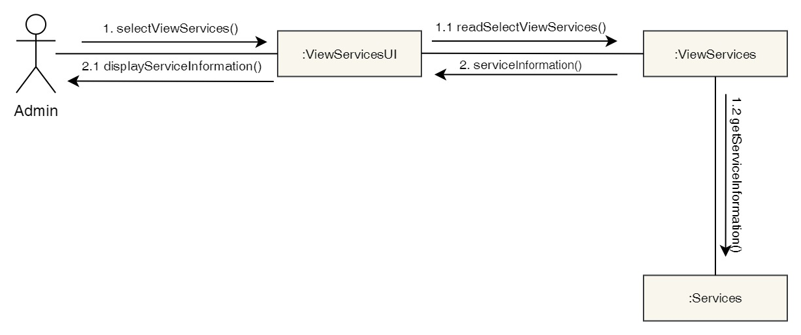

Figure 121: Collaboration Diagram – Admin View Services

**Activity Diagram**



Figure 122: Activity Diagram – Admin View Services

**Sequence Diagram**

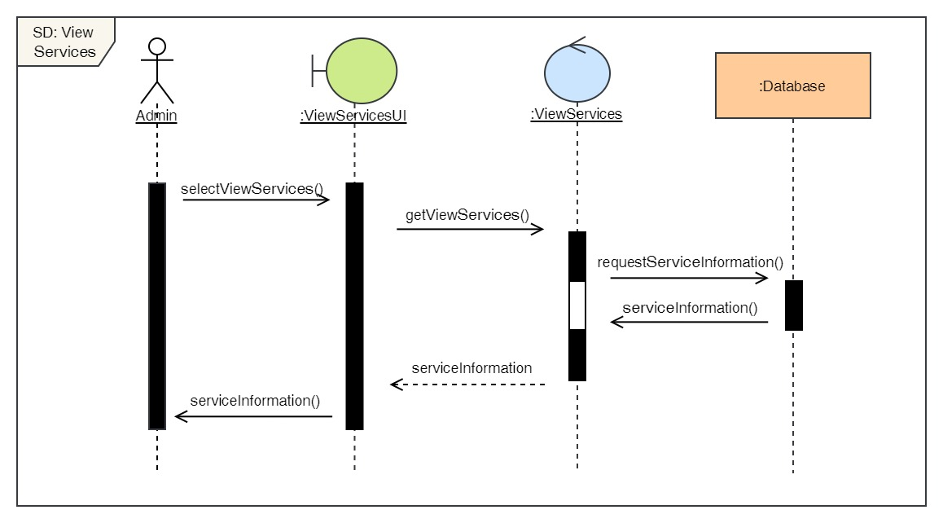

Figure 123: Sequence Diagram – Admin View Services

29. Add services

**High Level Use Case Description**

|  |  |
| --- | --- |
| **Use Case:** | Add services |
| **Actor:** | Admin |
| **Description:** | Admin can add new services in the system. |

Table 30: High Level Use Case – Admin Add Services

**Use Case Diagram**

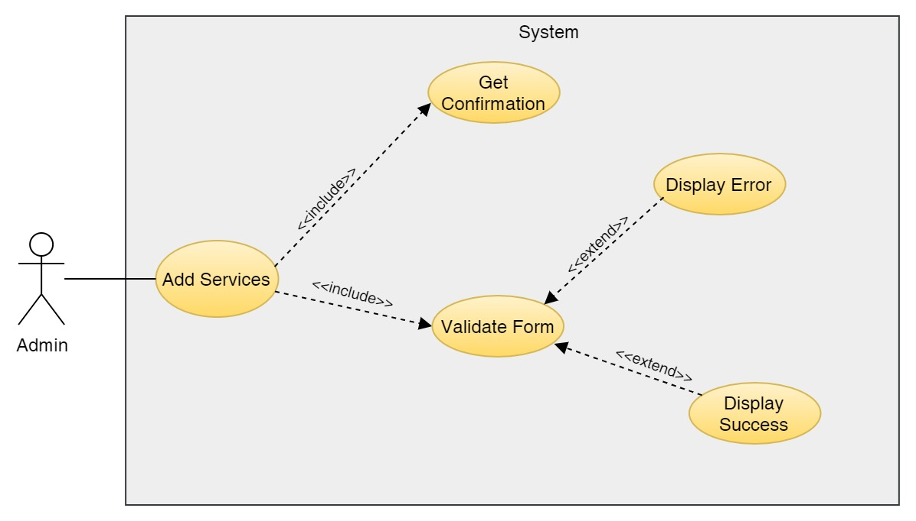

Figure 124: Use Case Diagram – Admin Add Services

**Collaboration Diagram**

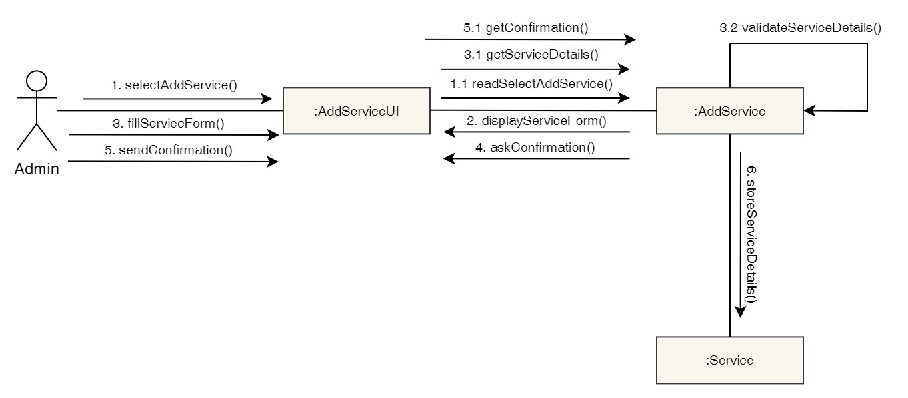

Figure 125: Collaboration Diagram – Admin Add Services

**Activity Diagram**

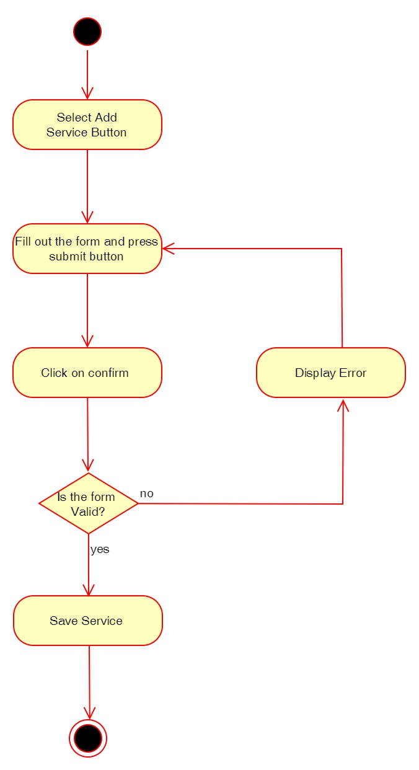

Figure 126: Activity Diagram – Admin Add Services

**Sequence Diagram**

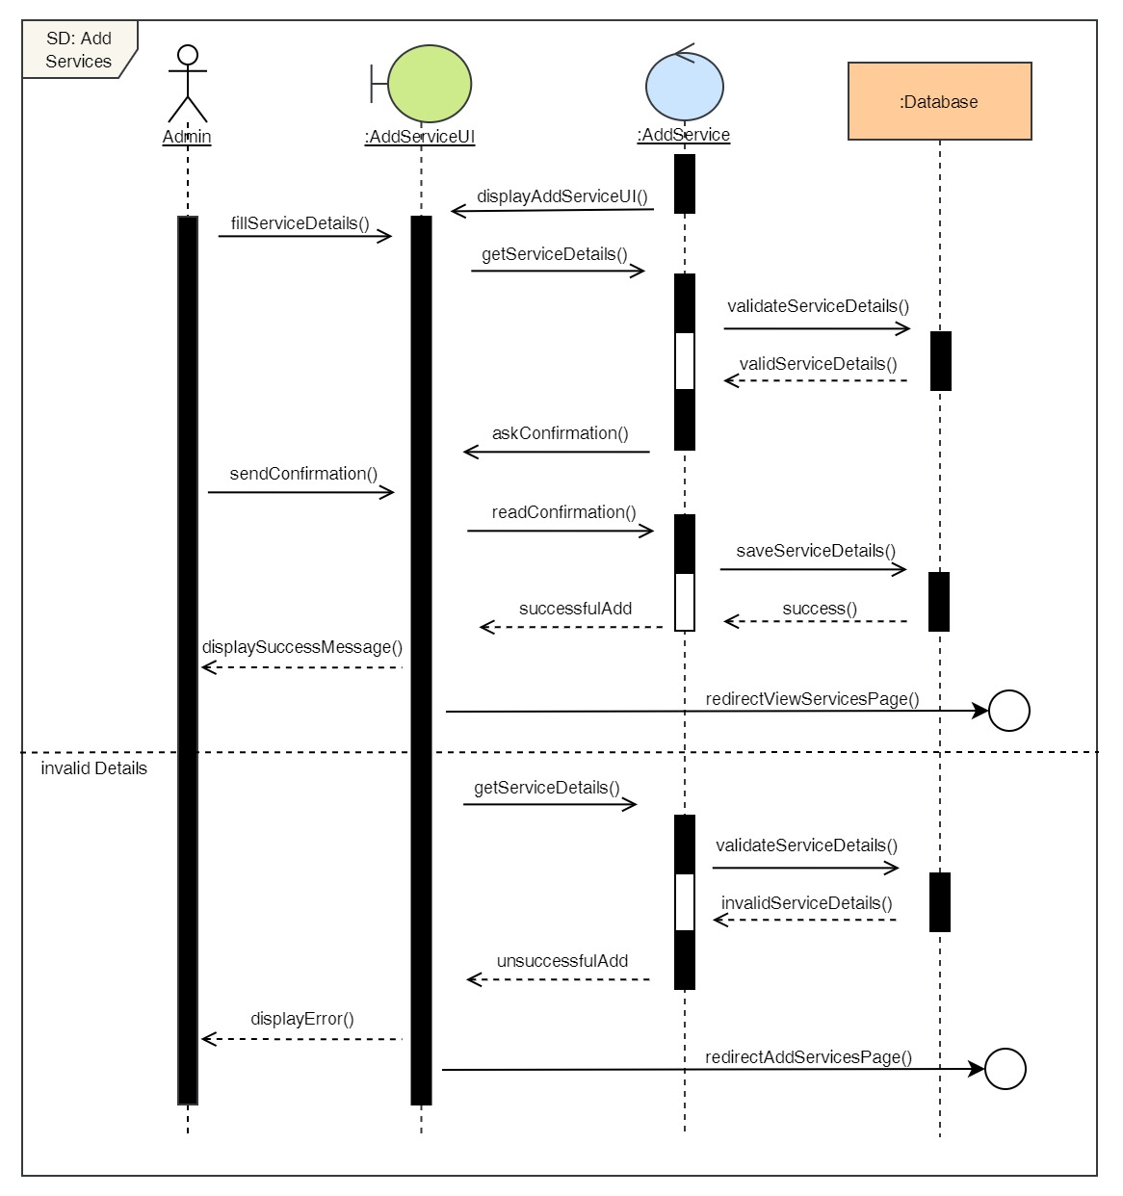

Figure 127: Sequence Diagram – Admin Add Services

30. Delete services

**High Level Use Case Description**

|  |  |
| --- | --- |
| **Use Case:** | Delete services |
| **Actor:** | Admin |
| **Description:** | Admin can add remove existing services from the system. |

Table 31: High Level Use Case – Admin Delete Services

**Use Case Diagram**

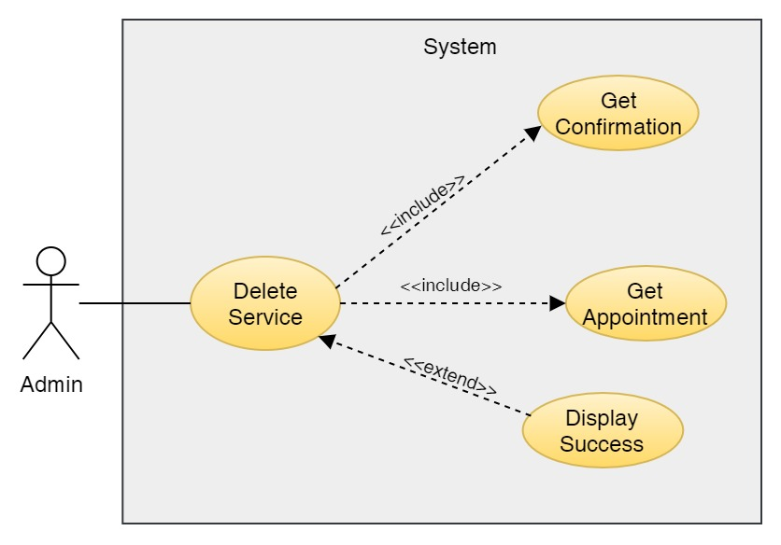

Figure 128: Use Case Diagram – Admin Delete Services

**Collaboration Diagram**

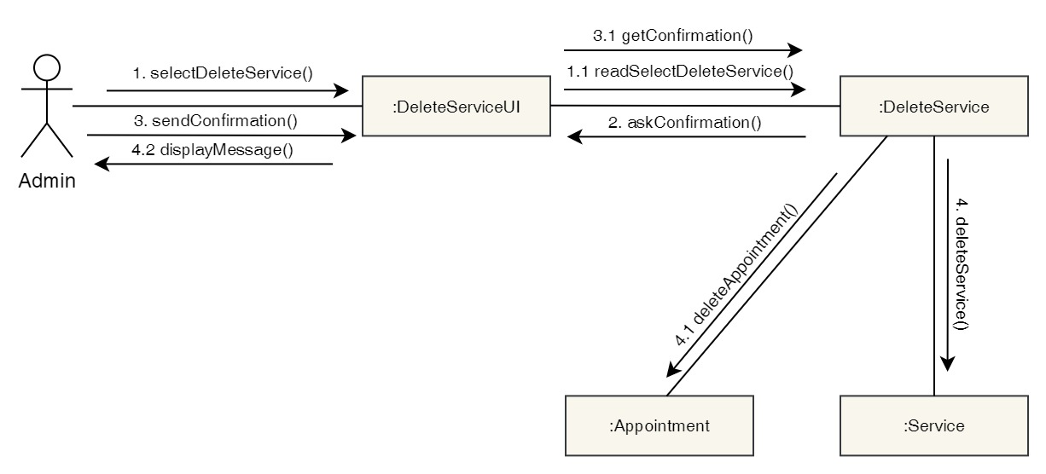

Figure 129: Collaboration Diagram – Admin Delete Services

**Activity Diagram**

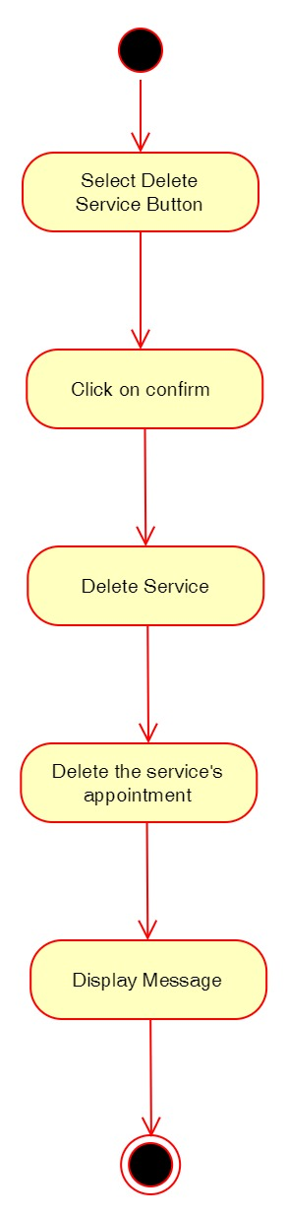

Figure 130: Activity Diagram – Admin Delete Services

**Sequence Diagram**

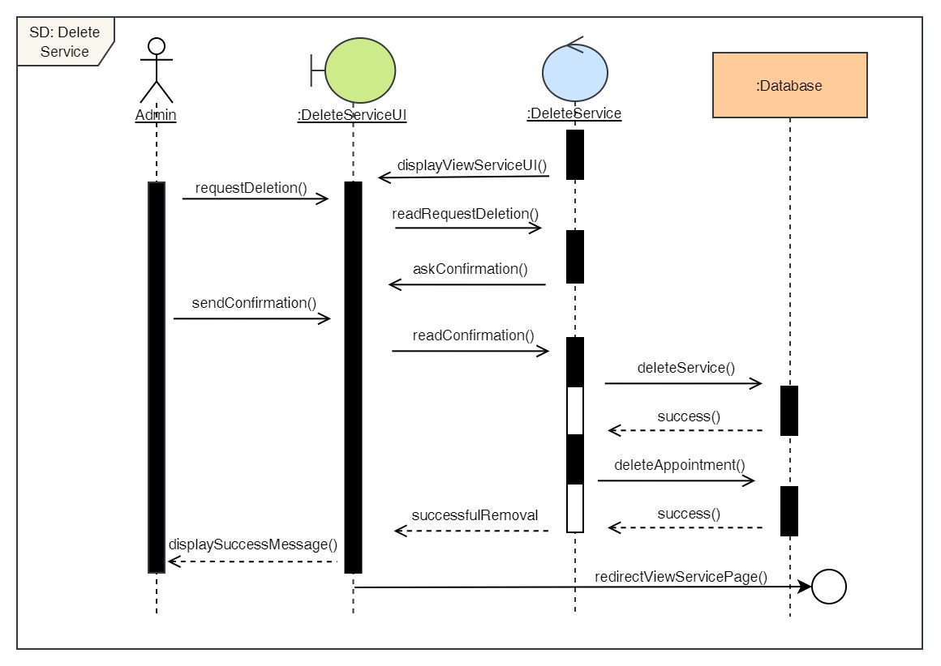

Figure 131: Sequence Diagram – Admin Delete Services

31. Edit services

**High Level Use Case Description**

|  |  |
| --- | --- |
| **Use Case:** | Edit services |
| **Actor:** | Admin |
| **Description:** | Admin can update the details of the existing services in the system. |

Table 32: High Level Use Case – Admin Edit Services

**Use Case Diagram**

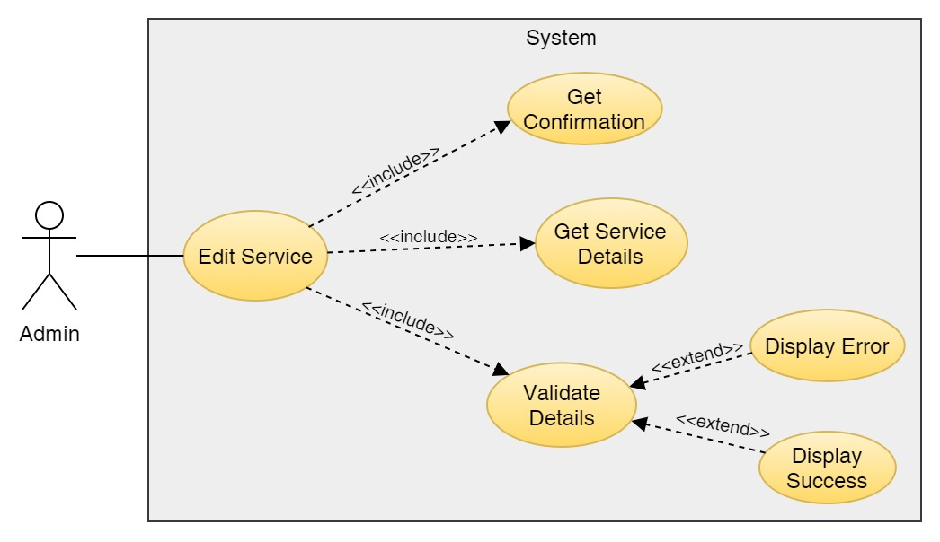

Figure 132: Use Case Diagram – Admin Edit Service

**Collaboration Diagram**

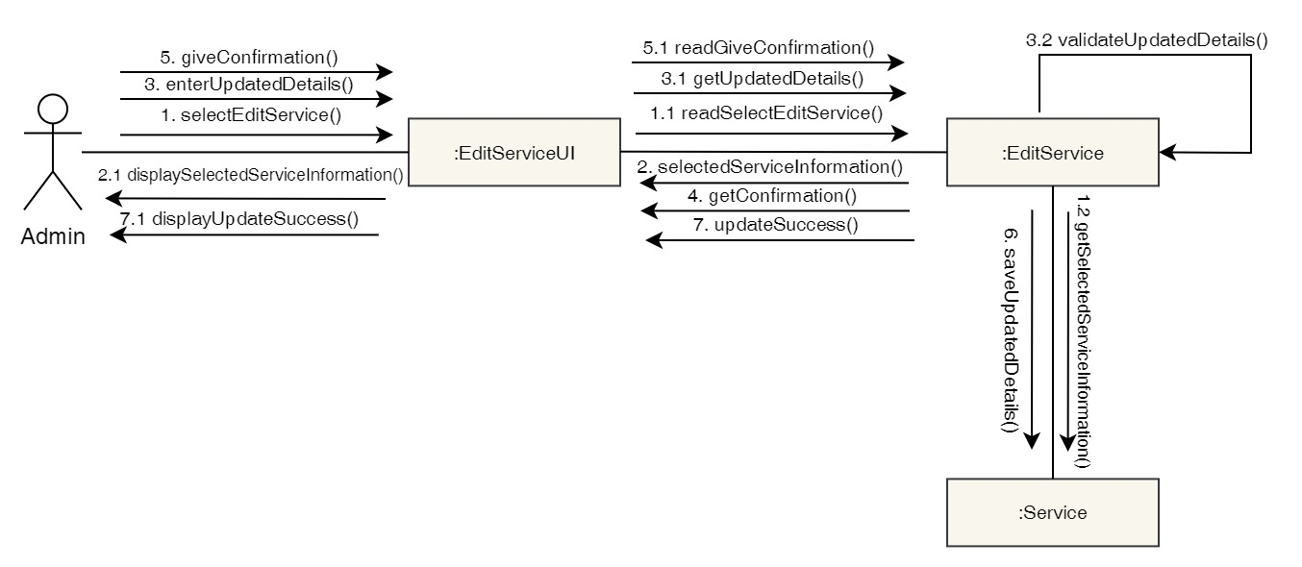

Figure 133: Collaboration Diagram – Admin Edit Service

**Activity Diagram**

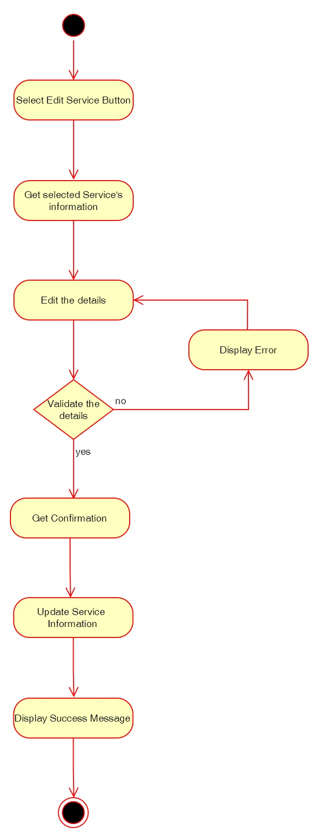

Figure 134: Activity Diagram – Admin Edit Service

**Sequence Diagram**

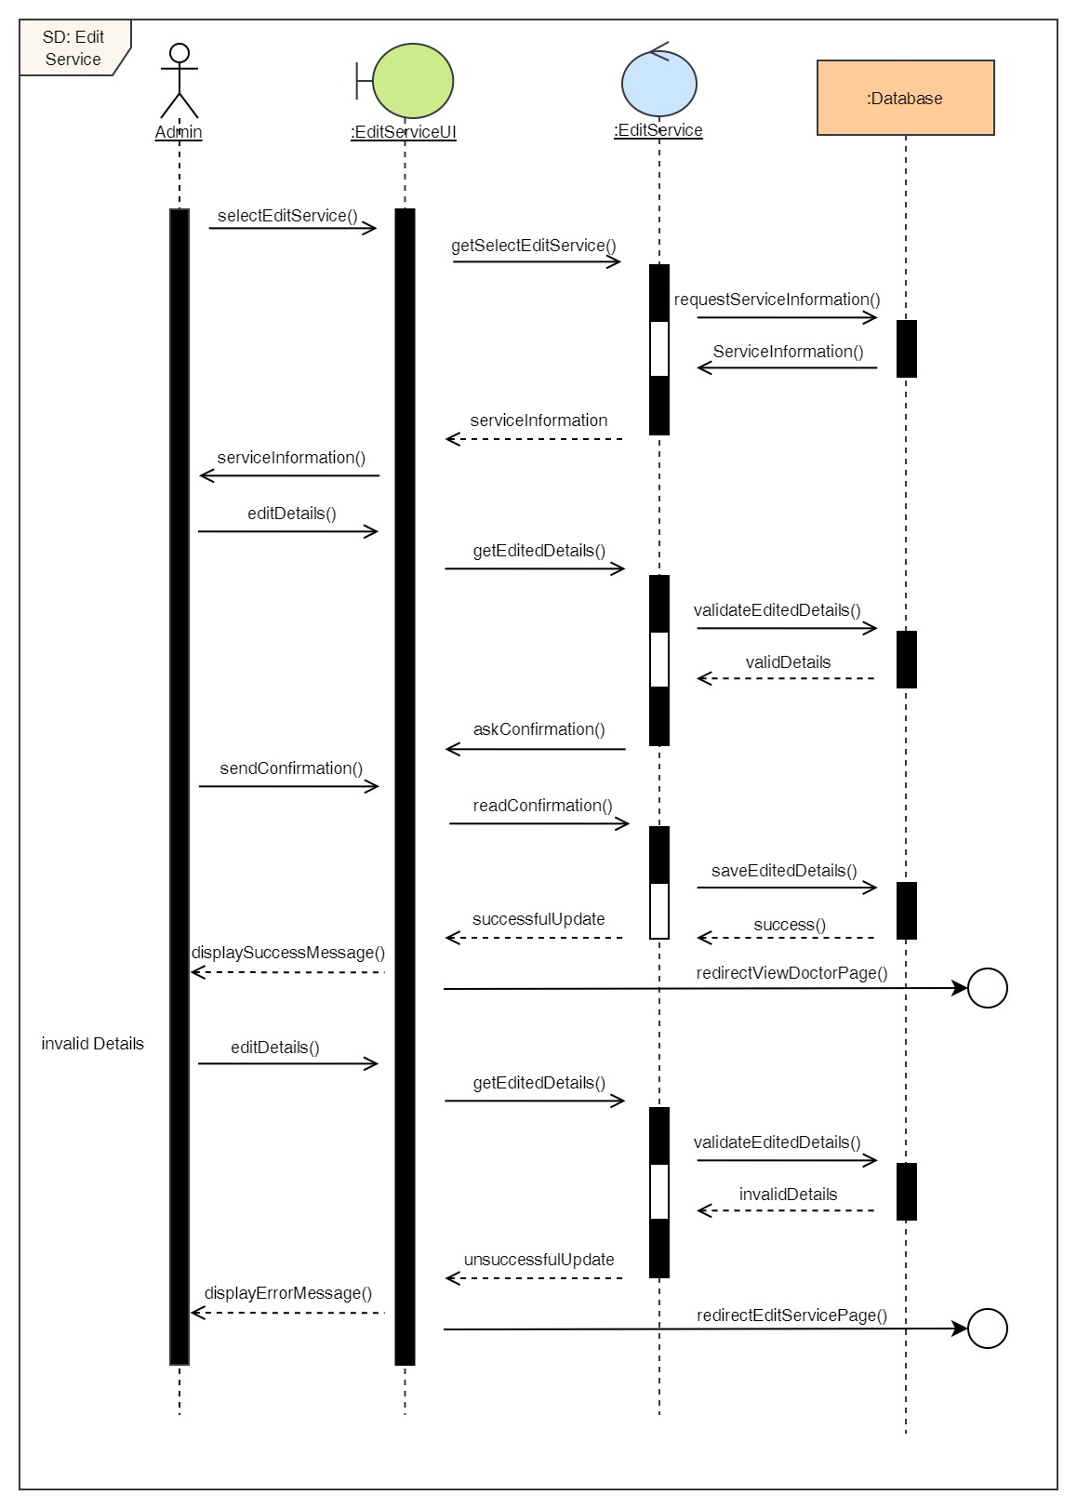

Figure 135: Sequence Diagram – Admin Edit Service

## 3.7 Implementation

# 4. Testing and analysis

## 4.1 Test Plan

### 4.1.1 Unit Testing, Test Plan

### 4.1.2 System Testing, Test Plan

## 4.2 Unit Testing

## 4.3 System Testing

## 4.4 Critical Analysis

# 5. Conclusion

## 5.1 Legal, Social and Ethical Issues

### 5.1.1 Legal Issues

### 5.1.2 Social Issues

### 5.1.3 Ethical Issues

## 5.2 Advantages

## 5.3 Limitations

## 5.4 Future Work

# 6. Reference

GeeksForGeeks, 2019. *GeeksForGeeks.* [Online]   
Available at: https://www.geeksforgeeks.org/software-engineering-incremental-process-model/  
[Accessed 10 12 2021].

Ghahrai, A., 2016. *DevQA.* [Online]   
Available at: https://devqa.io/software-development-methodologies/  
[Accessed 11 12 2021].

Martin, M., 2021. *Guru99.* [Online]   
Available at: https://www.guru99.com/software-engineering-prototyping-model.html  
[Accessed 10 12 2021].

TestBytes, 2019. *TestBytes.* [Online]   
Available at: https://www.testbytes.net/blog/rational-unified-process/  
[Accessed 10 12 2021].

# 7. Appendix

## 7.1 Appendix A: Pre-Survey

### 7.1.1 Pre-Survey Form

### 7.1.2 Sample of filled pre-survey forms

### 7.1.3 Pre-Survey Result

## 7.2 Appendix B: Post-Survey

### 7.2.1 Post-Survey Form

### 7.2.2 Sample of Filled Post-Survey Forms

### 7.2.3 Post-Survey Result

## 7.3 Appendix C: Sample Codes

### 7.3.1 Sample code of the UI

### 7.3.2 Sample code for the Automation Script

## 7.4 Appendix D: Designs

### 7.4.1 Gantt Chart

### 7.4.2 Work Breakdown Structure

### 7.4.3 Algorithms and Flowcharts

### 7.4.4 Hardware Architecture

### 7.4.5 Data Flow Diagram

### 7.4.6 Use Case

### 7.4.7 Wireframes

## 7.5 Appendix E: Screenshots of the System

## 7.6 Appendix F: User Feedback

### 7.6.1 User Feedback Form

### 7.6.2 Sample of Filed User Feedback Forms

## 7.7 Appendix G: Future Work

### 7.7.1 Readings for future work